Precinct 2 – High Street North

Vision for Precinct
The vision for this precinct is to encourage the development of high-quality medium density residential units, townhouses and apartments (up to 4 storeys) in residential streets, that contribute positively to the streetscape. This housing will provide a transition to residential development to the north comprising predominantly single and double storey dwellings. The local streets are to be generously landscaped and pedestrian friendly. New development should be attractive and of contemporary architectural styles and minimise the visual dominance of private dwelling car parking from the street.

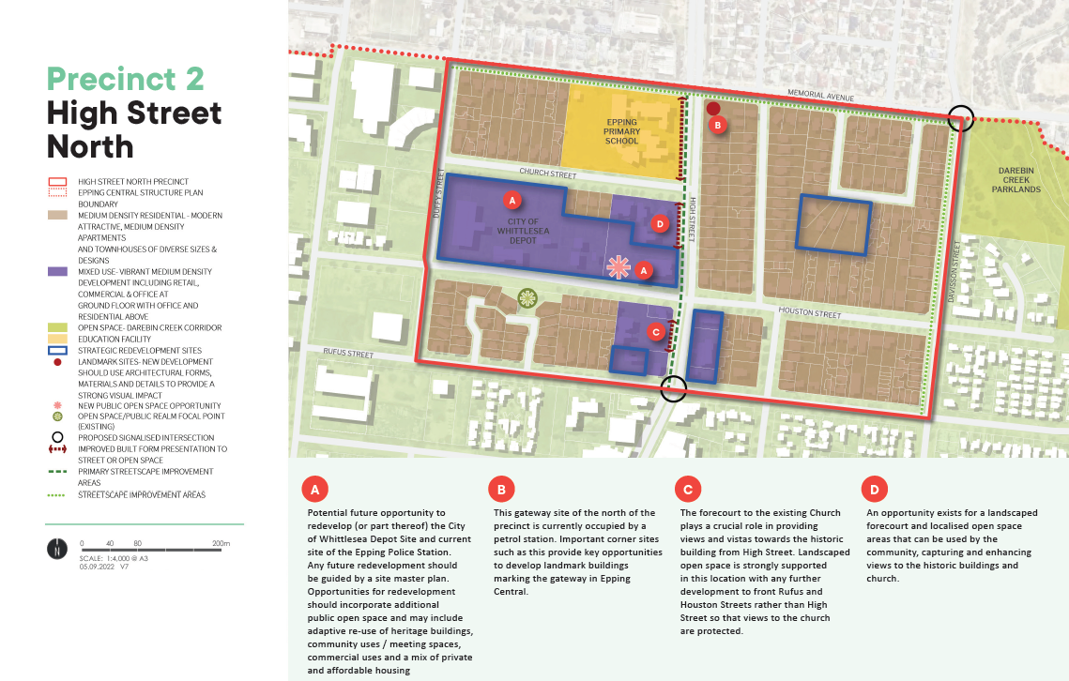
What is proposed by the refreshed draft Structure Plan?
- realignment of the precinct boundary with some properties west of Duffy Street removed from this precinct and included in Precinct 5 (along the western edge).
- it is proposed to designate land currently used as the City of Whittlesea Depot and the Epping Police Station for mixed use purposes to recognise the potential future opportunity for the redevelopment of the site or part of the site in the future. Any potential development on the site should incorporate additional open space and may include adaptive use of heritage buildings, community uses, commercial uses and a mix of private and affordable housing. Please note that there is no current proposal for the Council Depot site to be redeveloped and it will be used as the Council depot for the foreseeable future.
- introduces new development guidelines and principles that direct new developments. This is to ensure high quality built form and an attractive interface to the local streets.
What is not changing?
- the vision for this Precinct as a largely residential area supporting medium density housing and with a strong civic focus.
- development of up to four storeys to provide a transition to residential development to the north which predominantly comprises single and double storey dwellings.
What we want your feedback on:
- Do you support the existing vision for this precinct?
- Do you support the types of opportunities identified to be incorporated into any potential future redevelopment of the Council Depot site?

