Precinct 3 – Epping Station Hub

Vision for Precinct
The vision for this precinct is to support the existing diverse mix of education, community and residential uses. There is opportunity for higher density housing (3-8 storeys) to be located in proximity to Epping Station and Melbourne Polytechnic. Medium density residential (2-4 storeys) is supported in the north of the precinct, providing a transition to residential development to the east of Epping Central and the Darebin Creek corridor. Streetscape improvements will contribute towards more attractive streetscapes and encourage greater pedestrian and cycling activity and use of public transport.

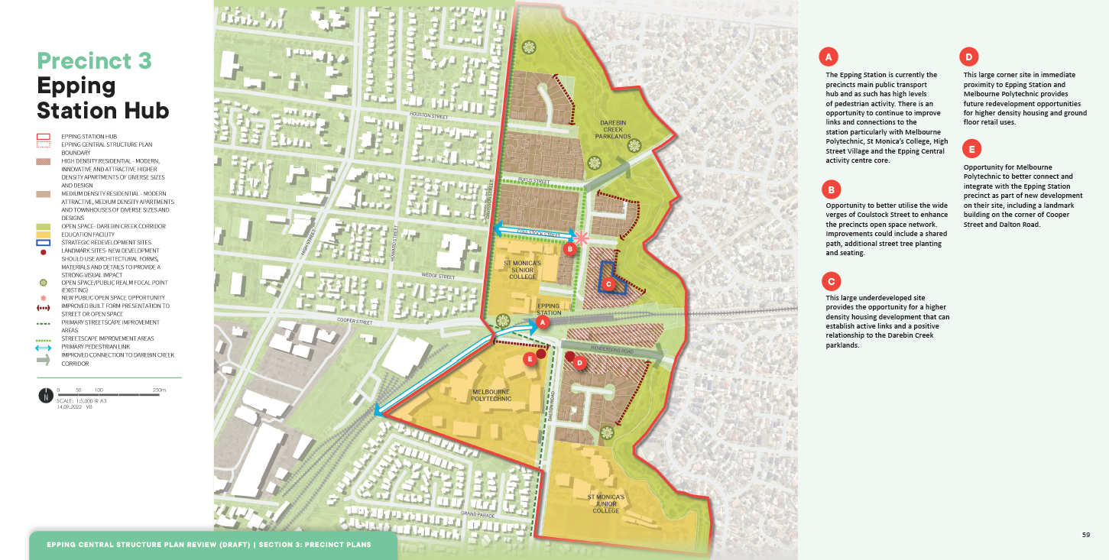

What is proposed by the refreshed draft Structure Plan?
- there is an opportunity to improve pedestrian connections between and to key locations within the Precinct such as the Epping Train Station, Darebin Creek, Melbourne Polytechnic, educational and community facilities. Improvements include landscaping, wayfinding signage and increased safety measures such as additional lighting. These improvements will contribute towards more attractive streetscapes and encourage greater pedestrian and cycling activity and use of public transport.
- Whilst the existing Structure Plan supported multi-storey high-density residential development in residential areas generally south of Rufus Street, the refreshed draft Structure Plan proposes to focus higher density residential development in locations in proximity to Epping Station. Medium density residential comprising apartments and town houses (up to 4 storeys) is supported in the broader residential area in this precinct.
- introduces new development guidelines and principles that direct new developments. This is to ensure high quality built form and an attractive interface to the local streets.

What is not changing?
- the vision for this Precinct, which is to support the existing diverse mix of education, community and residential uses.
- development which reinforces the educational and transport functions of this precinct.
- improvements which maximise accessibility and the attractiveness of the streetscapes and provide strong pedestrian connections between key activities including Epping Station, educational facilities and the Darebin Parklands.
What we want your feedback on:
- Do you still support the vision for this precinct?

