Precinct 7 – Epping Renewal
(Contributory Precinct)

Vision for Precinct
The redevelopment of this site offers the opportunity to establish a new urban character which responds to its site context adjoining the Edgars Creek and proposed mix of uses and activities. The area will be broken up into a number of smaller precincts: health quarter, urban quarters (north and south), living quarter and conservation quarter, each with a distinct character.
- West of Edgars Creek will be the Living Quarter providing a range of housing types with a residential focus. The Edgars Creek corridor will form the Conservation Quarter with a focus on nature, conservation and recreation.
- East of Edgars Creek will be a northern Urban Quarter with a mixed business, commercial, hotel, residential, education and community focus. The southern Urban Quarter will have a focus on commercial, employment and warehousing activities. The Health Quarter, in the north-east corner of the site, which abuts the Northern Hospital, will have the greatest intensity of employment opportunities.
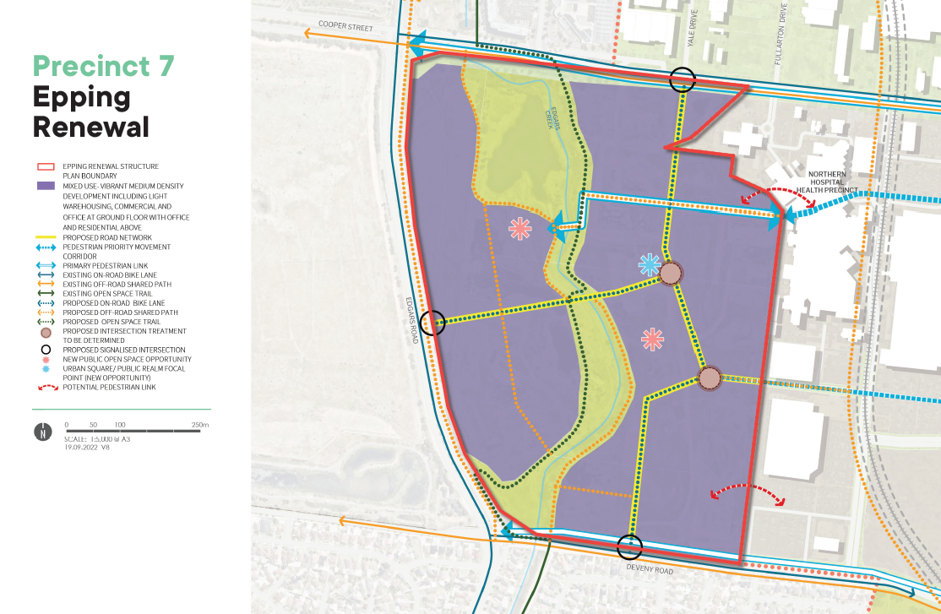

What is proposed by the refreshed draft Structure Plan?
- The Epping Renewal Site is located (south of Cooper Street, north of Deveny Road, east Edgars Road and west of the northern hospital) at the western edge of the Epping Central Metropolitan Activity Centre. It is proposed to be included within the Structure Plan boundary as it provides a significant redevelopment opportunity for further residential, commercial, health and some retail uses in proximity to Epping Central.
- The site has been designated as a contributory precinct on the basis that significant work has previously been undertaken to apply site specific controls to guide the future use and development of the site, including the rezoning of the land. More recently a Development Plan has been prepared for the site and is expected to be approved shortly.
What we want your feedback on:
Do you support inclusion of this precinct into the broader Structure Plan area?

