Precinct 6 – Employment

Vision for Precinct
A mix of modern, high quality commercial and industrial based land uses that results in development at various scales is encouraged in this precinct. As the industrial core of Epping Central, a mix of warehousing, advanced manufacturing, office and commercial space within this precinct (in appropriate locations) will provide further opportunities for food and health-based activities. Development scale is to intensify towards Cooper Street and present a more mixed-use commercial focus that reflects commercial and health services development occurring on the south side of Cooper Street. Development on the north side of Cooper Street should maximise building height requirements and provide podium architectural styles. Residential development is prohibited in this precinct. Improvements in sustainable transport outcomes and streetscapes will help people travel safely between where they live and work.

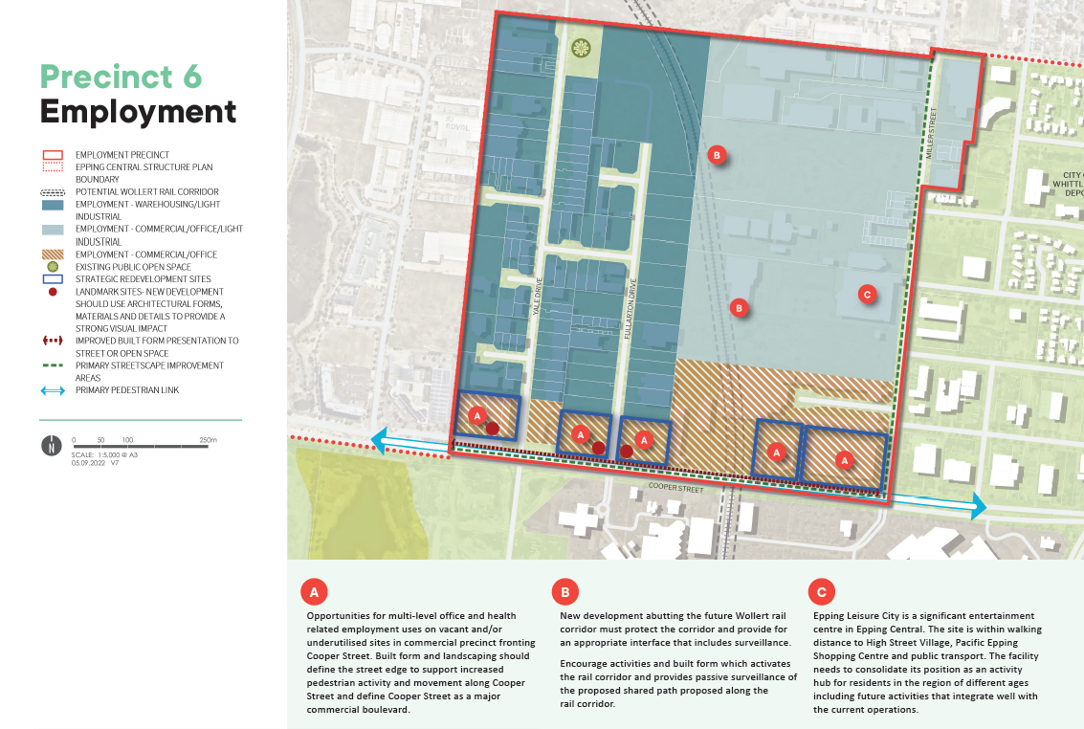

What is proposed by the refreshed draft Structure Plan?
- realignment of the boundary incorporates land generally west of Miller Street into this Precinct. This is a significant change as some uses previously permitted on these lots (primarily residential use) are prohibited within the Employment Precinct. The primary intent of the realignment of the boundary is to provide a clear demarcation between the Employment Precinct and the adjoining Regeneration Precinct (where residential is permitted) promote additional employment opportunities in the precinct and seek to minimise amenity impacts by avoiding land use conflicts.
- support for the intensification of health and food innovation based land uses that builds on the regional significance of the Northern Hospital and other significant health related facilities and proximity to the Melbourne Markets and proposed Melbourne Food and Innovation Export Hub.
- introduces new development guidelines and principles that direct new developments. This is to ensure high quality built form and an attractive interface to the local streets.
What is not changing?
- the employment focus of this precinct which supports a thriving local economy and generates a high level of employment opportunities at a local and regional level.
- ensuring that uses proposed on the eastern periphery of the precinct are sensitive to future commercial and officer based mixed use within the Regeneration precinct.
- providing a sense of arrival to Epping Central by encouraging high quality built form and innovative design outcomes of new development along Cooper Street
What we want your feedback on:
Do you support the vision for this precinct?
Do you consider the provision of local jobs is an important priority within Epping Central?

