Precinct 5 – Regeneration

Vision for Precinct
The vision for this area as a mixed use precinct undergoing significant transformation, providing a strong transition between industrial uses to the west and residential uses to the north and east remains unchanged from the existing Structure Plan. The draft Structure Plan encourages the use and development of this area as a high density employment precinct for the purpose of commercial and office activities as a primary priority. Whilst residential use is permitted in this precinct as part of mixed use developments, this is a secondary priority. Residential uses will need to be located and designed in a way that minimises land use conflicts and does not undermine the employment focus of this precinct.
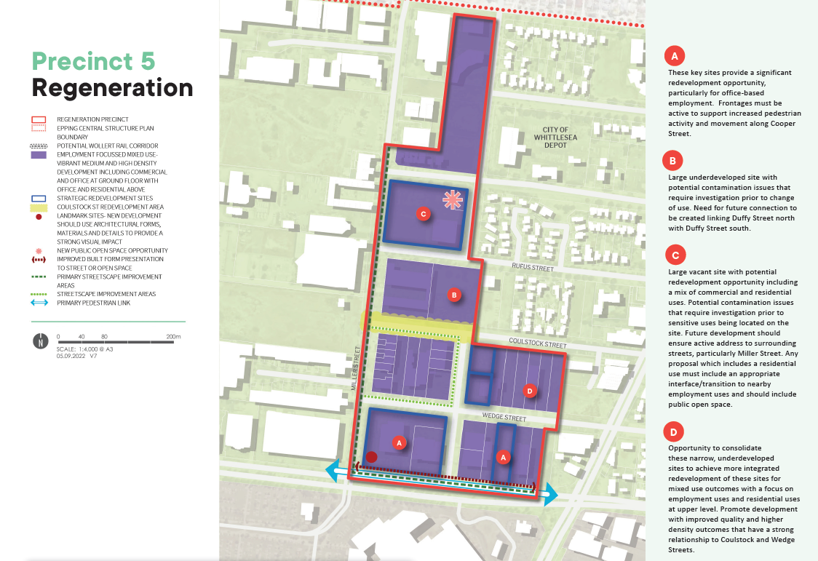
What is proposed by the refreshed draft Structure Plan?
- the boundaries of this Precinct has undergone the most significant change with some properties from Precincts 1 (High Street Village) and 2 (High Street North) added to this precinct and properties generally west if Millar Street removed from this Precinct and included in Precinct 6 (Employment Precinct).
- a focus on the use and development of land in this precinct for high density employment activities including a mix of office and commercial activities to maximise opportunities for local jobs.
- introduces new development guidelines and principles that direct new developments. This is to ensure high quality built form and an attractive interface to the local streets.

What is not changing?
- consideration of opportunities that overcome the movement barrier created by Cooper Street by encouraging a stronger pedestrian and cyclist based street network and improving the amenity of local streets.
- support for development that significantly intensifies the use and development of land in the precinct and which encourages an improved mix of uses.
What we want your feedback on:
Do you support prioritising development that supports local jobs and employment activities in preference to residential uses in this precinct?

