Precinct 4 – Regional Demand

Vision for Precinct
The future vision for this Precinct is a high change, multi-level, mixed use precinct with a strong focus on employment and health and human services. The expansion and growth of this precinct will reinforce and expand upon the regional role of the Northern Hospital, Pacific Epping Shopping Centre and Epping Homemakers Centre. Multi-storey development of 3-8 storeys providing a mix of retail shops, office, entertainment and residential uses is encouraged. New development must feature active frontages to all streets and car parking should not dominate views from the street. Priority will be given to improving pedestrian and cyclist networks and movement. Land around the Pacific Epping Shopping Centre and Epping Homemakers Centre provides significant opportunity for pedestrian scale retail, commercial and residential development set within a more permeable street network.
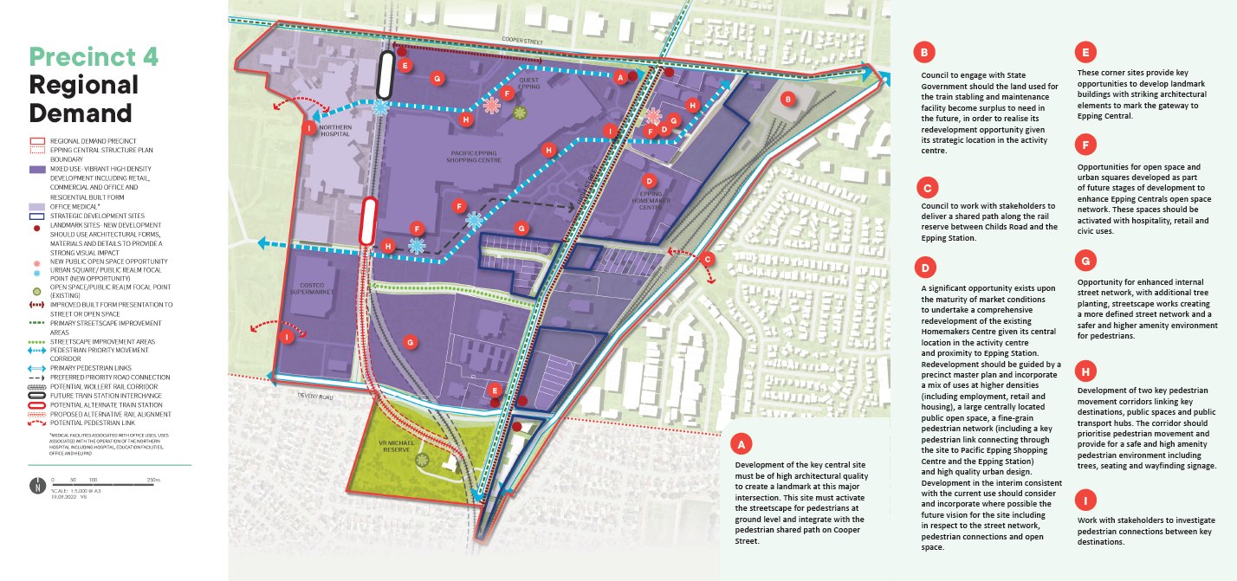
What is proposed by the refreshed draft Structure Plan?
- continued support for a new rail line to Wollert including a station at Epping Central. The draft plan considers an alternate rail alignment and train station location as part of the future Wollert rail corridor. The proposed alignment would see more of the VR Michael Reserve impacted by the elevated railway line in order to direct it along the length of Main Street. It also considers locating the station further south of Cooper Street providing more direct access to development proposed at New Epping.
- refers to this precinct (comprising the key anchors including Pacific Epping Shopping Centre, Epping Homemakers Centre, Northern Hospital) as the ‘activity heart’ of Epping Central in recognition of the significant retail and commercial activity in this precinct.
- facilitates the development of pedestrian priority movement corridors between key destinations including Epping Station, Epping Homemakers Centre, Pacific Epping Shopping Centre, the Northern Hospital and New Epping which prioritises pedestrians and provides for high levels of amenity including provision of wayfinding elements, lighting and public art.
- proposes a preferred priority road connection to improve accessibility between New Epping and High Street as part of the future redevelopment of Pacific Epping Shopping Centre.
- introduces new development guidelines and principles that direct new developments. This is to ensure high quality built form and an attractive interface to the local streets.
What is not changing?
- the vision for this Precinct as a high-density, mixed-use precinct including commercial and residential uses in a pedestrian and cycle friendly environment.
- Support for Improvements to the physical relationship and pedestrian connections between the Northern Hospital, Pacific Epping Shopping Centre and Epping Homemakers Centre.
- delivery of the proposed Wollert rail Corridor and new train station at Epping Central.
- support for the redevelopment of anchor sites within the precinct in an integrated manner to achieve the shared vision for the precinct.
What we want your feedback on:
Whether you support the existing Rail Alignment and Station Location or the alternative rail alignment and station location.
Your thoughts on the proposed route of the Priority Pedestrian Movement Corridors.

