Precinct 8 – Dalton Road Neighbourhood (Contributory Precinct)

Vision for Precinct
The Dalton Road Neighbourhood Precinct forms the south eastern corner of Epping Central and is centred around the Dalton Road Shopping Village.
This predominantly residential area is expected to experience low to moderate change over the life of the Structure Plan. New development in the retail centre is to comprise high quality, multi-level retail and residential development with attractive frontages. Architectural styles are to be attractive and modern and contribute to the ‘urban village’ feel of the Dalton Road Shopping Village. Improved landscaping and tree planting of local streets will improve the pedestrian environment. Increased focus on enhancing existing pocket parks and links to Darebin Creek Linear Parkland will improve accessibility and amenity of open spaces for the local community.

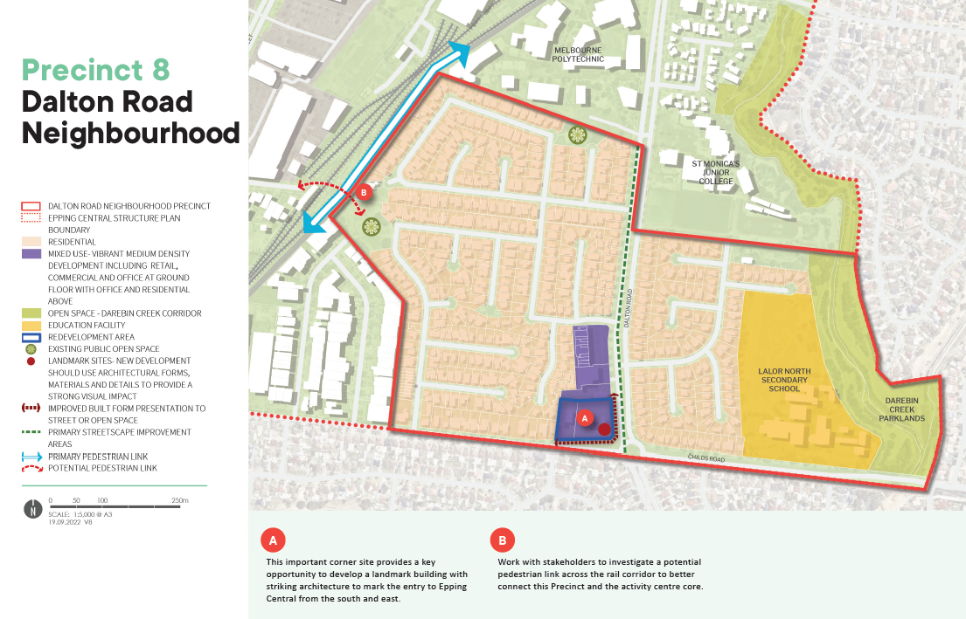

What is proposed by the refreshed draft Structure Plan?
- This precinct is to be retained within the Structure Plan boundary, however it has been designated as a contributory precinct on the basis that it is located some distance from the ‘activity centre core’ and is separated from the centre by the railway corridor.
- This area is also expected to only experience low to moderate change and is therefore not going to significantly contribute to achieving the vision for Epping Central.
- It is proposed that this precinct will be rezoned to an appropriate residential zone in the future.
What we want your feedback on:
Do you support the revised vision for this Precinct?
Do you support the investigation of a potential future pedestrian link to provide access across the rail line to improve pedestrian access to other key destinations?

