Precinct 9 – Childs Road Employment
(Contributory Precinct)

Vision for Precinct
The Childs Road Employment Precinct is a discrete pocket of industrial development located at the junction of Childs Road and the Mernda Rail Line.
Future development in this precinct should comprise modern, high quality employment-based development which provides buildings at various scales and intensities. Development is to demonstrate a reduction in front setback, attractive landscaping and screening and seek to improve the public realm and street-based environment. Cyclist and pedestrian movements and amenity are prioritised to increase active travel to and from this precinct. Non-employment-based uses are discouraged in this precinct.
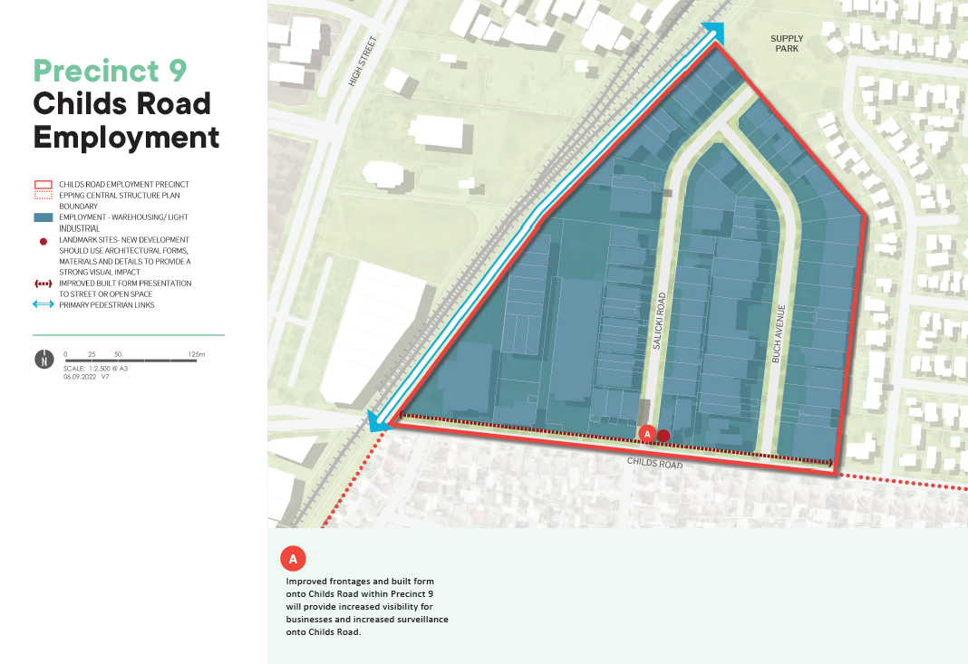
What is proposed by the refreshed draft Structure Plan?
- This precinct is to be retained within the Structure Plan boundary, however it has been designated as a contributory precinct on the basis that it is located some distance from the ‘activity centre core’ and is separated from the centre by the railway corridor.
- This area is unlikely to experience significant change over the life of the Structure Plan and is therefore not going to significantly contribute to achieving the vision for Epping Central.
- It is proposed that this precinct will be rezoned to an appropriate commercial zone in the future.
What we want your feedback on:
Do you support the revised status of this precinct?

