Precinct 1 – High Street Village

Vision for Precinct
The future vision for High Street Village is for multi-level, mixed use development. Higher residential densities will be encouraged in appropriate locations to support the retail precinct. Development along High and Cooper Streets will comprise activity generating retail and commercial activity at the ground level with office and residential use on the upper levels. Multi-storey apartment buildings will be located in surrounding streets
Enhancement of the existing retail shops and other services along High Street and enticing new types of specialty shops, cafes and restaurants will create a ‘neighbourhood heart’ for local residents, visitors and workers.

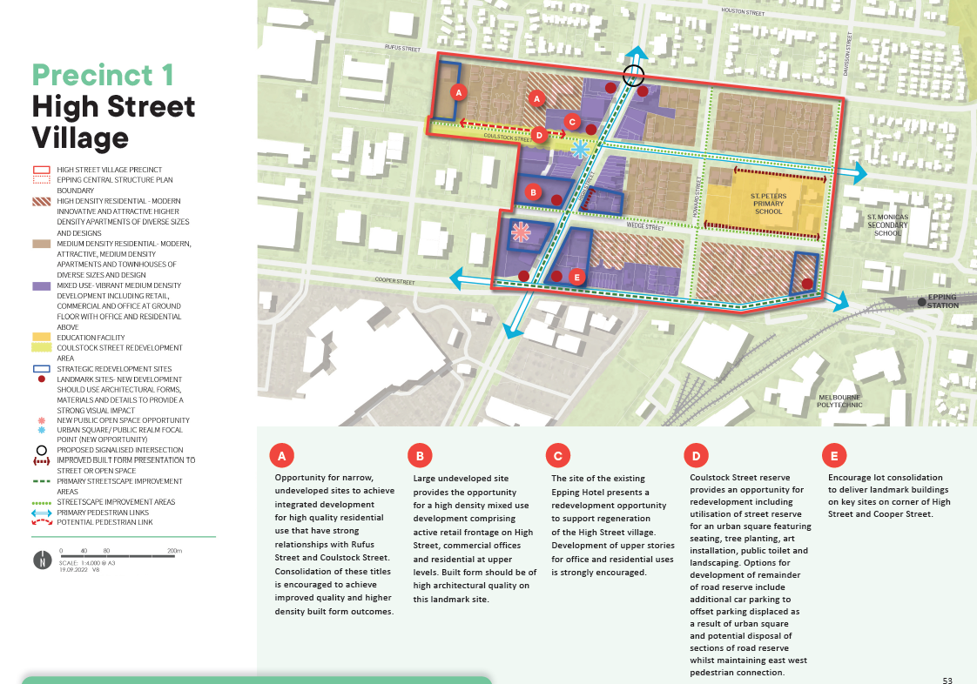

What is proposed by the refreshed draft Structure Plan?
- realignment of the precinct boundary with some properties removed from this precinct (along the western edge)
- refocussing this area as the ‘neighbourhood’ heart in recognition of the importance of High Street to the local community.
- reduces the areas designated for high-density residential housing to focus taller buildings in appropriate areas close to Epping Train Station and on strategic redevelopment sites.
- designates properties on the north side of Cooper Street between Howard and Davisson Streets from ‘mixed use’ to high-density residential.
- introduces new development guidelines and principles that direct new developments. This is to ensure high quality built form and an attractive interface to the local streets.
- deletes the proposed open space reserve at the western end of Coulstock Street. In it is place, a future opportunity has been identified in the street reserve close to High Street for a new urban square with seating, tree planting, public art and amenities.
- Identifies a need for a new open space area near the corner of High Street and Wedge Street.
What is not changing?
- support for cafes, dining and specialty shops which encourages pedestrian activity and a lively local area that encourages activity during the day and night.
- multi-level mixed use development offering a greater diversity of housing to support the High Street Village neighbourhood precinct.
- High and Cooper Streets are a priority for streetscape improvement works.
What we want your feedback on:
- Do you support the new opportunities for open space in the precinct?
- Do you support new guidelines to direct the built form outcomes of new development?

