Mernda Recreation Reserve master plan

Engagement Summary

September 2022

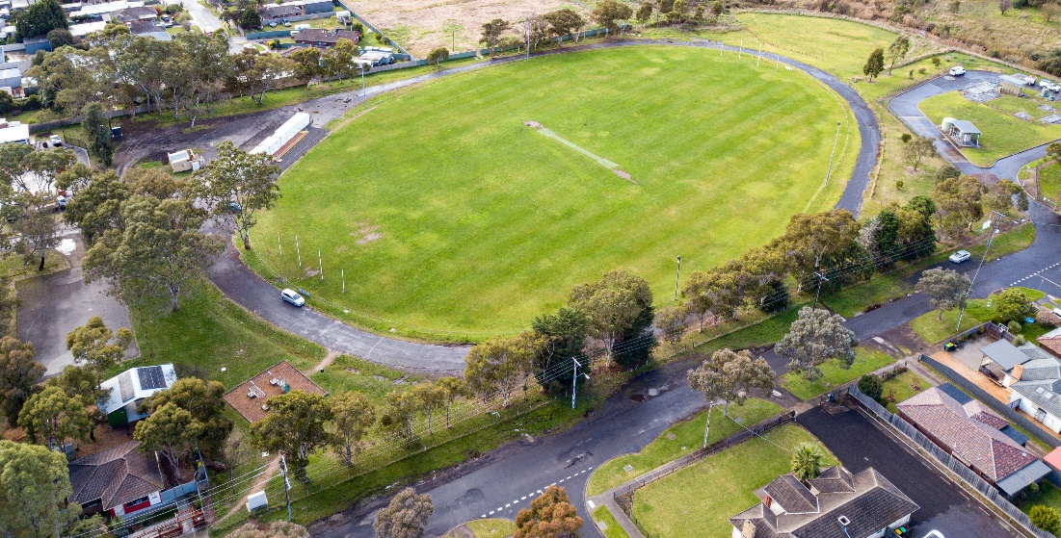

Introduction
Council is planning to upgrade Mernda Recreation Reserve with features that help our community get active, socialise and enjoy the outdoors. We are developing a master plan to create a vision and direction for the reserve’s future. The master plan will include short- and long-term improvements to be delivered over the next 10 years.
The Mernda Recreation Reserve master plan is a high-level document providing a broad vision for the entire reserve. The master plan does not focus on one specific item or user group, but instead looks at all of the reserve’s features, equipment and users. The master plan aims to find a balance for the needs of all the user groups and the facilities required by the different types of activities. It will outline the improvements required to achieve this balance in a staged action plan. In addition, the plan will need to meet the needs of current and future community and users.
The master plan will look at issues such as:
- Out of date sports and park equipment (including the playground)
- Public access and connections to pathways
- Visibility and safety (including lighting)
The master plan will also consider ways to increase active and passive activities in the reserve. These may include:
- Circuit walking paths
- Picnic shelters and seating
- Informal multi-sport courts (for example, half-court basketball, table tennis, volleyball or bocce)
- Fitness stations.

PRACE lease extension
As part of the Mernda Recreation Reserve master plan engagement Council also consulted the local community on the extension of the lease to PRACE for another 11 years.
PRACE is a community organisation that provides education and community services including language, literacy and numeracy, and vocational training to adults from its facilities located on part of Mernda Recreation Reserve known as 54-68 Schotters Road, Mernda; land that is leased from Council for a five (5) year term commencing February 2022 and with the option of a further four (4) year extension. The building was constructed by PRACE and given the services provided to the community, the land was offered to PRACE for a rental commencing at $250 pa.
PRACE is committed to delivering services to the community from this location and has invested in the establishment of additional facilities on land adjoining the reserve and had requested that Council considers extending the current lease term by a further eleven (11) years broken up into several additional terms exercisable by PRACE. Pursuant to S115 of the Local Government Act 2020, Council is seeking submissions from its community as part of the consultation process for the Mernda Recreational Reserve Master Plan before Council considers the request from PRACE.

How we engaged you
The Mernda Recreation Reserve master plan consultation was open for community comment from 15 June to 31 July 2022 and again from 4 August to 26 August 2022.
During this period the project team held a staffed community pop-up at the nearby Mernda Adventure Playground on Wednesday 29 June from 12 to 2pm. Visitors were informed of the consultation and the project team captured feedback on their experiences with the reserve and encouraged them to share additional feedback via the projects digital engagement page.
Residents within 400m were letterbox dropped in early August to inform them of the development of the master plan and encourage them to share their feedback through the community consultation.
Visitors to the reserve were alerted to the consultation through large corflute signage installed at the main entry point.
The community consultation and community pop-up were shared on Councils social channels including Facebook, Twitter and Instagram. The four posts (two on Facebook) were viewed by a combined total of 14,480, with 578 of these people interacting with it in some way (sharing, commenting or leaving a reaction).
Subscribers to the Engage Whittlesea platform that had previously indicated an interest in parks and/or the Mernda area were notified via email of the new project page (total 578 subscribers). Of these, 355 recipients read the email with 64, or 11 percent clicking through to view the Mernda Recreation Reserve master plan engage page.
A separate aspect of the consultation focussed on the PRACE lease extension was added to the project engage page on 8 July and remained open for the remainder of the consultation period. Followers of the project page (12 at that point in time) were notified via email of the new item on the page, with 67% clicking through to view the PRACE lease extension information.

Participation
The Mernda Recreation Reserve master plan page on Council' Engage platform attracted 598 visitors during the consultation period. In that time 28 community members opted to follow the project page to remain abreast of developments.
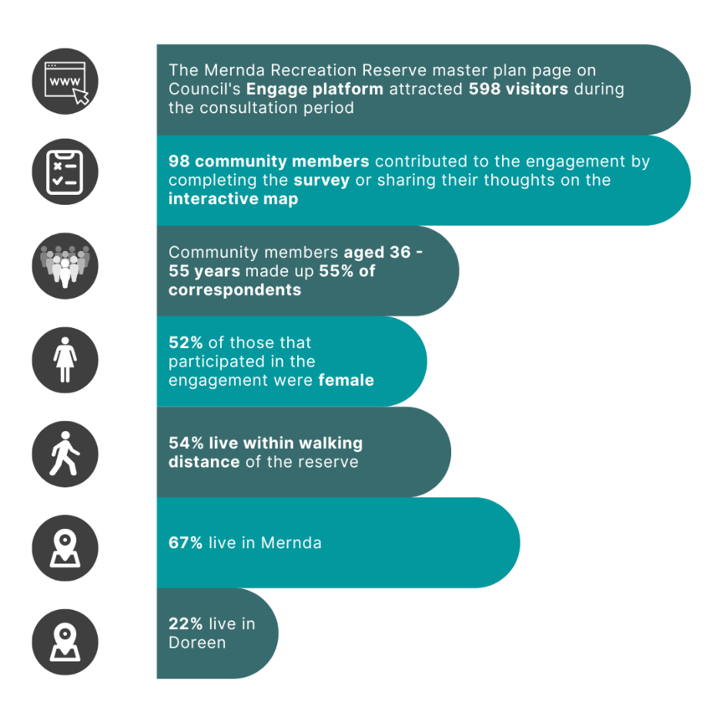
A total of 19 respondents, all of which live within 300m of the reserve, provided 27 contributions to the project interactive map.
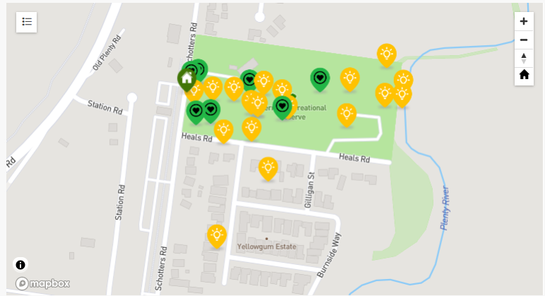

PRACE lease extension
In total, 53 responded to the additional question related to the extension of the lease to PRACE.

What we heard
Almost 92% of respondents have been to Mernda Recreation Reserve previously.
The five respondents that indicated they hadn’t ever visited Mernda Recreation Reserve revealed the reason they haven’t visited is because the reserve in its current state doesn’t meet their needs or they don’t know much about the reserve.
Of the 55 respondents that had visited Mernda Recreation Reserve an equal number visited either weekly or a few times a year (27% each). Combined around 30% of respondents indicated they visit the reserve daily or 2-3 times per week, 16% and 14% respectively. The remainder visit the reserve fortnightly (5%), monthly (5%) or indicated that they no longer visit (3%).
Majority of respondents indicated their connection to the reserve is that they are a local resident (82%). Almost 55% of respondents live within walking distance of the reserve, however only 46% walk/run (42%) or ride a bike, scooter or skate (4%) to access the reserve. The remaining 54% drive to access the reserve when they visit.
The oval is the facility used most by respondents, with almost 75% indicating they use the oval when visiting Mernda Recreation Reserve. The carpark is also well utilised with 52% of respondents using this space, followed by 32% using the playground and almost 31% visiting Mernda Community House.
The main reasons respondents visit the reserve is to exercise (running, yoga, walking) and to partake in casual sport/activities (kick to kick, ball game with friends). A lesser number meet family/friends, hang out, exercise their dog or use the playground. Refer to graph below for actual figures.

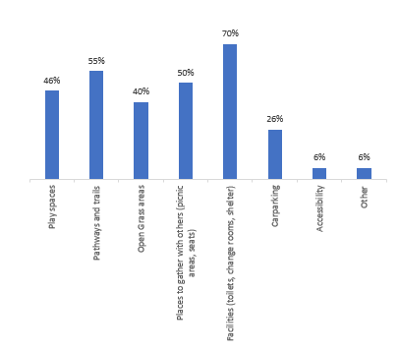
The perception of safety is important when planning park upgrades. Positively, over 56% of respondents feel safe or very safe visiting the reserve in its current state during the day. A further 22% haven’t thought about how safe they feel visiting the reserve.
These figures are reversed when respondents were asked to reflect on how safe they feel visiting the reserve in the evening/night, with only 9% indicating they felt safe or very safe. Lack of lighting, limited visibility from the street, minimal passive surveillance and the perception of the reserve inviting undesirable behaviour were the main reasons 60% of respondents indicated they feel a bit unsafe or very unsafe visiting the reserve at night, with 40% and 20% respectively. Almost 31% hadn’t thought about how safe they feel visiting the reserve at night.
Overall, when presented with a scale of one to five stars, with one being very poor and five being very good, majority (83% combined) of respondents rated the reserve as very poor, poor or ok (16%, 33% and 35% respectively).
Facilities including toilets, change rooms and shelters were the most important feature of parks and reserves in general to respondents. Other important features are pathways and trails, places to gather with other such as picnic areas and seating, and play spaces. Refer to graph below for the full breakdown of responses.

Opportunities
Respondents shared many potential future opportunities for Mernda Recreation Reserve, some of which may be out of scope of this project. These have been grouped below.

Recreation for all users and abilities
Playground – replacing the existing playground with a play space for all ages and abilities was a recurring theme through the consultation. Respondents also suggested that there be equipment for toddlers and separate equipment for older children and that the area be fenced off to help keep users safe.
Walking, running and cycling– community members suggested upgrading existing paths for walking and running as well as introducing new walking and cycling connections.
“Please keep the running track around the oval and if that can be upgraded to a synthetic running track it will be great”.
“A bicycle track to connect to plenty gorge park lands bike track would be awesome. This can be combined with a running track too. A bridge to walk and cross the Plenty River and a walking track connection to Plenty Gorge Parklands would be ideal too”.
Fitness - introducing fitness facilities that cater for family-friend groups as opposed to formal sporting facilities.
“A space to do outdoor group training or yoga/tai chi”
“Fitness stations, something for older residents”.
“Please think of other user groups instead of the same core group that are continually catered for. We do not need any more AFL / Soccer / Cricket items. An all access all hours running / walking space would be a really nice change given we cannot access Meadow Glen. Poles to bring our own net to play volleyball would be amazing”.
“There should be focus on recreational sports and space for tennis and volleyball courts. Lot of attention is given to clubs but not for family-friend groups. Would like to see tennis and volleyball courts and good lighting after dark. This will be very useful”.
Sports – multiple community members highlighted improvements needed to the existing sporting facilities and offered suggestions of suitable additions to be considered, from lawn bowls to turf cricket, volleyball to badminton, tennis to netball and basketball.
“If you used the grassed area on the left (runs along the backs of houses) to install some baseball nets (the ones where you can hit the baseball off a T and it gets caught in the net) and some for golf, that would attract different kinds of sportsmen/women”.
“Oval requires resurfacing and additional training facilities”.
“Council doesn't have a turf cricket pitch. The multicultural society will engage in playing cricket in the summer if a turf pitch maintained at this oval as part of Laurimar or Mernda Cricket Clubs”.
“Please replace the tennis courts (they were only public access tennis courts in Mernda /Doreen) and the cricket nets that were recently removed”.

Facilities and safety
Facilities – replacing or introducing new facilities including toilets, seating, picnic tables BBQs and bins.
“Seating for those supervising children; a garden of sorts to be enjoyed by those just wanting to sit with a friend and enjoy”.
“You could even install a small lockable cafe/kitchen so sporting groups i.e.: football teams could open and feed/serve/raise money for their teams. This would see mums and dads attend the training sessions. It could become a great community hub”.
Safety – introducing additional lighting, new fencing and car park improvements to make users feel safer. Additionally, looking at safety when upgrading facilities, such as installing a safety net behind the footy goal posts to protect users of the playground.

Community spaces
Mernda Community House – it was suggested that the master plan incorporate and possibly extend the Mernda Community House.
“The Reserve can be an extension of the Community House, and the programs and activities at the Community House will help to bring life to the Reserve”.
Arts and Events – multiple community members highlighted hosting events at the reserve including regular markets and the Mernda Community Festival. There were also suggestions for incorporating the work of local artists.
“Bring back the events. For example, the food truck festivals and fairs and festivals that were held in previous years”.
“It would be great to have some artistic areas maybe a soundshell for events”.
“The back of some seating that can be adorned with canvasses to attract local artists”.
Natural environment spaces – community members suggested incorporating a community garden or introducing a bush play area to the reserve.
It is worth noting that community members also made general comments that will be taken into consideration, including:
Mernda Recreation Reserve is a “great place for the local sporting clubs to have a practice”
“We feel public toilets could cause more drug use and draw the homeless to the area as you can see the ransacked houses along Schotters Road would reflect this as well”.
“Fix interface between Heals Road and the reserve. This area is very poor standard with no formal drainage or footpaths and floods during winter making walking access the reserve an issue”.

PRACE lease extension
Almost 12 percent of visitors to the project engage page viewed the information on the PRACE lease extension with a total 53 responding to the survey. Majority of respondents (96%) support the extension of the lease to PRACE for another 11 years.
Respondents were offered the opportunity to explain why they do/don’t support the extension of the PRACE lease.
Comments in support of the lease extension centred around PRACE being a valuable service for the local community and the importance of local education for people of all backgrounds and abilities.
“PRACE provides an invaluable service to the community, for both youth and adult education”.
“It’s such an important service being provided. Kids who weren't going to school now are. They are making friends and getting their certificates. I think that is fantastic”.
“It is not just an adult education centre it is also a college for teenagers who are disengaged from mainstream schools. It provides them an education that the otherwise would not receive. This is very important for our community”.
The comments from those that did not support the lease extension of PRACE centred around the previous lack of consultation when the decision was first made to locate PRACE within the footprint of Mernda Recreation Reserve.

Next steps
Thank you to everyone that completed the survey, dropped a pin and participated in the community engagement.
Feedback gathered from the community is being used to develop the design and will be incorporated into the decision-making process. While we are not able to accommodate everyone’s comments, the project team will provide solutions to the issues raised and balance them with the requirements of Council.
A draft master plan design will be presented in the second phase of community consultation, providing an opportunity for the community to see how the feedback provided has helped shape the master plan. The draft master plan and concept design will be endorsed by Council prior to community consultation which is expected in the next few months.

