To change the main landscape picture and add alt text:
- Double click in the header.
- Hover over the City of Whittlesea logo and right click once.
- Select ‘Send to back’
- Hover over the main picture and select right click once.
- Select ‘Change picture’
- Navigate to and select the picture you want to replace it with.
- Hover over the main picture and select right click once.
- Select Format Picture, and the select Alt Text. In the description box briefly describe the image. E.g. Children’s playground, Taunton Park. Select Close.
- Hover over the main picture and select right click once.
- Select ‘Send to back’
- Close Header and Footer.
- Delete this box once complete.

Gorge Road Shops Upgrade

Phase 2 Participation and Engagement Findings Report

Prepared by Andrew Chau
Parks Development, Capital Delivery
January 2023, Version 2

Introduction
The Gorge Road Shopping Precinct Upgrade is an upgrade of the existing streetscapes to address the opportunities identified in the Town Centre Revitalisation Program. The project is being led by the Parks Development team in the delivery and assisted by the Urban Design and Transport team for strategy and background. The Community Engagement team was key in developing the consultation plan and activities and facilitating the activities.
The project study area is the immediate area around the shopping strip, encompassing the car parks, pedestrian footpaths, landscape, and park interface. This project does not include Reid Street Park, however, a project for the upgrade of Reid Street Park will commence in 2023 after grant funding was secured in late 2022 from the Victorian Government.

How we engaged you
The Gorge Road Shopping precinct upgrade phase 2 consultation was open for community comment from 22 November to 18 December 2022, following Council endorsement for public exhibition of the draft concept plan. Traders and property owners were consulted in the weeks prior to the broader community.
Property owners and managers were mailed a letter and design package in the week of 3 November informing them of the draft concept design and Council’s intended project timeline. On 9 November 2022, Council officers attended each business at the Gorge Road shopping strip to provide a design package and consultation information to traders and business owners.
The design package included the draft concept plan, high level phase 1 consultation summary, high level traffic study summary, and design rationale prepared by the design consultant. Contact information was also provided to allow for comments and additional queries.
The broader community within 400m of the shopping strip were letterbox dropped in late November to inform them of the draft concept plan and encourage them to attend a pop-up session or provide comments online.
The community consultation and community pop-up were shared on Council’s social channels, including Facebook, Twitter and Instagram. These social channels were the most successful in directing attention to the engagement page, with almost 60% of all visitors referred by a social channel. The remaining visitors accessed the engagement page directly (31%), through Council’s webpage (5%), or via a search engine (4%).

Participation
The Gorge Road Shops Streetscape Upgrade page on Council’s engage platform received 895 visitors with 112 community members providing feedback or completing the quick poll during the consultation period.
There were 113 downloads of the Gorge Road Shops Draft Concept package, and 37 downloads of the phase 1 consultation summary.
Three community pop-ups were scheduled to be held onsite at the Gorge Road Shops, however one was cancelled on short notice due to Council staff having COVID. Council staff spoke to 39 people at the two pop-ups, with the majority of the conversations taking place at the Friday afternoon/evening session.
Traders, business owners, and employees were alerted of the upcoming consultation before it was made public and were encouraged to provide written feedback. We spoke to each business and provided them with the design package and contact information.
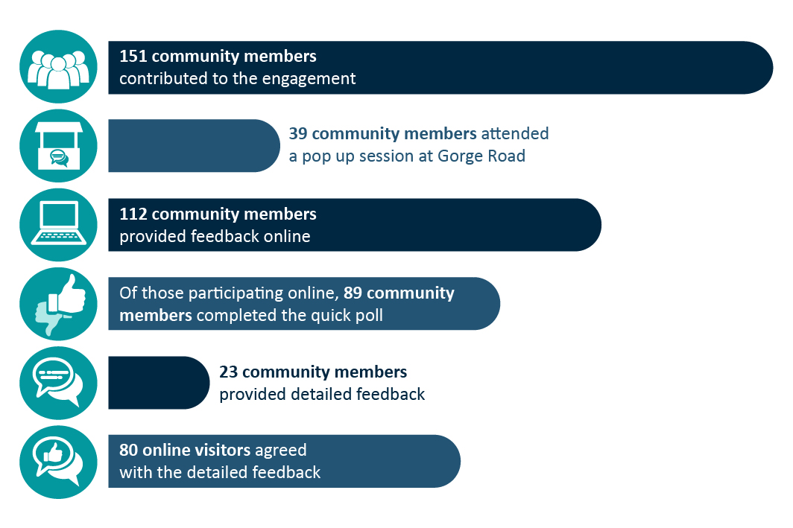

What we heard
The online quick poll is a good indication of the community’s thoughts on the draft concept plan.
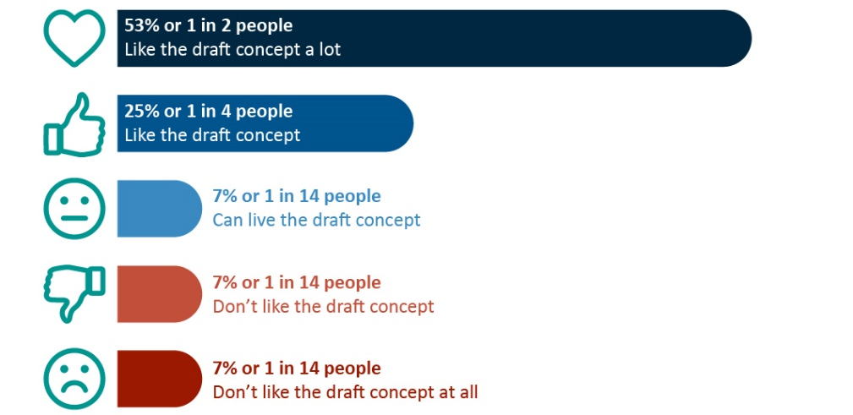
The in-person pop-up had a similar quick poll but for each of the main elements of the design. Interested community members were invited to use stickers to indicate their preference for each element.
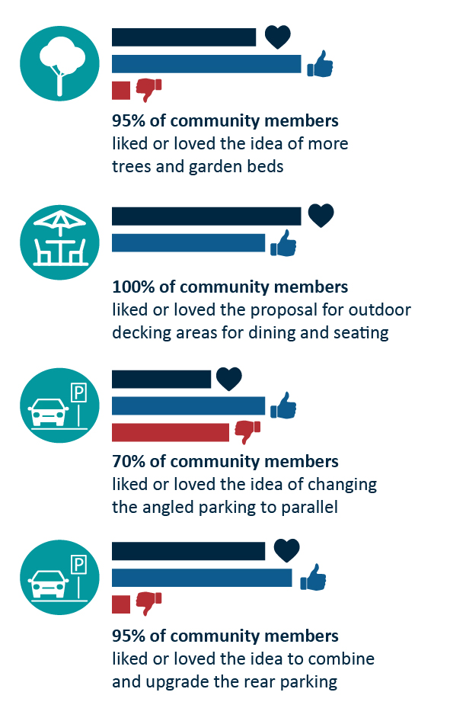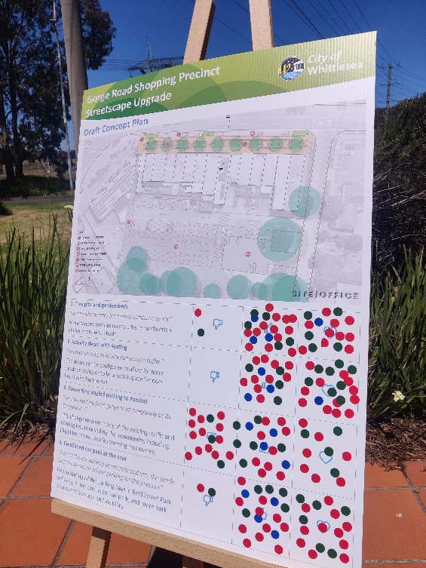
The detailed comments on the project engage page delve deeper into the perceived issues. The most discussed item was the proposed car parking arrangement, with a total of 12 comments supporting the change, seven comments suggesting the retention of the existing arrangement, and six comments suggesting a total reduction in precinct parking.
Of the 12 comments supporting the change, there were 43 up-votes by other participants, and some people even calling for the total removal of parking at the front:
“Parking at the front is unnecessary and perpetuates existing issues”
“No need for all that parking out front”
“I’d go further and ditch the parking out front”
There were an additional seven up-votes to the seven comments suggesting keeping the parking at the front of the shops. The comments cited the impact it may have on the shops with the potential to reduce opportunistic quick stops:
“keep the car parking at the front of the shops to ensure easy quick access”
“shops may loose [sic] weekday business if cars have to use the rear”
“doubt people would park at the back and walk around”
The six comments suggesting an overall reduction in precinct parking had 34 up-votes. The suggestions ranged from removing just the front parking to a total revision to the proposed combined car park at the back.
“There’s excessive parking at the rear of the shops”
“Carpark at rear is a lot of carparking. Is it necessary?”
Other items raised in the online comments and in person discussions include:
- Needing more public amenity lighting
- Concerns with increased traffic and parking on Reid Street
- Narrowness of keep clear area at the entry to Reid Street
- Concerns with pedestrian connection to the shops from the rear
- Loss of business from less parking at the front
- Left turning lane onto Plenty Road, with removal of power pole
- Loss of parkland for hard paved car parks
- Request for formal form trees instead of Eucalyptus
- More trees in rear carpark.

Traders and property owners
In-person discussions with traders were positive, with a majority of the traders excited by the proposed changes and keen to see Council invest in the area. The main concerns expressed were similar to those we heard during the first phase of community consultation – disruption to business during construction, and potentially reduced opportunistic customers with the proposal to reduce parking at the front.
A suggestion to be considered in amending the design is the positioning of trees to be aligned with the property allotments, this will ensure the shop frontage remains visible from the street and is not blocked by vegetation in the future.
It should be noted that no property owner or manager responded to the direct mail of the design package and covering letter.

Next Steps
Thank you to all community members who have provided feedback and have engaged with the project team.
The design consultant will review this consultation report and develop a revised concept plan with amendments to address the highlighted concerns. The concept will be presented to Council prior to proceeding to construction.
The finalised concept will be published on the project engage page (https://engage.whittlesea.vic.gov.au/gorgeroad) for the community to view.
We will continue the conversation with traders and property owners to ensure construction timeframes and staging minimises disruption.

