Draft Economic Participation Plan
Engagement Summary
10 March to 9 April 2023

Introduction
Council is currently reviewing its Draft Economic Participation Plan that has been informed by feedback received in the phase one community consultation undertaken in November and December 2022. The plan aims to increase economic participation for priority groups including youth, people with disabilities, women, culturally and linguistically divers (CALD) community and Aboriginal and Torres Strait Islanders.
Community consultation for Phase2 of the Draft Economic Participation Plan was undertaken between 10 March and 9 April 2023 and included both broad community engagement and more targeted discussions with key stakeholders.
The Draft Economic Participation Plan presented to community sets out 8 challenges/opportunities and four key focus areas to increase economic participation. The plan fundamentality aims to assist the above-mentioned priority groups to gain work.
Feedback received in response to the Draft Economic Participation Plan will be considered, and where appropriate, changes made to the Economic Participation Plan.
The Proposed Economic Participation Plan will be presented to Council Briefing on 6 June 2023 and then presented for endorsement at the Council meeting on27 June 2023.
How we engaged you
The Draft Economic Participation Plan Phase2 community engagement was open for community comment from 10 March – 9 April 2023.
Community feedback was sought online through Council’s Engage Whittlesea platform and through direct conversation and activities at community-based pop-ups and meetings with key stakeholders.
The project Engage page featured a voting tool for participants to identify their top three challenges/ opportunities and a poll on the key focus areas of the plan.
The project team hosted six community pop-ups in high foot traffic locations across the municipality. At the pop-ups, participants were encouraged to identify their top three out of the eight challenges/ opportunities of the plan, complete a poll on the key focus area’s and make comment.
The project team partnered with Whittlesea Community Connections and Jobs Victoria Advocates at local events namely at the Community Festival, Pacific Epping Shopping Centre and Aboriginal and Torres Strait Islander employment event. The team also partnered with the Hume Whittlesea Local Learning and Employment Network (HWLLEN) at the Careers & Network Expo.

The community pop-ups held were:
- Community Festival at Civic Terrace Lawn on Sunday 19 March from 11am – 5pm.
- Diversity Week event at Epping Memorial Hall on Monday 20 March from 5.30pm – 8pm
- Careers Expo at PRACC on Thursday 23 March from 9am – 3.30pm
- Pacific Epping Shopping Centre on Thursday 30 March from 9.30am – 11.30am
- Mernda Town Centre on Thursday 30 March from 3.30pm – 5.30pm
- Aboriginal and Torres Islander employment event on Thursday 6 April from 1pm – 3pm.
The community engagement was promoted through a range of tactics including:
- Council digital engage platform Engage Whittlesea
- Social media – we shared posts across Council’s channels (Facebook, LinkedIn and Twitter)
- Email to key stakeholder groups including the Business Advisory Panel and key not for profit organisations, including Whittlesea Community Connections, HWLLEN, Yarra Plenty Regional Library Network, Araluen Disability Services, North Link, Melbourne Polytechnic and Brotherhood of St Laurence
- Discussed at the Youth Advisory Council meeting on 3 April and the link to the Economic Participation Plan was emailed to all YAC Members.
- Email to those that provided feedback during Phase 1 engagement activities.

Participation
368 contributions with 18 people participating online and 350 at community-based pop ups.
Highlights of the participation included:
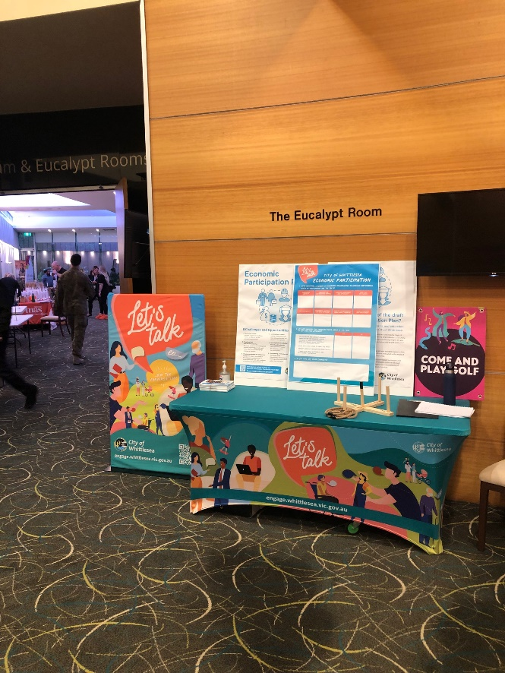
Above picture of pop-up stall display with dot board activity.

- 18 Aboriginal and Torres Strait Islander community members contributed
- 157 Youth under 18 years of age contributed
- 50 community members from CALD backgrounds contributed
- 8 People with a disability contributed
- 232 contributors identified as female
- Over 90% of contributors live or work within the municipality (333 people).

What we heard
We have separated what we heard through the digital engagement with what we heard through community-based pop-ups and meetings with key stakeholders.
Digital engagement
Respondents were presented with 8 challenges/ opportunities and asked to vote for their top three. What we heard through this exercise is presented in the tables below.
A total of 896 people received notification of the digital page with 185 people visiting the page and 54 of these downloading the draft plan.
Top three opportunities and challenges heard online were local jobs and careers, targeted and coordinated labour market programs and inclusive recruitment. 11 people contributed to this data.
Theme | Ranked as important %
1.Local Jobs and careers | 64%
1.Targeted and coordinated labour market programs | 64%
3.Inclusive recruitment and employment | 55%
4.Place Based Context | 45%
5.Social enterprise and procurement | 27%
6.Volunteering, mentoring and work experience | 18%
6.Vocational / Non-Vocational Barriers | 18%
8. Self-employment | 9%

Focus Area of the Draft Economic Plan
A total 7 people participated online, with 4 respondents (58%) identifying that they ‘liked or liked a lot’ the focus areas of the draft economic participation plan, 1 (14%) “can live with it” and 2 (28%) “don’t like it”.
We asked if we missed anything
A total of 2 comments was shared on the digital page and include:
- “Education & training you've missed out on a lot here about how ppl with "diffabilities" can make a huge or significant difference to employers so as an (autism advocate/educator/trainer in the past) I'd be more than willing to do this if people can understand my story from a personal life's perspective even on the recent experiences that I've had of being discriminated, bullied & harassed at in my previous job, the significant consequences that someone suffers because of this!
I also feel that an employment program to hire more people with "diffabilities" in the council would be very highly beneficial to not only the council, but also the staff as they learn the

benefits of having someone with a diffability within their teams/areas that can make strategies work for them or completely go way beyond their capabilities to exceed the expectations of others & achieve goals that have not been done so before in a business or workplace. Those people think outside the square box but also do things really out of the ordinary which I'm one of those individuals who's in this category.
As the saying goes "You ain’t seen nothing yet!" 😀”
- “Where in any of the plan besides identifying that Aboriginal people are a priority group, is there any targeted work to increase Aboriginal people's opportunities or commitments by council to increase access to employment for Aboriginal people.”
We asked if respondents had any other comments
A total of 3 comments were shared on the digital page and include:
- “IF you identify a co-hort that needs support then they should also be part of the plan with targeted work by council to increase their participation be they Aboriginal or CALD”
- “No, but I would like to participate in this plan if possible”
- “Great initiative to support businesses in tapping into human resource that would otherwise potentially go without the right opportunities.
Has there been a consideration in the CoW establishing an online platform for local businesses to advertise positions whereby opportunities could be accessed by all? Perhaps support with resume building, interview skills and support with applications? I know RPI would certainly as a business be keen to tap into this resource. Equally a 2 way street for those looking for opportunities and potentially not being equipped with the tools to access employment opportunities. RPI would certainly list job openings on such a platform to encourage local employment.”

Community Pop Ups
Key themes at the Pop Ups
Participants at community pop-ups were presented with the eight challenges and opportunities and asked to identify the top three using sticky dots on a dot board activity.
We also featured the four focus areas of the plan and asked if community supported our approach to increasing economic participation.
There was also opportunity to comment or converse with our project leader.
A total of 350 face to face contributions was received at the community pop-ups.
The pop-ups held were:
- Community festival - saw 112 participants from across the municipality and included people with disabilities, youth, Aboriginal and Torres Straight Islanders, women, and members of the CALD community. The top three identified at the festival were local Jobs and careers, volunteering, mentoring and work experience and inclusive recruitment and employment.

- Cultural diversity week event – saw 45 participants from the Arabic, Punjabi, Macedonian, Assyrian and Chinese communities with bilingual support officers in attendance. The top three identified at the diversity week event were volunteering, mentoring and work experience, vocational and non-vocational barriers and local jobs and careers with social enterprise and procurement equal third.
- Careers expo - saw 130 youth who attended from a range of schools in Whittlesea. The top three identified at the expo were volunteering, mentoring and work experience, self-employment and local jobs and careers.
- Aboriginal employment event - saw 17 Aboriginal and Torres Strait Islander community members participate. The top three identified at the employment event were local jobs and careers, volunteering mentoring and work experience with inclusive recruitment and employment equal first and vocational and non-vocational barriers equal second.
- Pacific Epping Shopping Centre and Mernda Town Centre shops saw a combined 51 people participated from the broader community and visitors to Whittlesea. The top three identified at the shopping centres were volunteering, mentoring and work experience, inclusive recruitment and employment and local jobs and careers.
The overall top three challenges/ opportunities were:
- local jobs and careers
- volunteering mentoring and work experience
- and inclusive recruitment and employment.
In last place was place-based context drawing the least number of votes.
Pop-up data summary per location and totals in table below.
Theme | Online digital engage page  11pax | Community Festival  112 pax | Diversity Week CALD event  45 pax | Careers Expo – Youth 130 pax | Pacific Epping Shopping Centre  30 pax | Mernda Town Centre  16 pax | Aboriginal and Torres Strait Islander Employment event  17 pax | Total Votes361 pax  1025 votes
Local Jobs and careers | 7 | 77 | 24 | 76 | 14 | 9 | 10 | 217 (21.18%)
Volunteering, mentoring and work experience | 2 | 70 | 29 | 82 | 17 | 6 | 10 | 216  (21.07%)
Inclusive recruitment and employment | 6 | 51 | 14 | 56 | 15 | 10 | 9 | 161  (15.7%)
Self-employment | 1 | 24 | 24 | 82 | 7 | 0 | 5 | 143  (13.95%)
Vocational / Non-Vocational Barriers | 2 | 42 | 26 | 37 | 12 | 4 | 9 | 132  (12.88%)
Targeted and coordinated labour market programs | 7 | 35 | 4 | 23 | 11 | 4 | 4 | 88  (8.58%)
Social enterprise and procurement | 3 | 26 | 1 | 21 | 2 | 3 | 4 | 60  (5.89%)
Social enterprise and procurement | 3 | 26 | 1 | 21 | 2 | 3 | 4 | 60  (5.89%)
Place Based Context | 5 | 11 | 3 | 11 | 4 | 1 | 0 | 35  (3.41%)

“Focus Areas of the Draft Economic Plan at Pop Ups “
A total 350 people participated at the community pop ups with of 99.9% respondents identifying that they ‘liked’ the focus areas of the draft economic participation plan.
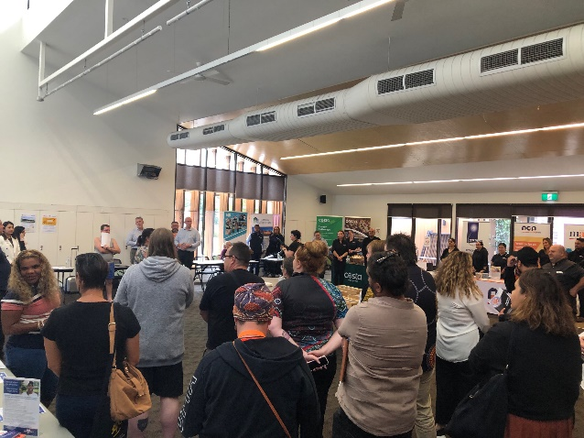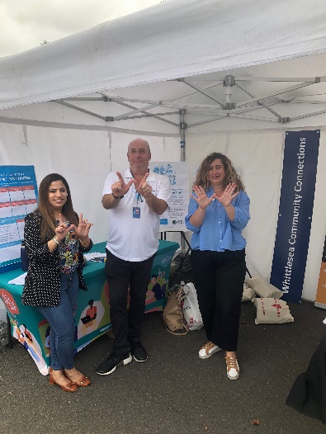
Above pictures at the Aboriginal and Torres Strait Islander employment event and the community festival.

Comments captured
“Using federal employment services support in the local area such as transition to work youth program”
“More diversity and ICT technology”
“Great.”
“Sounds like a plan, we are with you.”
“Support for inclusive workplaces and volunteering”

Next steps
Thank you again to everyone that participated in the community engagement by sharing feedback and completing our top three priorities activity and thoughts on our focus areas.
Feedback gathered from the community is being used to finalise the plan. The plan will then be presented for endorsement by Council in mid-2023 with the final document available on the https://engage.whittlesea.vic.gov.au/epp
We encourage you to register and follow the project Engage page at https://engage.whittlesea.vic.gov.au/epp to keep updated on the project.

