Draft 2023-24 Budget and Community Plan Action Plan

Engagement Summary

Introduction
City of Whittlesea’s Community Plan 2021-2025 is Council’s main medium-term strategic planning document. It expands on the long-term 20-year community vision, Whittlesea 2040: A place for all, to include key outcome priorities, services, and initiatives over the next four years. It plays a central role in Council’s overall strategic planning and reporting framework.
Each year Council develops a Community Plan Action Plan (CPAP) which is an annual supplement to the Community Plan 2021-25. This action plan outlines the key actions to be completed over the next financial year to build towards achieving the Community Plan and ultimately our Whittlesea 2040 goals. These goals are for a Connected Community, Liveable Neighbourhoods, a Strong Local Economy, a Sustainable Environment, and a High-Performing Organisation.
Similarly, each year the City of Whittlesea releases an annual Budget that sets a financially responsible path forward for the organisation to continue to deliver critical investment in services and key infrastructure to support our rapidly growing community. The budget is formed to align to our long-term financial plan which balances our current spending on projects and services for the community and strengthens our long-term financial sustainability.
Council consulted with people who live, work, study or visit the municipality to understand what was important to them and the areas they thought funding should be allocated to. The multi-phased engagement approach was designed to ensure feedback was captured from a diverse range of community members at a time where they could have a genuine influence on the priorities as well as where and how funds are directed in the formation of the Budget and CPAP.
The feedback gathered through the engagement was used to inform the development of the 2023-24 Budget, the Community Plan Action Plan as well as other strategies and plans including the Connected Communities Strategy and, Long-term Community Infrastructure Plan.
How we engaged you
The community engagement was undertaken in three phases as below:
Phase 1 : Shape your Community broad community engagement
8 August – 11 September 2022
Phase 2 : Community Pulse Check
December 2022
Phase 3 : Draft Budget and Community Plan Action Plan (CPAP) shared with the community
30 March – 25 April 2023.

Community feedback was sought online through Council’s Engage Whittlesea platform and through direct conversation and activities at community pop-ups and meetings with Council Advisory Groups. This Engage Whittlesea platform features a translation tool to mitigate any language barriers to participation, allowing the page to be translated into the top ten languages spoken within the municipality.

Phase 1
In Phase 1 a place-based approach was taken to the consultation which enabled us to gain valuable insights into the differing needs and wants of the different districts across the municipality. The six areas were:
- Whittlesea Township and Rural Surrounds (including Beveridge, Eden Park, Humevale, Kinglake West, Woodstock, and Yan Yean
- Donnybrook
- Wollert and Epping (North of the O’Herns Road)
- South Morang, Mernda, and Doreen
- Thomastown, Lalor and Epping (South of O’Herns Road)
- Bundoora and Mill Park.

On the project’s Engage page, participants were asked to first select the district they wanted to comment on (usually where they live, work, study or visit) and then asked to identify what they most like about where they live and what they would like to see more of in their local area. Participants were presented with the choice of 19 options for each question, with these themes coming from previous consultation conducted for the development of the Community Plan. These questions were designed to understand what was most important to the community in each district and the areas they think funding should be allocated.
In Phase 1 the project team hosted 12 community pop-ups in high foot traffic locations across the municipality. The consultation activity mirrored the information being sought through the digital consultation with participants to place sticky dots on the things they like about where they live and what they would like to see more of in their local area. There was also opportunity for them to add additional suggestions.
The community pop-ups held were:

- Thomastown Recreation and Aquatic Centre (TRAC)
- Church Street Whittlesea
- Stables Shopping Centre in Mill Park
- May Road shops in Lalor
- Uni Hill, Bundoora
- Olivine at Donnybrook
- Laurimar shops, Doreen
- Mernda Junction
- Galada Community Activity Centre and Epping North shops
- Pacific Epping
- Mill Park Lakes
- Westfield Plenty Valley.

Phase 2
Phase 2 was designed as a pulse check and enabled Council to share what we’d heard already and check that it was still reflective of current community sentiment. The project Engage page was updated to share what we’d heard were the top 10 most liked things about each district along with the top 10 things the community wanted to see more of. Participants were asked if they agreed with what had been captured and offered the opportunity to add additional comments and suggestions.

The project team held an additional two community-based pop-ups at the Administrator Meet & Greet event in Mernda and at the City of Whittlesea Christmas Carols event held at the Civic Centre. The information provided and sought at the pop-ups mirrored that of the project Engage page.

Phase 3
In Phase 3 of the consultation, the community was presented with key points from the draft 23-24 Budget and draft 23-24 Community Plan Action Plan as well as access to the full draft documents. The community were encouraged to provide feedback on the draft documents online through the projects Engage page or at community-based pop-ups.

A quick poll was available on the project Engage page that enabled participants to indicate their support of the drafts with yes, no and unsure options available. Participants at community-based pop-ups were able to undertake the same activity on large activity boards that posed the same questions and possible responses.
The community were able to provide further feedback on the drafts by making a submission through the project Engage page.
In Phase 3 the project team hosted an additional nine community pop-ups in high foot traffic locations across the municipality. At the pop-ups, participants were encouraged to vote yes, no or not sure on whether they support the drafts and comment further. Participants were provided with the key highlights of the drafts and hardcopies of the drafts were available for residents to take home to read. There was also opportunity to comment or converse with our project leaders at the pop-ups with subject matter experts available at all sessions.

- Mernda Town Centre
- Mill Park Library
- Thomastown Recreation and Aquatic Centre (TRAC)
- Westfield Plenty Valley
- Aurora Village Shopping Mall, Wollert
- Church Street Whittlesea
- Lalor Library
- Olivine at Donnybrook
- Epping Village Shops.

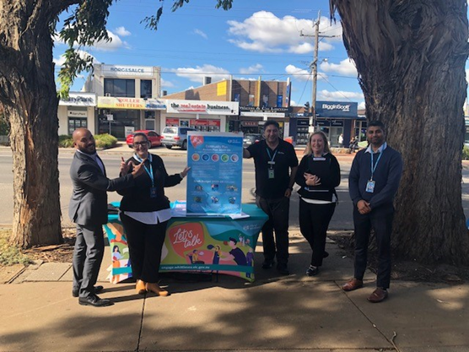
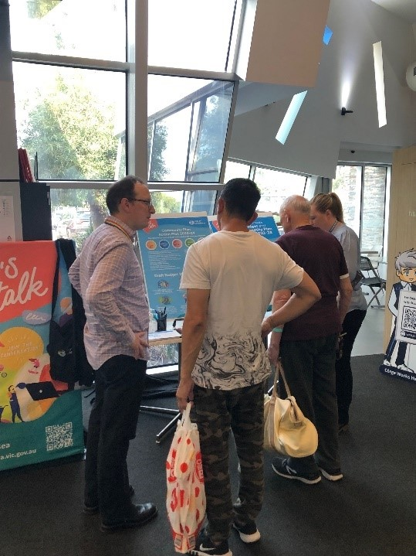

Above: Project team at community-based pop-ups at Epping Village and TRAC

The project team presented at meetings of the below Advisory Groups as part of the community consultation.
- Whittlesea Reconciliation Group
- Whittlesea Disability Network
- Youth Advisory Committee
- Whittlesea Community Futures
- Business Advisory Group
- Community Leadership Program participants.

The community engagement was promoted through a range of strategies to have a widespread reach across the municipality including:
- Council’s digital engagement platform Engage Whittlesea
- Social media – we shared 12 posts across Council’s channels (Facebook, LinkedIn and Twitter)
- Direct email to key stakeholder groups
- Discussion at a range of Advisory Group meetings
- Flyers and posters at Council facilities and libraries.

Participation
A total of 1308 contributions were made online or in-person throughout the three phases on community engagement. In Phase 1 there were 977 contributions, 614 of which were captured at community-based pop-ups. The project team heard from an additional 27 people during the Phase 2 pulse check. There were 320 contributions made during Phase 3, 228 of which were captured at community-based pop-ups.
A snapshot of consultation activities and community participation is below:
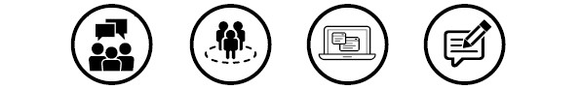

23 community-based pop-ups | 7 Advisory Group presentations | 466 digital contributions | 842 in-person contributions

On the next page is a snapshot of the diversity of participation:

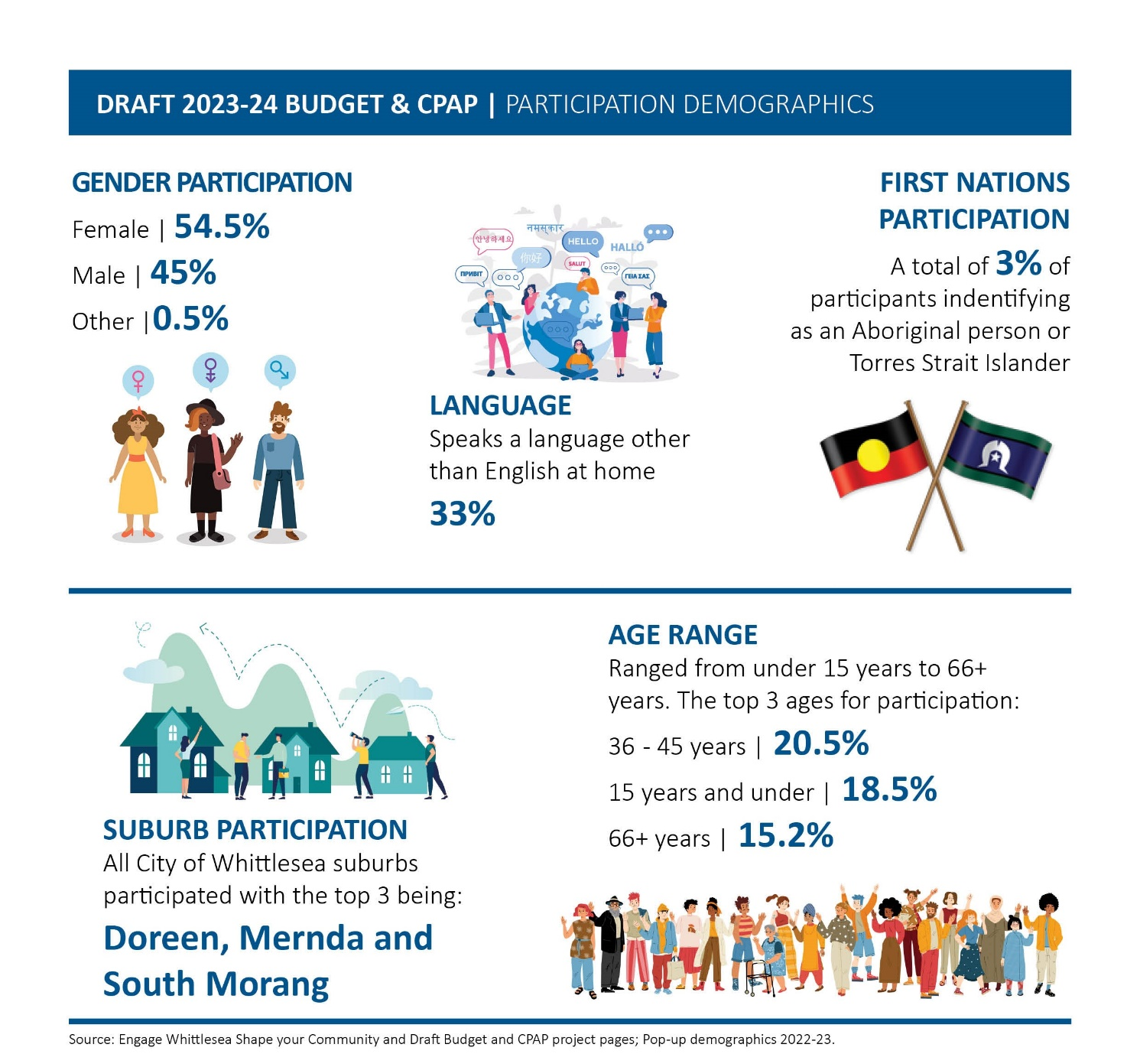

What we heard
Phases 1 & 2
In Phase 1 of the consultation participants were asked what they most like about where they live and what they would like to see more of in their local area. These questions were designed to understand what was most important to the community in each district and the areas they think funding should be allocated.
Phase 2 was designed as a pulse check and enabled Council to share what we’d heard already and check that it was still reflective of current community sentiment. We shared the top 10 most liked things about each district along with the top 10 things the community wanted to see more of Participants were asked if they agreed with what was captured.
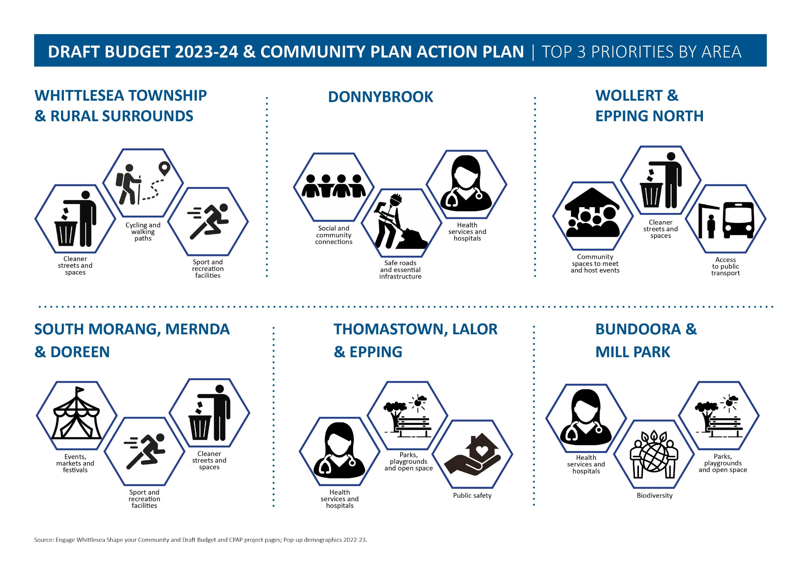

Phase 3
There were 320 contributions made during phase 3, 228 of which were captured at community-based pop-ups.
In this phase the community were asked separately whether they supported the draft 2023/24 Budget as well as whether they supported the draft 2023/24 Community Plan Action Plan.
Below are the activity boards that were used at the community-based pop-ups throughout phase 3.
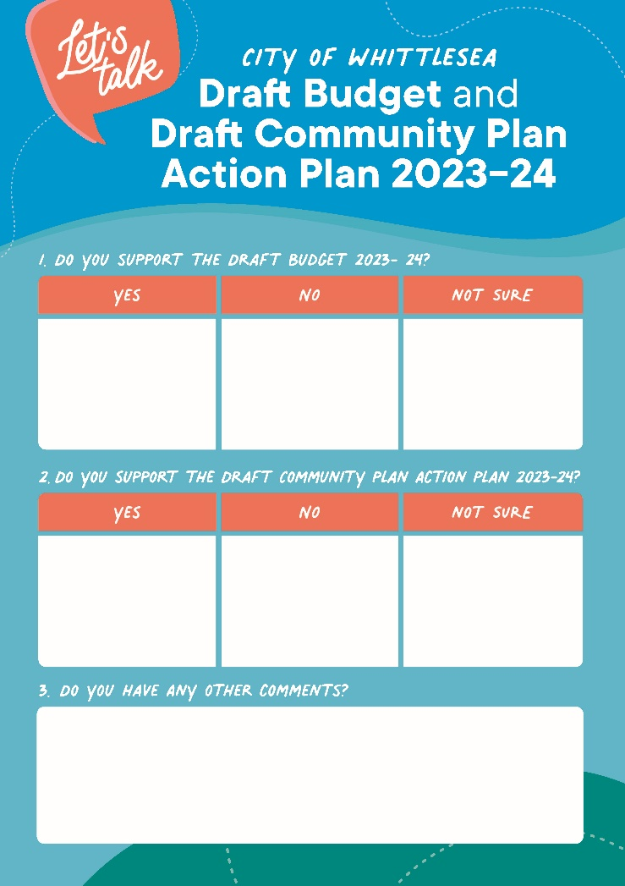
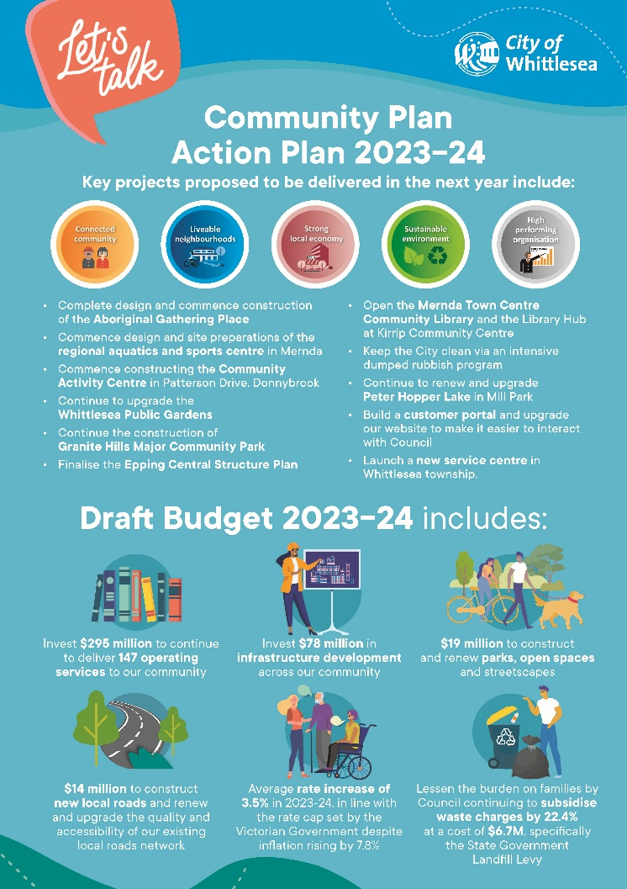

Above: Activity boards used during Phase 3 community-based pop-ups

A total of 15 people participated in the quick poll on the engage page that asked whether they supported the draft 2023-24 Budget, of these 47% were supportive and a further 34% were unsure.
The draft 2023-24 Budget received a total of 52 comments submitted through project engage page. The comments focussed on:
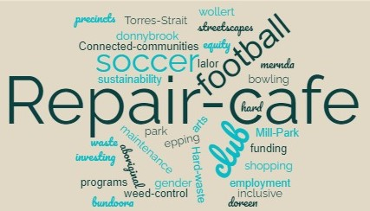

A total of nine people participated in the quick poll on the engage page that asked whether they supported the draft 2023-24 Community Plan Action Plan, of these 56% were supportive and a further 20% were unsure.
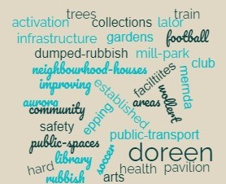
The draft 2023-24 Community Plan Action Plan received a total of 15 comments submitted through project engage page. The comments focussed on:

At the community-based pop-ups 81% of participants indicated that they were supportive of the draft 2023-24 Budget and a further 16% were unsure. When asked about the draft 2023-24 Community Plan Action Plan, 82% were supportive and a further 16% were unsure.
Community comments captured at the pop-ups have been themed below:
Transport and connectivity
- Improve traffic road management (Mernda)
- Streets in Beveridge need to be upgraded (South Morang)
- Better layout of local roads in new estates in Wollert (Epping)
- Love the walking paths and park trails around South Morang (Epping)
- More roads and shops in Donnybrook (Donnybrook)
- More public transport (Epping)
- More parking for shops around Epping village (Epping).
Festivals and events
- Council is doing a great job - we loved the colour festival, plant show, improvements to the parklands (South Morang)
- More celebrations/decorations for Christmas (South Morang)
- More promotions of community activities (Epping)
- Like the idea of the Gathering Place for First Nations people (Epping)
- More community focused projects (Donnybrook).
Streetscape and amenities
- Safety and lighting at night (Whittlesea)
- Spend more money on trees (Lalor)
- Update parks and streetscapes in older established areas (Epping)
- Improve street furniture (Whittlesea)
- Public toilet in May Rd shops Lalor (Lalor)
- Parks to have public toilets (Epping)
- Improve the dog park at Whittlesea Gardens (Lalor)
- More electric car stations (South Morang).
Inclusivity and accessibility
- TRAC facilities need to be upgraded (water temperature, disabled facilities) (Thomastown)
- More focus on making people feel loved, safe and connected (South Morang)
- Mental health services and affordable housing (Whittlesea)
- More services for domestic violence and youth (Lalor)
- All new programs introduced by Council should be inclusive of all groups (Thomastown).

Next steps
The information gathered from each district informed the development of the draft 2023-24 Budget and the 2023-24 Community Plan Action Plan. The feedback captured has also been used to inform the development of other key plans and strategies Council are working on to make Whittlesea: A Place for All.
Thank you again to everyone who participated in the community engagement by sharing feedback and throughout the three phases of community consultation.
Council appointed an Advisory Committee of Council to consider any written submissions and hear those persons requesting to be heard in relation to their submission. A total of 71 submissions were received for the draft 2023-24 Budget and Community Plan Action Plan, 24 of which requested to be contacted by Council. Although 17 people identified that they wanted to speak to their submission at the advisory Committee of Council held in May 2023, only five attended on the night.
Of the 71 submissions, 52 were made in relation to the draft 2023-24 Budget, 19 of which requested to be contacted by Council and 14 who elected to speak to their submission. The remaining 15 participants made submissions for the 2023-24 Community Plan Action Plan, five of which requested to be contacted by Council and three who elected to speak to their submission.
The draft 2023-24 Budget and the 2023-24 Community Plan Action Plan will be presented for endorsement by Council in June 2023 with the final document available on the project Engage page
- 2023/24 Draft Budget and Draft Community Plan Action Plan | Engage City of Whittlesea and Council’s website www.whittlesea.vic.gov.au

