VR Michael Recreation Reserve Master Plan

Engagement Summary
August 2023

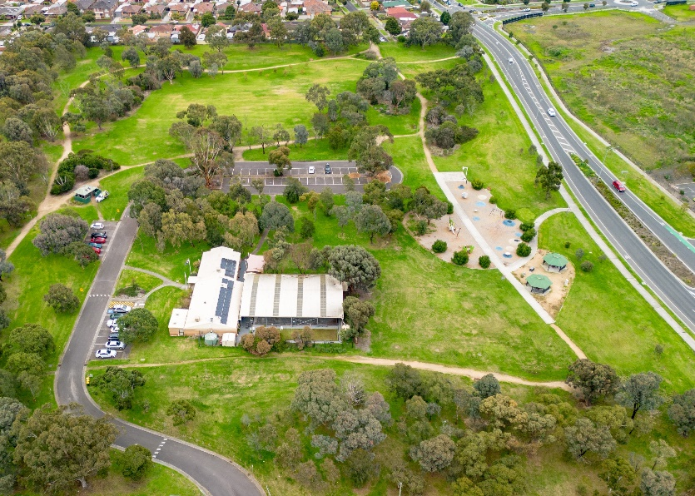

Introduction
VR Michael Reserve is one of the City of Whittlesea’s open space reserves in Lalor, an established area of the municipality.

In response to a petition from the Lalor United Bocce and Social Club, Council resolved in December 2022 to upgrade the offsite parking (east of VR Michael Reserve entrance) and provide an all-weather pedestrian connection from the parking area to the clubrooms as part of the 2023/24 capital works program. The future upgrade of the carpark will improve accessibility for all individuals using the facility. Council also agreed to develop a reserve master plan, including features that help our community get active, socialise and enjoy the outdoors. The master plan will include medium and long-term improvements to be delivered over the next 10 years.
The VR Michael Recreation Reserve master plan is a high-level document providing a broad vision for the entire reserve. The master plan does not focus on one specific item or user group, but instead looks at all features, equipment, and users of the reserve. The master plan aims to find a balance between the needs of all current and future user groups and the facilities required. It will outline the improvements required to achieve this balance in a staged action plan.
The master plan will look at issues such as:
- Public access and connections to the reserve
- Visibility and safety
- Visual appearance and maintenance of the reserve.

The master plan will also consider ways to increase usage of the reserve by providing facilities in the reserve that cater to current and future users. These may include:
- Circuit walking paths
- Picnic shelters and seating
- Fitness stations
- A small off-leash dog park.

Feedback from the community and stakeholders will inform the VR Michael Reserve master plan.

How we engaged you

The VR Michael Recreation Reserve Phase 1 master plan consultation was open for community comment from 26 June to 24 July 2023.
Phase 1 consultation was undertaken with diverse representation from a range of targeted stakeholders including retailers along Deveney Road and High Street, The United Lalor and Bocce Social Club users, visitors to the reserve and residents within 400 meters of the reserve.
The purpose of this engagement was to assist Council to identify key issues, challenges and opportunities of the site and discover the key ideas for improvement.
Visitors were informed of the consultation through several channels; letterbox drop within 400m of the reserve, large corflute signage installed at the main entry point of the reserve, Council’s social channels including Facebook, Twitter and Instagram and the Lalor and Epping Community Development Officers shared details with their connections, including local schools and CALD groups. The communications materials encouraged residents to attend the planned pop-ups and to share feedback via the project’s digital engagement page.
During this period the project team held staffed community pop-ups on Wednesday 5 July at VR Michael Recreation Reserve in two areas, near the playground that captured families with young children and inside the United Lalor Bocce and Social Club that enabled us to hear from seniors who regularly attend the Bocce and Social Club. An additional community-based pop-up was held in the first week of the school term on Wednesday 11 July at the Lalor Library.
The project page on the Engage Whittlesea platform featured three consultation activities, a survey, an ideas board and a pinpoint map. The survey captured feedback on how respondents use the area as well as any insights on how we could best improve the area. The pinpoint map enabled respondents to drop a pin and make a comment on a specific point within the project area and provide feedback or an improvement idea for that location. At in-person consultations respondents were presented with the same survey and offered the opportunity to share their thoughts on large activity boards.
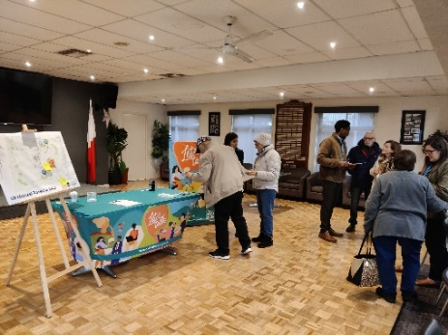
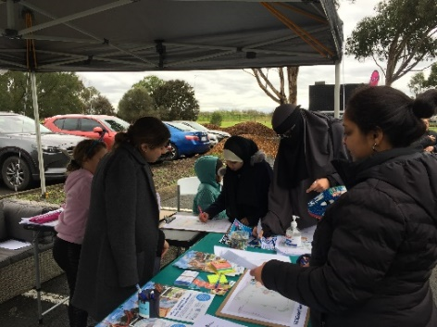
Above: Community participating in consultation at VR Michael Reserve pop-up on 5 July

Participation
A total of 172 people contributed to the consultation, with majority (131 people) participating in person at our community pop-ups by filling out a survey and/or sharing ideas on the map activity. The project Engage page was viewed by 305 people of which 41 contributed by completing the survey or participating in the online map activity.

Below is an overview of the demographics of participants:

48% live in Lalor  10% live in Epping  6 % live in Bundoora | 37% of participants at pop-up sessions were over the age of 66  Majority of these are regulars at the United Lalor Bocce and Social Club
60% of those that participated in engagement activities are female | Community members aged under 15 made up 21% of respondents

Majority of participants aged over 66 years that shared feedback at on-site community pop-ups are members of the United Lalor Bocce and Social Club, and attend the club at least once a week for activities. The main concern for members is the lack of parking, particularly when an event is being held at the club. Suggested improvements shared by members focussed on parking improvements through the introduction of additional parking spaces including accesible parking, an adjustment to the current parking layout and creating a drop-off zone.

A snapshot of community participation is captured below:
VR Michael Recreation Reserve Master plan page on the Council’s Engage Whittlesea platform attracted 305 visitors of which 45 participated in the consultation by completing the survey or sharing their thoughts on the interactive map.

Three social posts and one event shared to Council’s social channels - Facebook, Twitter and Instagram.
Posts reached more than 5,499 people with 208 of these people interacting with it in some way (sharing, commenting, or leaving a reaction).

A total of 131 community members attended pop up sessions. Of these participating , 74 community members competed the survey and 57 participated in the map activity.

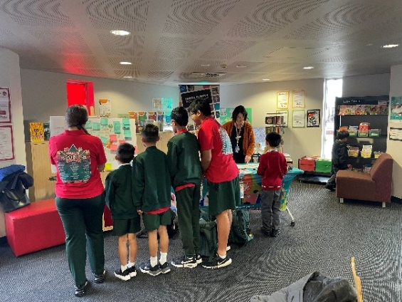
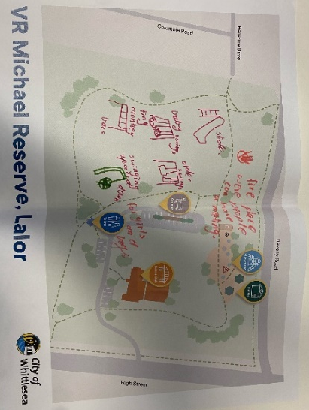
Several local families attended pop ups; with the older children sharing their innovative and interesting ideas on the map activity while the younger children enjoyed drawing a picture.
Above: children sharing their ideas at community pop-up sessions.

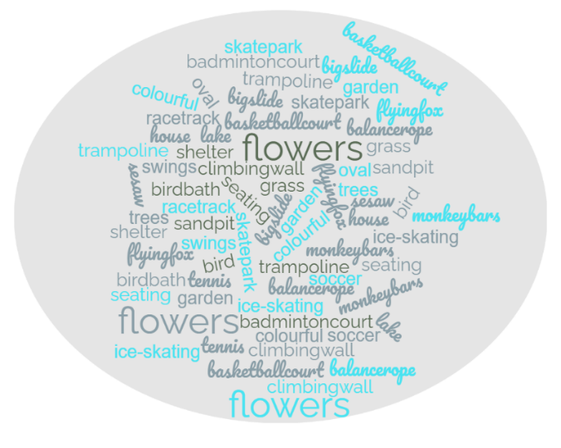
See below for the some of the ideas that our young people would like to see included in the master plan.

What we heard
The survey was completed by 103 community members online and at community pop-ups. Almost 98% of respondents indicated they have been to VR Michael Recreation Reserve previously. Of the 96 respondents who answered that they had visited VR Michael Recreation Reserve, 43% visit the reserve 2-3 times a week. Interestingly 23% selected other and stated that they attend the United Lalor Bocce and Social club once a week to attend a planned social event, such as Bingo. Almost a third of the respondents claim to rarely visit the reserve as they find safety and parking a major issue.
Many of the respondents (70%) indicated that they drive to the reserve, 22% walk/run to the reserve and only 3% and 2% utilise public transport of ride to the reserve. An elderly man (88 years of age) who came to the Lalor Library to have his say, walks daily around the reserve. Safety was his main concern, minimal lighting and dead branches make it difficult to walk around the reserve.

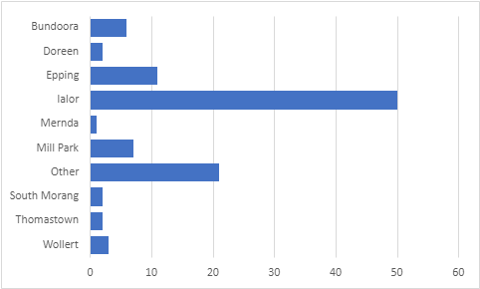
Majority of respondents live in Lalor (48%), followed by Epping (10%). We also heard that 20% of participants live outside the municipality in nearby suburbs, Greensborough, Eltham, Reservoir and Research. These visitors of VR Michael reserve attend the United Lalor Bocce and Social Club.

The top two reasons that visitors use the reserve is to use the playground facilities (50%) and attend events/activities at The United Lalor Bocce and Social Club (20%). Others use the reserve to walk/run or catch up with family or friends. Fifteen members of the Bocce and Social Club that participated in the engagement stated that they attend activities at the Bocce and Social Club, as well as take grandchildren to the playground and catch up with family and friends on the weekend. Refer to graph below for actual figures.

When asked what would make them visit the reserve more and their priorities for improving the reserve, safety was the highest ranked priority for many participants (26%). Lack of lighting, security cameras and the playground’s proximity to the road were the main concerns raised.
A couple who regularly take their grandchildren to parks in the municipality, choose not to go to VR Michael Reserve because the playground is located too close to the main road and there is no access from Deveney Road and access from High Street is difficult.
An upgrade to the public toilet block was identified as a second priority (15%) for improvement. Additional toilets including all ability toilet should be considered, as well as the position of the toilet block when designing the master plan. “The remote location is too far from the playground and has many bushy areas that are not visible. Put the toilets closer to the playground where they’re clearly visible”.
The VR Michael Reserve has a bad reputation amongst community members for anti-social behaviour in and near the public toilet, which has hindered the number of visitors to the reserve. “It has a bit of a bad reputation in the area, it needs to be salvaged so families can feel safe to use the area (not just the playground)”.
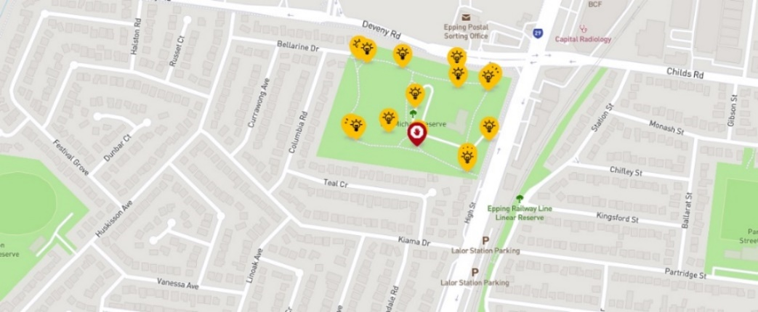
Of the 45 online contributions, 16 chose to participate in the social map activity and suggested that a jogging track, adult outdoor gym, footpath upgrade, public toilets near the playground, more bins and an off-leash dog park be included in the draft VR Michael master plan.

Participants were asked to rate the existing condition of the reserve which saw 65% rate it as in an average to very poor condition.
42% Identified the reserve in an average condition
14% Identified the reserve in a very poor condition
9% Identified the reserve in a poor condition
9% Identified the reserve in a very good condition
26% Identified the reserve in a good condition

Opportunities
Respondents shared potential future opportunities for VR Michael Recreation Reserve, some of which may be out of scope of this project. These have been grouped below:
Recreation for all users and abilities
Playground | Walking, Running and Cycling | Fitness and Sports
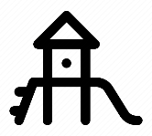 | 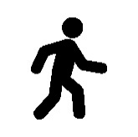
Extending the playground with age-appropriate equipment to cater for all age groups. Consider the materials when upgrading the reserve and to always keep safety in mind. Big rocks are used in many upgrades, but they are dangerous.  “A proper playground that is suitable for toddlers 1 – 3 years old, challenging, but also age appropriate so they can navigate themselves”  “More picnic and undercover areas to socialise” | More regular grass and tree maintenance to keep paths clear and accessible by all users. Access to the reserve and adequate pathways/walking track around the reserve will increase reserve users.  “Paved paths, jogging/running track with outdoor exercising equipment”  “Provide concrete all-weather track instead of existing dirt/gravel track”  “Connecting and clearly marked cycle trails leading into the reserve” | Introducing fitness facilities that cater for family and friend groups as opposed to formal sporting facilities. Outdoor gym equipment was a common suggestion. Community members highlighted the need for sporting facilities for older children, such as upgrading the existing basketball court and introducing a synthetic grassed areas for sport play.  “There is no need for a skateboard facility at this reserve. The demographic in the local area is mainly retired and young families. The playground and basketball facilities are enough. Maybe include some bench seating next to the basketball area for players and spectators”
Facilities and safety
Facilities | Safety | Off-Leash Dog Park
 |  | 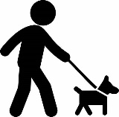
Additional facilities that complement the current playground equiptment, extra seating (senior friendly), picnic tables, shelter, BBQ and bins.  “would like to see it become a more functional and recreational space where families in the area can gather and have picnics and do fun activities”  “Higher raised benches for elderly people to sit on. They are sometimes too low and hard to get up if you have mobility issues” | Introducing lighting and security cameras around the reserve to make users feel safer.  Additionally, safety concerns around the position of the playground were raised. A fence around the playground was suggested by a number of participants.  “Lights around existing/new paths which make them safer to walk at night”  “The entrance to the reserve looks too uninviting and does not provide you with a sense of safety” | 17 community members left a comment that they would like to see an off- leash dog park as part of the Master plan for the reserve.  “Safe areas for dogs to socialise and exercise is desperately needed in Lalor and this spot seems ideal given the park is large enough to accommodate this”  “To have an off-leash dog enclosure for dogs to socialise in a safe and controlled environment. Our neighbourhood needs one badly with the number of dogs I meet at the reserve”

Community spaces
Historic Display | Arts and Events | Natural Environment
Introducing an area in the reserve that recognises the man, VR Michael, possibly an information board with historical details.  “I would like to commemorate VR Michael the man, other that just having his name attached to the park. Some information boards or something like that to show all the ways that VR Michael helped the community”  “I would also like to see some historical information about the park/neighbouring area such as, I believe it was and old quarry site” | Activating the area by holding events at the reserve, including regular markets, multicultural events, Christmas Carols and structured events during school holidays. | Incorporating a community herb garden and sensory garden to the reserve.

Other opportunities identified through the consultation included:
- Areas to socialise and better facilities for families to meet and have fun
- More rubbish bins
- More visible wayfinding signage from High Street
- Mini outside gym, soccer goals
- More facilities for older children
- More parking and disabled parking
- More shade trees
- Fence off the playground
- Feature landscaping
- Special events or programs such as weekend fun activities, multicultural events, community cycling events and food trucks and crafts markets
- More play equipment like zip lines, water play, sensory play and skate ramp
- Better maintenance of the central lawn and paths as they are prone to flooding.
Participants also took the opportunity to highlight concerns with the reserve, including:
- Flooding occurs during winter
- Dumped rubbish
- Poor access path to the toilet block
- Poor lighting in the car park
- Poor access path from the off-site car park to the Bocce Social Club

Next steps
Thank you to everyone that completed the survey, dropped a pin and participated in the community engagement.
Feedback gathered from the community is being used to develop the master plan design and will be incorporated into the decision-making process. While we are not able to accommodate everyone’s comments, the project team will provide solutions to the issues raised and balance them with the requirements of Council.
Council will endorse the draft master plan for phase two of community consultation, providing the community with an opportunity to see how their feedback has helped shape the master plan and to provide any further feedback.

