Lalor Recreation Reserve Master plan
Engagement Summary
December 2023

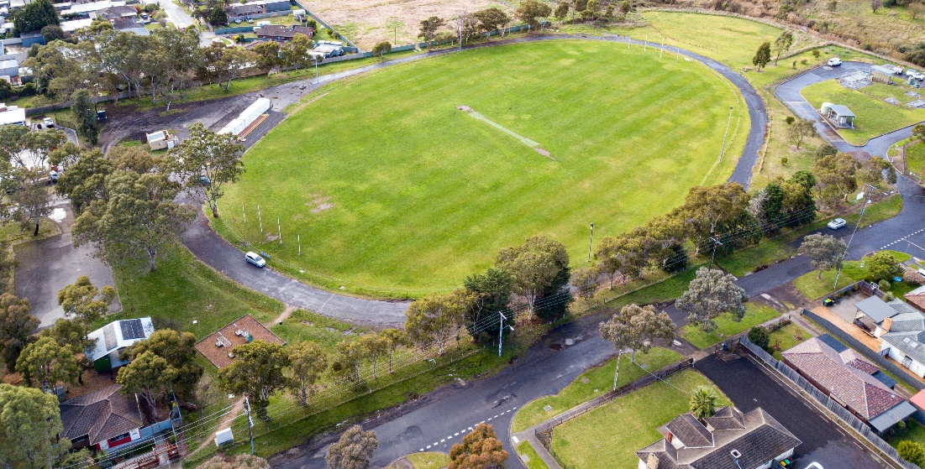

Introduction
Council is planning to upgrade Lalor Recreation Reserve with features that help our community get active, socialise and enjoy the outdoors. We have developed a draft master plan that creates a vision and direction for the reserve’s future. The master plan includes short and long term improvements to be delivered over the next ten years.
The Lalor Recreation Reserve Master plan is a high-level document providing a broad vision for the reserve. The master plan looks at the reserve’s features, equipment, and users. The master plan aims to find a balance for the needs of all the user groups and the facilities required by the different types of activities. It will outline the improvements required to achieve this balance in a staged action plan. In addition, the plan will need to meet the needs of current and future community users.
When developing the draft master plan, the project team looked at issues such as:
- Out of date sports and park equipment (including the playground)
- Public access and connections to pathways
- Visibility and safety (including lighting).

During phase 1 consultation we heard that recreation for all users and abilities as well as facilities and safety were important to the community and have explored opportunities shared by community to increase active and passive activities in the reserve.
These included:
- Circuit walking paths
- Picnic shelters and seating
- Informal multi-sport courts (for example, half-court basketball, table tennis, volleyball or bocce)
- Fitness stations.

How we engaged you

Phase 1: gathering ideas – June to August 2022
Ideas were captured online through the Project Engage page and at community pop-ups at the Lalor Recreation Reserve. Residents within 400m of the reserve were letterbox dropped to inform them of the consultation and invite them to share their ideas. The ideas captured in this phase helped shape the draft master plan that we shared with the community in phase 2. Find out more about what we learnt in the Engagement Summary Report
Phase 2: sharing the draft master plan for community feedback – 20 September to 27 October 2023
During this phase we shared the draft master plan with key stakeholders previously consulted in phase 1, as well as the wider community to understand if the proposed draft master plan meets community expectations and the current and future needs of sporting groups.
The community was able to view the draft master plan and have their say online via the project Engage page or in person at two community-based pop-ups.
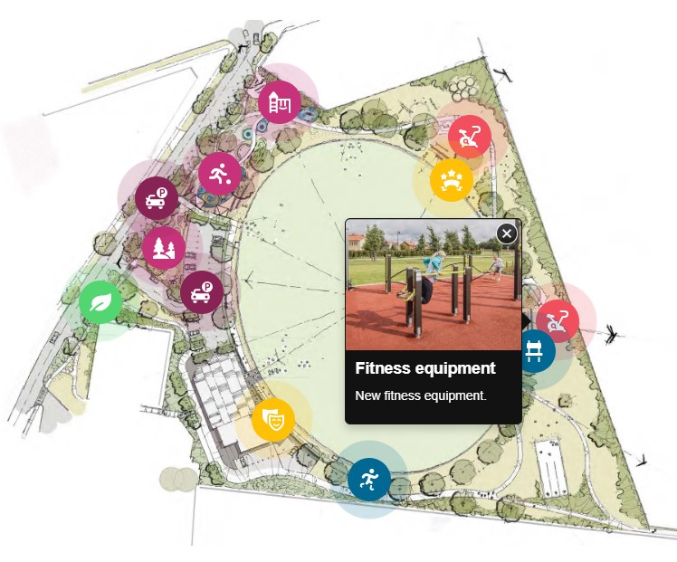
The project Engage page presented a summary of opportunities captured from the community through the phase 1 consultation period and offered visitors an opportunity to learn more about the key actions of the plan on an interactive map. Visitors to the page were also encouraged to complete a short survey to let us know if they liked what was being proposed and their top four priorities for the Lalor Recreation Reserve (this activity mirrored the in-person engagement activity).
Above: Interactive map from Lalor Recreation Reserve Master plan page on Whittlesea Engage platform
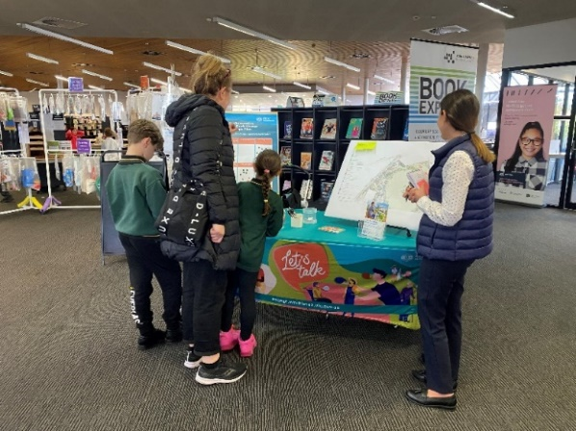
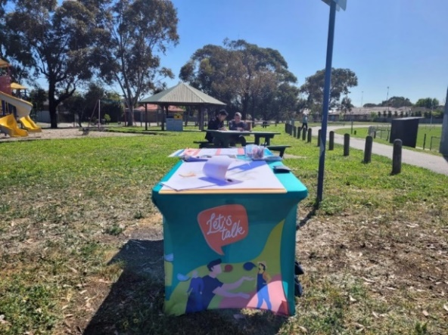
During the phase 2 consultation period, the project team hosted a staffed community-based pop-up at the nearby Lalor Recreation Reserve on Tuesday 26 September from 10am to 12pm and at Lalor Library on Thursday 12 October from 2.30pm to 4.30pm. Both pop-up locations were central and easily accessible to the targeted residents of Lalor.
Above: Community in-person engagement at the Lalor Recreation Reserve and Lalor Library
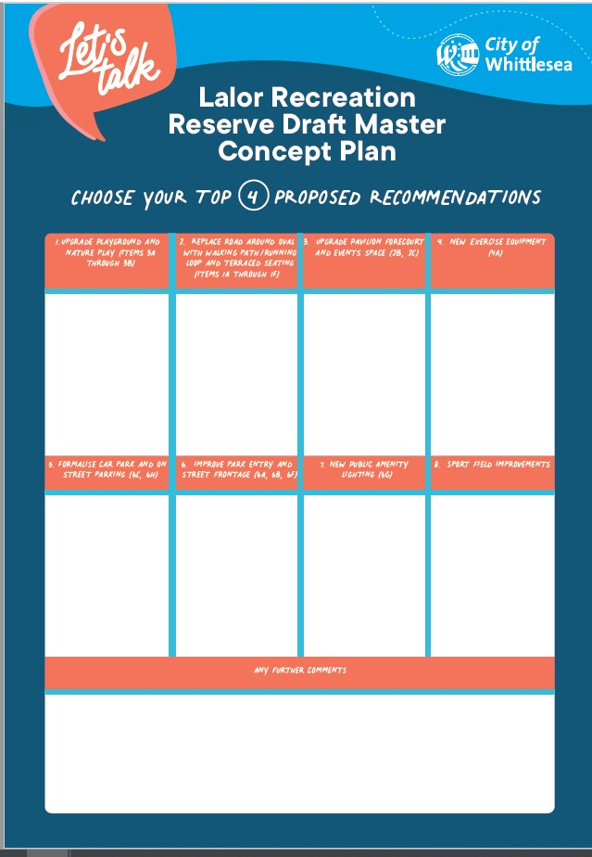
Participants of in-person engagement activities were invited to view the draft master plan and participate in a dot board activity that asked them to choose their top four (out of eight) recommendations for the upgrade and offer any additional comments about the project.
The available eight options were:
1.Upgrade playground and nature
2. Replace Road around the oval with a walking/running loop and terraced seating
3. Upgrade pavilion forecourt and events space
4. New exercise equipment
5. Formalise carpark and on street parking
6. Improve Park entry and street frontage
7.New public amenity lighting
8. Sport field improvement
Above: Dot Board Activity for in person consultation for Lalor Recreation Reserve
Flyers with a QR code directing community to the project’s online engage page were available, with participants encouraged to share the opportunity to participate in the engagement with family and friends.
Residents within 400m of the reserve, were again letterbox dropped to update them on the project status and invite them to view the draft master plan and share their feedback through the project Engage page or at one of the community-based pop-ups.
Visitors to the reserve were alerted to the consultation through large corflute signage installed at the main entry point. The signage featured the QR code directing them to the project Engage page.
The opportunity to participate in the community engagement and community-based pop-ups were shared on Council’s social media channels including Facebook, Twitter, and Instagram.
The Engage Whittlesea platform utilises an accessibility add-on which enables users to easily switch to screen reader mode or easily adjust settings such as font size, contrast, dyslexia friendly options to improve the overall accessibility of the site. The platform also has an in-built translation tool to reduce language barriers to participation, allowing the page to be translated into the top ten languages spoken within the municipality.

Subscribers to the Engage Whittlesea platform that had previously indicated an interest in parks and/or the Lalor area were sent a project update by email and encouraged to visit the project page and share their feedback.

Participation
During phase 2 a total of 74 contributions were received, 35 of which were captured at community-based pop-ups and the remaining 39 contributions made on the Whittlesea Engage Platform.

A total of 339 unique visitors to the project Engage page, 13 of which opted to follow the page to receive project updates.
Below is a snapshot of community participation in the community consultation.
Community participation
Organic social media posts reached 1,411 people and were engaged with 30 times, meaning they were liked, shared, or commented on by 30 people.

Two community-based pop-ups were held and saw 35 people share their feedback. The first pop-up was held at Lalor Reserve and the other at Lalor Library.

The project Engage page was viewed close to 600 times during the consultation period, with 39 people participating in the online survey. Of these 87% reside in the Lalor area.
Of the 74 community members who participated in the consultation, 32% spoke a language other than English at home.
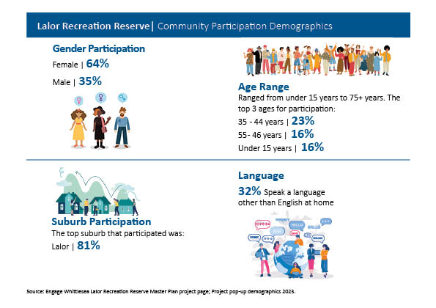
Above: A snapshot of community who participated in Lalor Recreation Reserve consultation

What we heard
In-person Engagement
The in-person engagement opportunities attracted 35 participants, with 15% of participants aged fifteen years and under. When asked about top four recommendations for improvement at Lalor Recreation Reserve, 100% of participants under the age of 15 selected an upgrade to the playground and new nature play area; new exercise equipment; and a walking path/running loop around the oval and terraced seating as their top three recommendations for the upgrade. Participants over the age of fifteen also selected an upgrade to the playground (56%) as a priority followed by introducing new exercise equipment (40%). Full results of the top priorities can be seen in the graph below.
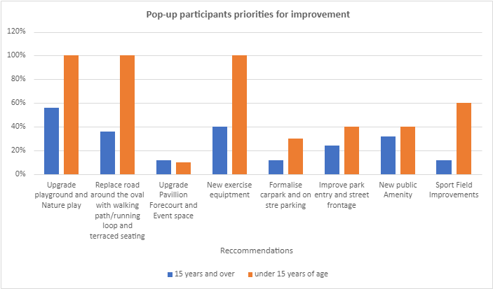
Above: graph represent the priorities for the under 15 years of age and over 15 years of age participants

Online Engagement
We heard from 39 members of the community through the online survey, 44% of which live in a two-parent family with one or more children.
A total of 39 online participants answered the question How do you feel about the proposed draft master plan for Lalor Recreation Reserve with 69% of participants providing a positive response to the proposed draft master plan. Full results below:
69.2 Like it/Like it a lot | 10.3% I can live with it | 21% Don’t like them/don’t like them at all

Online participants were asked to select four recommendations (from the eight available) that they would like to see upgraded as a priority at the reserve. As illustrated below, the top priorities captured from online participants is an upgrade to the playground and nature play area and replacing the road around the oval with a walking/running loop and terraced seating. The full breakdown of priorities from online participants is as below:
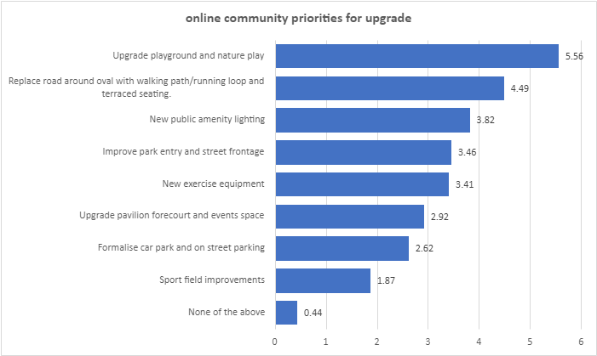

When asked what they do when visiting the reserve, 36% of online participants shared that they visit the reserve to exercise (walking or running) with only 6% using the reserve to play competitive sport. The full breakdown of captured community usage isas below:
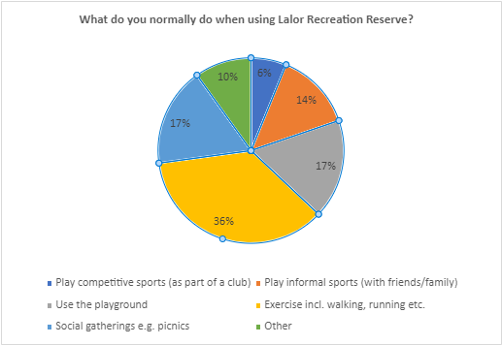

Opportunities
Participants were invited to share their thoughts on the proposed draft master plan and offered potential future opportunities for Lalor Recreation Reserve, some of which may be out of scope of this project. Below are the themed comments received through both online and in-person engagement activities.
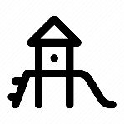
Playground – replacing the existing playground with a play space for all ages and abilities was a priority for respondents. Some suggestions included introducing popular play equipment such as a flying fox, a big slide, a merry go round, waterplay area, climbing elements. Many respondents hope for an accessible playground with equipment for all ages and abilities.
“I have a granddaughter with a disability, so an all-ability swing would be great to have in the playground”.
“A double swing for young child and parent”

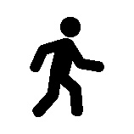
Walking, running, and cycling – community members suggested a running/walking track around the oval and upgrade paths.
“Overall, I really like it especially the proposed walking track. It would be great if this could be flat rather than sloped”.

Sports and Fitness – multiple community members highlighted improvements needed to the existing oval such as the installation of goal posts and offered suggestions for suitable additions to be considered, including a volleyball court and fitness equipment.
“Please add a public Volleyball court. There is a lack of attention and public amenities compared with other similarly played sports. There is little active volleyball scene in our area, forcing me and others to seek clubs and sporting events in the city suburbs”
“Personal Training and cycling/walking should be improved so that the youth can easily access these facilities”.

Facilities - replacing or introducing new facilities including toilets, seating, picnic areas, BBQ and bins. Many residents would like to see a gated dog park on the reserve and a fence surrounding the playground.
“A small off-leash dog park”
“More seating and shade for parents in the playground. Current seating is unsafe”
“Considering its significant changes that invite families to spend a significant amount of time playing and/or exercising, there are no toilet amenities. This has always been an issue with this recreation area and those in the immediate areas of Lalor. The only and closest public toilets are those located in the Lalor shopping precinct, which is a 17 min walk away. This is enormously inconvenient and takes away from the now user-centred focus this recreation area is proposing”
“Please put more bins in the new facility. Littering is a massive issue in this area”
“Concern that making a formal walking track around the oval is taking away parking around the oval for footy viewing”
Safety - introducing additional lighting, new fencing, and car park improvements to make users feel safe and help with areas prone to flooding.
“Extra lighting and CTV cameras”
“Need to consider the safety of children when cars enter the reserve”
“Please consider keeping some fencing at the Sydney crescent street front, as it keeps kids safe in the playground area. The road is notorious for hoons and its safer to have some fencing”
“Do not remove the fence. If remove it replace with a lower fence”
“Please keep the shape of the walking path around the oval the same, it is open and safe”
Natural Environment – community members suggested incorporating a community garden in the plan. Others would like the existing trees retained.
“It's fantastic and much needed. I like the desire to maintain established trees and plant more trees for canopy. General increase in open green spaces and maintenance of parks and facilities”

Next steps
Thank you to everyone that visited the project Engage page and contributed through the online survey or at in the in- person community engagement opportunities.
Feedback captured from the community in Phase 2 is being used to develop the final Lalor Recreation Reserve Master plan. While we are not able to accommodate everyone’s comments, the project team will provide solutions to the issues raised and balance them with the requirements of Council.
The final master plan design will be presented to Council for endorsement in early 2024. The community will be kept updated on further developments via the Lalor Recreation Reserve project page.

