Mernda Recreation Reserve Master plan
Engagement Summary
December 2023

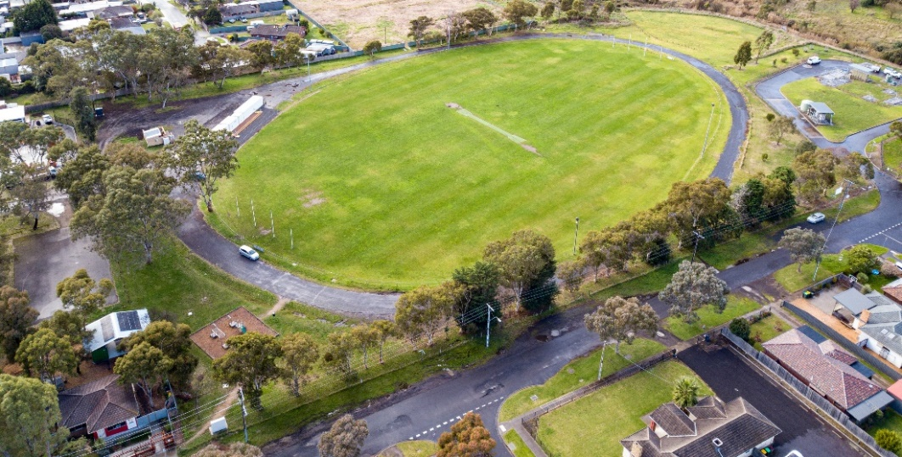

Introduction
Council is planning to upgrade Mernda Recreation Reserve with features that help our community get active, socialise, and enjoy the outdoors. We have developed a draft master plan that creates a vision and direction for the reserve’s future. The master plan includes short and long term improvements to be delivered over the next ten years.
The Mernda Recreation Reserve Master plan is a high-level document providing a broad vision for the reserve. The master plan looks at the reserve’s features, equipment, and users. The master plan aims to find a balance for the needs of all the user groups and the facilities required by the different types of activities. It will outline the improvements required to achieve this balance in a staged action plan. In addition, the plan will meet the current and future needs of community users.
When developing the draft master plan, the project team looked at issues such as:
- Out of date sports and park equipment (including the playground)
- Public access and connections to pathways
- Visibility and safety (including lighting).

During phase 1 consultation we heard that recreation for all users and abilities as well as facilities and safety were important to the community. Council considered the ideas shared by the community and have explored opportunities to increase active and passive activities in the reserve. These included:
- Circuit walking paths
- Picnic shelters and seating
- Informal multi-sport courts (for example, half-court basketball, table tennis, volleyball, or bocce)
- Fitness stations.

How we engaged you

Phase 1: gathering ideas – June to August 2022
Ideas were captured online through the project Engage page and at community pop-ups at the nearby Mernda Adventure Park. Residents within 400m of the reserve were letterbox dropped to inform them of the consultation and invite them to share their ideas. The ideas captured in this phase helped shape the draft master plan that we shared with the community in phase 2. Find out more about what we heard in this phase in the Engagement Summary Report.

Phase 2: sharing the draft master plan for community feedback - 20 September to 27 October 2023.
During this phase we shared the draft master plan with key stakeholders previously consulted in phase 1, as well as the wider community to understand if the proposed draft master plan meets community expectations and the current and future needs of sporting groups.
The community was able to view the draft master plan and have their say online via the project Engage page or in person at two community-based pop-ups.
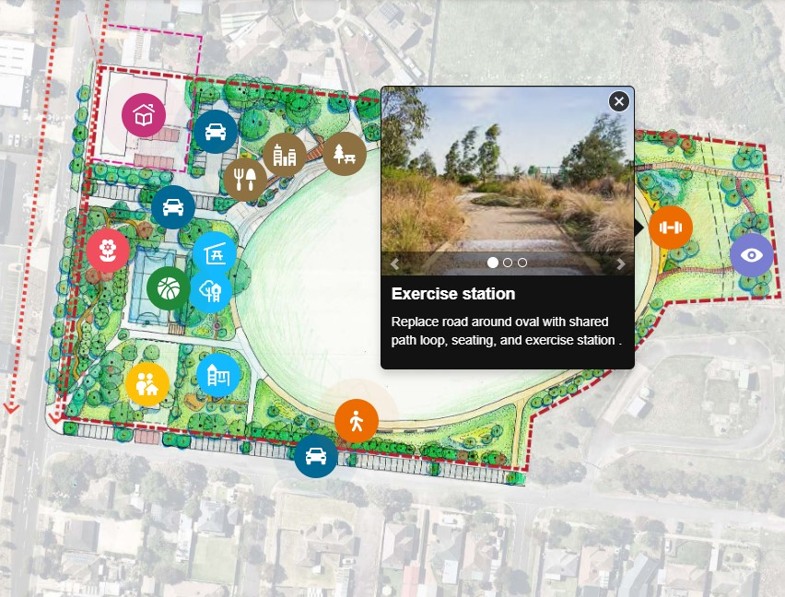
The project Engage page presented a summary of opportunities captured from the community through the phase 1 consultation period and offered visitors an opportunity to learn more about the key actions of the plan on an interactive map. Visitors to the page were also encouraged to complete a short survey to let us know if they liked what was being proposed and their top four priorities for the Mernda Recreation Reserve upgrade (this activity mirrored the in-person engagement activity).
Above: Interactive map from Mernda Recreation Reserve Master plan page on Whittlesea Engage platform
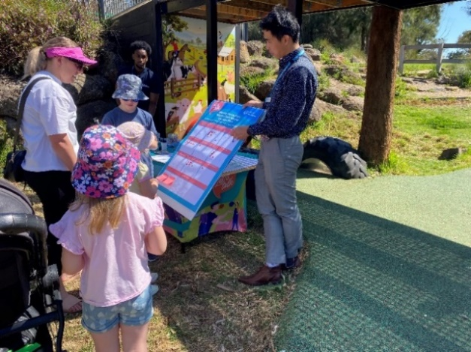
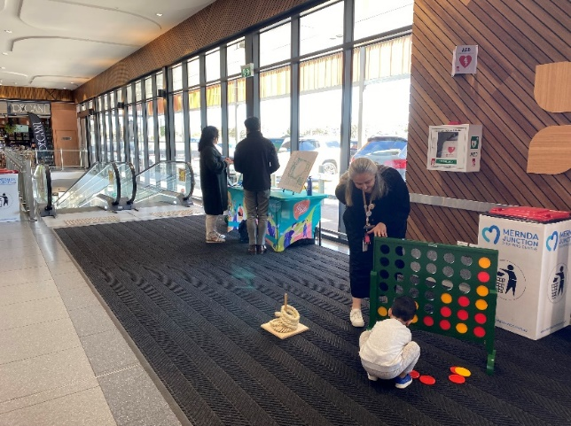
During the phase 2 consultation period, the project team hosted a staffed community-based pop-up at the nearby Mernda Adventure Playground during the school holidays on Monday 25 September from 10am to 12pm and at Mernda Junction shops on Tuesday 10 October from 2.30 – 4.30pm. Both pop-up locations were central and easily accessible to the targeted residents of Mernda and Doreen.
Above: in person consultation at Mernda Adventure Playground and Mernda Junction Shopping Centre
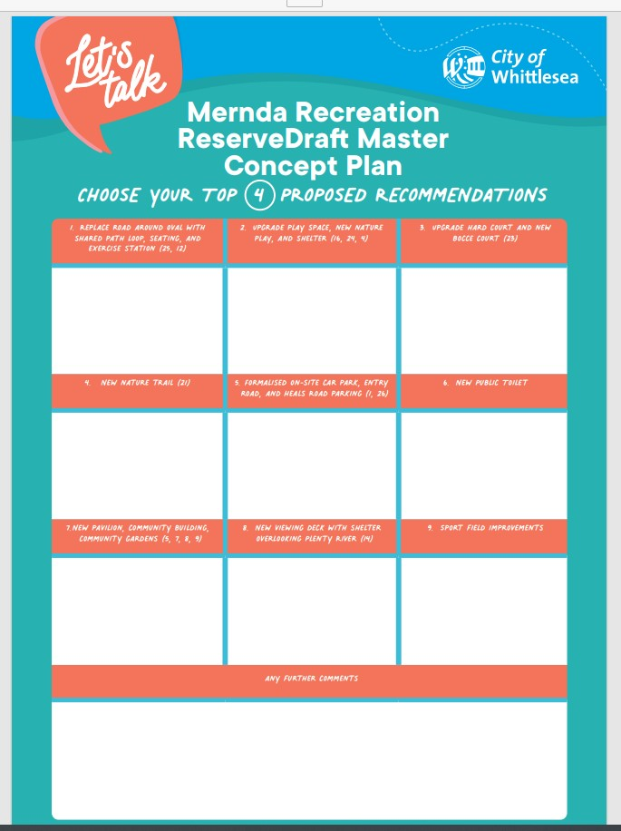
Participants of in-person engagement activities were invited to view the draft master plan and participate in a dot board activity that asked them to choose their top four (out of nine) recommendations for the upgrade and offer any additional comments about the project.
The available nine options were:
- Replace the road around the oval with shared path loop, seating and exercise station
- Upgrade play space, new nature play area, and shelter
- Upgrade hard court and new Bocce court
- New nature trail
- Formalised on-site carpark, entry road and Heals Road parking
- New public toilet
- New pavilion, community building, community gardens
- New viewing deck with shelter overlooking Plenty River
- Sport Field improvements

Above: Dot Board Activity for in person consultation for Mernda Recreation Reserve
Flyers with a QR code directing community to the project Engage page were available at all in-person activities and participants were encouraged to share the opportunity to participate in the engagement with neighbours, family, and friends.
Residents within 400m of the reserve, were again letterbox dropped to update them on the project status and invite them to view the draft master plan and share their feedback through the project Engage page or at one of the community-based pop-ups.
Visitors to the reserve were alerted to the consultation through large corflute signage installed at the main entry point. The signage featured the QR code directing them to the project Engage page.
The opportunity to participate in the community engagement and community-based pop-ups were shared on Council’s social media channels including Facebook, Twitter, and Instagram.
The Engage Whittlesea platform utilises an accessibility add-on which enables users to easily switch to screen reader mode or easily adjust settings such as font size, contrast, dyslexia friendly options to improve the overall accessibility of the site. The platform also has an in-built translation tool to reduce language barriers to participation, allowing the page to be translated into the top ten languages spoken within the municipality.

Subscribers to the Engage Whittlesea platform that had previously indicated an interest in parks and/or the Mernda area were sent a project update email and encouraged to visit the project page and share their feedback.

Participation
During phase 2 consultation a total of 88 contributions were received, 52 of which were captured at community-based pop-ups and the remaining 36 online through the project Engage page.

A total of 670 people visited the project Engage page, seven of which opted to follow the page to receive project updates.
Below is a snapshot of community participation in the community consultation.

Seven social posts reached more than 12,000 accounts and saw over 400 people engaged with close to 200 people clicking through from socials to the project Engage page.
Two community-based pop-ups were held and saw 52 people share their feedback. The first pop-up was held at the nearby Mernda Adventure Park and at Mernda Junction shops.

The project Engage page was viewed 947 times during the five-week engagement period with 670 unique visitors. A total of 36 participants completed the online survey, of which 46% indicated they reside in Mernda.

Of the 88 community members who participated in the consultation, 26% advised they speak a language other than English at home. Participants identified 19 different languages spoken, with Arabic and Tamil the most spoken.
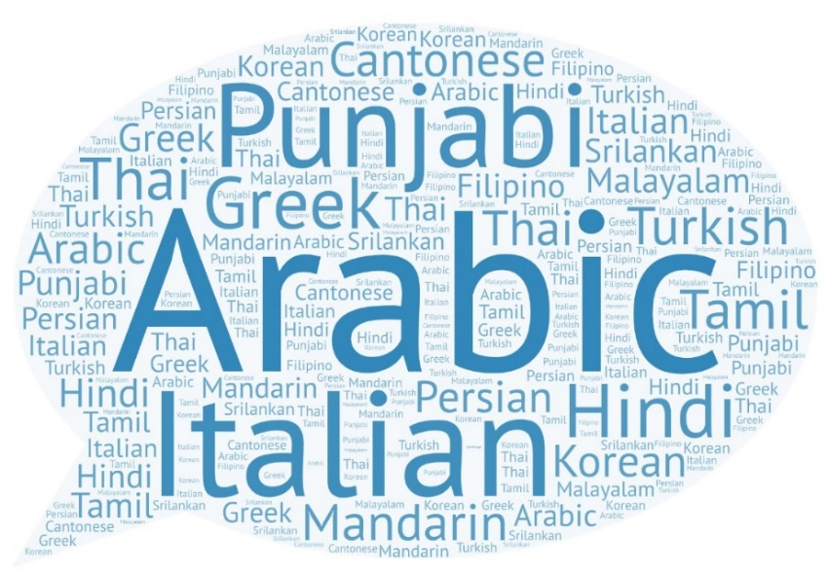
Above: A snapshot of the many languages spoken by residents in the City of Whittlesea
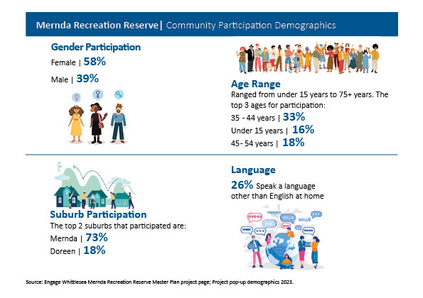

Above: A snapshot of community who participated in Mernda Recreation Reserve Consultation
What we heard
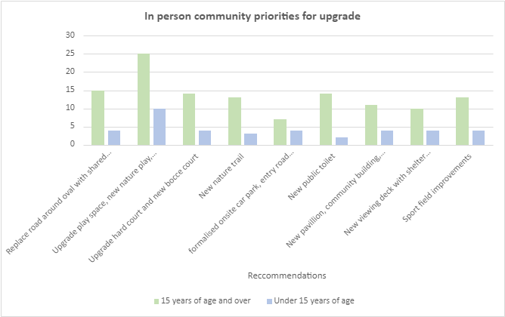
In-person Engagement
The in-person engagement opportunities attracted 52 participants, with just under a third of participants aged fifteen years and under. The youth in Mernda told us that an upgrade to the play space, a new nature play area and a sheltered area to gather with friends and family is what they would like to see upgraded as a priority at the reserve. This was also a high priority for community members aged over fifteen years, followed by replacing the road around the oval with a shared path as seen in the graph below
Above: graph that represent the upgrade priorities for participants at in person engagement
Online engagement
We heard from 36 community through the online survey,. 58%of which live in a two-parent family with one or more children.
A total of 36 online participants answered the question How do you feel about the proposed draft master plan for Mernda Recreation Reserve with most participants (83%) providing a positive response to the proposed draft master plan. Full results below:
83% Like it/Like it a lot | 6% I can live with it | 11% Don’t like them/don’t like them at all
Online participants were asked to select four recommendations (from the nine available) that they would like to see upgraded as priority at the reserve. As illustrated below the top three priorities captured from online participants is a new public toilet followed by an upgrade to the play space, a new nature play area and additional shelter areas to gather with friends and family; and, a new pavilion, community building and community garden. The full breakdown of priorities from online participants is as below:

When asked what they do when visiting the reserve, 56% of online participants shared that they visit the reserve to exercise (including walking and running). Another popular reason for visiting the reserve (36%) is to gather with friends and family for a picnic and take children to the playground (31%).

Opportunities
Participants were invited to share their thoughts on the proposed draft master plan and offered potential future opportunities for Mernda Recreation Reserve, some of which may be out of scope of this project. Below are the themed comments received through both online and in-person engagement activities.
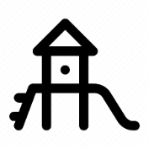 | Playground/Facilities – upgrading the existing playground with a play space for all ages and abilities was a priority for respondents. Some suggestions included introducing a separate netball and basketball court, as well as adding soccer goals and exercise equipment.  “I would like to say that an upgrade to a children’s park being priority would be fantastic. The park that exists at this current time is very old and outdated”  “A new public toilet”  “Separate netball and basketball court”  “Better exercise equipment (e.g., weighted) is needed so more people can use it. Body weight equipment suits very few people”  “Women’s facilities”  “Kids in the area love soccer, it would be great if you can put soccer goals in the ground for Socceroos to practise their skills”  “Please include badminton /pickleball court as it's a growing popular all ability sport”  “Would love to have an electronic football wall like they have in Europe, it is called a Yalp Sutu and is a lot of fun”  “Dog taps and more bins”  “It needs to have more interactive and recreational spaces, that suits the age of young people in the area children and young people (mainly 3 to 16)”  “Use the oval as an overflow oval for local clubs to use for cricket and summer pre-season for football”.
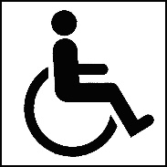 | Accessible – upgrading paths and adding additional all ability car parks and equipment to make the park accessible to all is a priority for respondents.  “I hope the path around the oval and the entrance via Jane St will be smooth as my partner is a wheelchair user. The current grassy entrance via Jane St is difficult to navigate, and the gravel track around the oval is very bumpy to push around on”.  “Disabled car park spaces and rails. Disabled play equipment for the young and old”
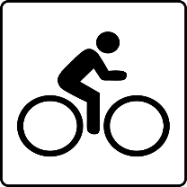 | Transport – Respondents highlighted the need for additional walking/cycling tracks and the need for public transport in the area to be prioritised.  “The reserve isn’t connected to the Doreen or Mernda centres. Where is the bike path links?”  “Are the car parks for all cars or are they just for Electric Vehicles?”  “The car parking is ok, but public transport and walking/cycling should be prioritised”
Safety - introducing additional lighting, new fencing, and car park improvements to make users feel safe and help to prevent anti-social behaviour.

“Several aspects of the plan leave themselves open to vandalism or defacement, this should be a serious consideration when adding features”

“A fenced oval for safety”

“It looks very beneficial for our community! As a resident of the area, my only (minor) concern is that the Heals Rd upgrade may increase traffic flow near our houses in the Yellow Gum Estate”

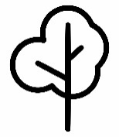 | Sustainibility - community members suggested incorporating a community garden in the plan. Others would like to see recycled materials used in the upgrade and additional trees planted to provide shade.  “Planting shade trees essential. Sun protection should be a priority”  “Recycle bins”  “Solar panels”  “Rainwater tanks for garden”  “Recycled materials being used”  “Vegie garden and community compost”  “It would be great to have a community garden and kitchen that can be hired by local clubs or have groups providing low-cost meals to local community once a week”
Community - opportunities to strengthen community connections is important to participants. Such as a community garden and community shed.
“The Mernda Community House is shown to be retained at its current location but with some of its activities (such as community garden) proposed near/ at the new sport pavilion. It does not gel and frankly, quite disappointing, as not only will it be inconvenient for the users, but it is also inefficient for the Community House to operate their programs all over the place. I would prefer to see proper consideration given to the existence of Community House in the reserve”
“A community Farmer’s market”
“A community shed in Mernda is an important addition to places for community to connect with others, learn and support each other”
“Literation/Education on nature river walk”

“A new, improved Neighbourhood House centre is exciting and would give community further opportunities to connect, learn and feel a sense of belonging”

Next steps
Thank you to everyone that visited the project Engage page and contributed through the online survey or at in-person community engagement opportunities.
Feedback captured from the community in Phase 2 is being used to develop the final Mernda Recreation Reserve Master plan. While we are not able to accommodate everyone’s comments, the project team will provide solutions to the issues raised and balance them with the requirements of Council.
The final master plan design will be presented to Council for endorsement in early 2024. The community will be kept updated on further developments via the Mernda Recreation Reserve Project Engage page

