Fair Access Policy
Policy statement
The City of Whittlesea will undertake the necessary and proportionate steps towards achieving more gender equitable access and usage of community sports infrastructure, and improved experiences for women and girls when participating in local sport.
This Policy establishes Council’s commitment that gender equality be considered and prioritised in all current and future Council planning, policy, service delivery, facility allocations and practice as they relate to community sports infrastructure.
Purpose
The Fair Access Policy (Policy) seeks to:
- address known barriers experienced by women and girls in accessing and using community sports infrastructure;
- ensure solutions developed and implemented are guided by the six principles of Fair Access detailed below;
- articulate criteria for Sports Clubs allocation of Council facilities that is consistent with the Fair Access principles;
- support Sporting Clubs in education and training regarding the Fair Access Policy; and
- align with the State Government’s Fair Access Roadmap.
Background

Sport is a highly visible and valued feature of City of Whittlesea’s culture and identity. The benefits of sport include physical and mental wellbeing, creating a sense of belonging and connection with community.

The Sport Participation Trends Across Victorian LGAS report released in April 2024 shows the City of Whittlesea ranks 73 out of 79 council areas for women and girls participating in organised sport. This figure was boosted by sports with traditionally high participation rates by women and girls including calisthenics, softball and netball. In several sports, female participation in the City of Whittlesea in 2023 was significantly lower than male participation and lower than state averages, including:

- Australian Rules 16.91% (AFL Victoria 17%)
- Football 15.44% (Football Victoria 21%)
- Cricket – 11.39% (Cricket Victoria 27%)
  - Basketball 34.7%

A reform agenda has been developed by the Victorian Government to change the systems that have perpetuated gender inequality by designing an enduring structure that requires implementation and tracking of progress over time.

This reform agenda includes addressing the traditional structures and the way community sport and recreation organisations operate through the implementation of all nine (9) recommendations from the 2015 Inquiry into Women and Girls in Sport and Active Recreation. This includes recommendation six (6) which includes:
“…encourage facility owners and managers to review access and usage policies to ensure women and girls have a fair share of access to the highest quality facilities at the best and most popular times”.
In response, the Council has designed a Fair Access Policy that will guide the necessary and proportionate steps towards achieving gender equitable access and usage of community sports infrastructure. This Policy establishes Council’s expectation that gender equality is considered and prioritised in all current and future Council recreation planning, policy, service delivery and practice as they relate to community sports infrastructure.
The Fair Access Policy will require sporting clubs to participate in education, consultation and undertake gender equity audits and develop gender equity action plans to increase participation by women and girls as players, coaches and committee members. Council officers will provide education and training modules which will include equity, participation, responsibilities and safe environments, gender audit and action planning.

Sporting clubs will be required to report annually on how they are aligning with the Fair Access Policy as well as provide progress reports at designated intervals on the progress of their Gender Equity Action Plans. Clubs who do not align with the Fair Access Policy or undertake and achieve progress in gender equity action plans will not be prioritised ground allocations, capital works projects, funding or subsidies on facility allocations.

Scope
This policy applies to Council officers, sports clubs and associations allocated Council Sporting infrastructure.

Alignment to Whittlesea 2040
The Fair Access Policy primarily guides Council’s work toward the following Goal as outlined in Whittlesea 2040: A place for all: Connected Community
This Policy enables effective and efficient integration of the requirements of the Gender Equality Act 2020, the Local Government Act 2020 and the Public Health and Wellbeing Act 2008. Providing safe and connected spaces for everyone to access sporting infrastructure.
Additionally, this Policy is informed by:
- Connected Communities Strategy
- City of Whittlesea Community Plan
- Long Term Community Infrastructure Plan
- Victorian Fair Access Policy Roadmap
- Active Whittlesea Strategy 2021
Overarching Governance Principles
The development of this Policy considered the Local Government Act 2020’s Overarching Governance Principles and the following were applied:

Lawful | ☒ |  | Community engagement | ☒ |  | Financially viable | ☐
Best community outcome | ☒ |  | Innovation & improvement | ☒ |  | Consistent with government plans | ☒
Sustainable | ☐ |  | Collaboration with government bodies | ☒ |  | Transparent | ☒

Gender Equality, Climate Change, Human Rights and Child Safe Compliance

All City of Whittlesea policies comply with the Victorian Charter of Human Rights and Responsibilities, Gender Equality Act, Climate Change Act and the Child Safe Standards.

Definitions
Community Sports Infrastructure means publicly owned local, rural, regional, or state level sport and recreation infrastructure operated and maintained primarily for the purpose of facilitating community sport activities, including sporting grounds, surfaces, facilities, and pavilions.

Gender means how you understand who you are and how you interact with other people. Many people understand their gender as being a man or woman. Some people understand their gender as a mix of these or neither. A person’s gender and their expression of their gender can be shown in different ways, such as through behaviour or physical appearance.

Gender Audit means a tool to assess and check the institutionalisation of gender equality into organisations, including in their policies, programmes, projects and/or provision of services, structures, proceedings and budgets.

Gender diverse means an umbrella term for a range of genders expressed in different ways. Gender diverse people use many terms to describe themselves. Language in this area is dynamic, particularly among gender non-confirming young people, who are more likely to describe themselves as non-binary.

Gender equality means the equal rights, responsibilities, and opportunities for all genders. Equality does not mean that all genders will be treated the same, but that their rights, responsibilities, and opportunities will not depend on their gender.

Gender equity means the provision of fairness and justice in the distribution of benefits and responsibilities based on gender. The concept recognises that people may have different needs and power related to their gender and these differences should be identified and addressed in a manner that rectifies gender related imbalances.

Gender Impact Assessment, or GIA means a requirement under the Gender Equality Act 2020 to be carried out on policies, programs and services which have a direct and significant impact on the public. The assessment must evaluate the effects that a policy, program or service may have on people of different genders.

Club Strategic/Business Plan means an internal sporting club document developed to guide good governance, future direction, and specific objectives for the organisation. Sporting Clubs Gender Equity action plan will sit within this document.

Council means the City of Whittlesea

Council Officers means full time, part time, casual and contractors employed by the City of Whittlesea.
Procedures and implementation
FAIR ACCESS PRINCIPLES

The Fair Access Principles have been developed by the Office for Women in Sport and Recreation, Sport and Recreation Victoria and VicHealth, in consultation with representatives from local government and the state sport and recreation sector. This Policy and any resultant action plan are based on six (6) principles of inclusivity, full participation, equal representation, encouraging and supporting user groups, and prioritising user groups committed to equality.

1. Community sports infrastructure and environments are genuinely welcoming, safe, and inclusive
2. Women and girls can fully participate in all aspects of community sport and active recreation, including as a player, coach, administrator, official, volunteer and spectator
3. Women and girls will have equitable access to and use of community sport infrastructure
a. of the highest quality available and most convenient
b. at the best and most popular competition and training times and locations
c. to support existing and new participation opportunities, and a variety of sports
4. Women and girls should be equitably represented in leadership and governance roles
5. Encourage and support all user groups who access and use community sport infrastructure to understand, adopt and implement gender equitable access and use practices
6. Prioritise access, use and support to all user groups who demonstrate an ongoing commitment to gender equitable access and use of allocated community sport infrastructure

Council considers these principles provide clear direction, while also enabling adaption to the specific environment within the City of Whittlesea.

FOCUS AREAS

Informed by the Fair Access Principles, Council will take action under the following key focus areas.

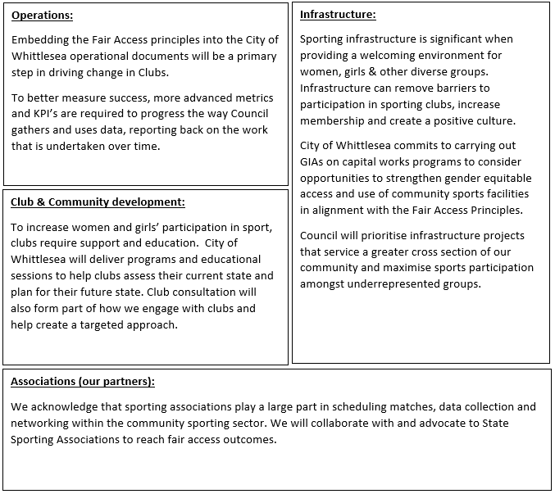

The Policy is designed to:
- Guide future sporting infrastructure development with a focus on fair access for all
- Ensure the provision of safe, inclusive spaces within sporting clubs where women and girls are welcomed
- Incorporate Fair Access principles into Council policies and strategies
- Comply with the Gender Equality Act 2020, and the wider Victorian Government gender equality strategy, Safe and Strong.

Council acknowledges:
- The disadvantaged position women, girls and gender diverse people have had in sport and recreation due to structural and attitudinal discrimination.
- That achieving gender equality will require different approaches for women and girls, men and boys and gender diverse people to achieve equitable outcomes for people of all genders.

Council will:
- Engage fairly and equitably with all staff, governance working groups, state sporting organisations, regional sport assemblies (where applicable) and members of our sport and recreation community, regardless of their gender, in a positive, respectful, and constructive manner
- Engage in the process of Gender Impact Assessments to assess the implications for women, men and gender diverse people of any planned action, including policies and communications. This is a strategy for making all voices, concerns and experiences, an integral dimension of the design, implementation, monitoring of policies and programs.
- Review and update lease and license and Service Level Agreements and incorporate Fair Access practices and principles where applicable.
- Operationalise the Fair Access Policy through an Action Plan that is reviewed biannually.

Sporting Clubs will:
- Outline how they comply with the Fair Access Policy as part of Council’s seasonal or annual application process based on consultation with Club members
- Undertake a Gender Equity Audit in consultation with Council Officers
- Incorporate actions developed through the Gender Equity Audit in their Strategic/Business Plan and report annually to Council on progress
- Work with State and Regional Sporting Associations to ensure fixtures comply with the Fair Access Policy
- Comply with the Fair Access Sporting Club Action Plan developed by Council in consultation with the community to ensure ongoing access to ground allocation and infrastructure.
- Provide club registration numbers as part of their annual ground application request.

