Parks and Open Space Asset Management Plan

APRIL 2022

Document Control
Version | Date | Revision Details | Author | Reviewed
1.0 | Feb 2018 | Initial plan development | MB/RZ | AM
2.0 | Mar 2022 | Updated to suit requirements of Local Government Act 2020 and updated condition data. | MB | DH/ND
2.1 | Apr 2022 | Updates and clarifications as per discussions with Councils Asset team. | MB | DH

Asset Management Plan Alignment
This document has been prepared in accordance with:
- Local Government Act Victoria (2020)
- Local Government Asset Management Better Practice Guide (2015)
Local Government Victoria,
- Asset Management Accountability Framework (2016)
Victoria State Government – Treasury and Finance,
- ISO 55000 Series – Asset Management (2014)
International Standards,
- International Infrastructure Management Manual (2020)
Institute of Public Works Engineering Australasia.
Table of Contents
1. Executive Summary 6
2. Introduction 9
3. Strategic Objectives 11
4. Asset Overview 14
4.1. Service Hierarchy 17
5. Levels of Service and Performance Indicators 19
6. Asset Condition and Service Lives 21
7. Operations 23
8. Maintenance 24
9. Capital Renewal 25
10. New Assets and Capital Upgrades 26
10.1. Overview 26
10.2. Private Developments 26
10.3. Infrastructure Contributions Projects 27
10.4. Councils 4-15 Year New Works Program 28
11. Transfers and Disposal Plan 29
12. Lifecycle Costs - Annualised 30
13. Financial Indicators 31
14. Risk Management 32
15. Improvement Plan 34
Appendix A: Parks and Open Space Assets 15 Year Financial Plan (2021 $,000) 36

List of Tables
Table 1.1 – Parks and Open Space Asset Portfolio Overview ($,000) 6
Table 3.1 – Parks and Open Space Asset Related Documents and Systems 12
Table 4.1 – Site Overview by Hierarchy ($M) 14
Table 4.2 – Asset Subclass ($M) 15
Table 4.3 – Data Confidence and Frequency of Collection 16
Table 5.1 – Levels of Service 20
Table 6.1 – Condition Descriptors 21
Table 6.2 – Asset Lives and Intervention Levels 21
Table 7.1 – Operational Activities and Expenditure (2021 $,000) 23
Table 8.1 – Maintenance Activities Costs (2021 $,000) 24
Table 9.1 – Renewal Expenditure, Requirements and Backlog (2021 $,000) 25
Table 12.1 – Indicative Annual Lifecycle Costings (2021 $) 30
Table 14.1 – Critical Strategic Risks 32
Table 14.2 – Critical Assets 33
Table 15.1 – Parks and Open Space Asset Management Improvement Plan 34

List of Figures
Figure 1.1 – Parks and Open Space Asset Condition Distribution 7
Figure 1.2 – 15 Year Rolling Backlog Forecast (2021 $, millions) 7
Figure 1.3 – Overall Parks and Open Space Financial Indicators for 2021/22 Financial Year 8
Figure 2.1 – Asset Management Framework 10
Figure 4.1 – Map of Park Hierarchy 18
Figure 6.1 – Current Condition By Component, Asset Type, and Hierarchy 22
Figure 10.1 – PowerBI Asset Growth Dashboard 27
Figure 10.2 - Capital Expenditure 28

Executive Summary
The City of Whittlesea manages a Parks and Open Space network to provide places and spaces to facilitate connected communities and opportunities to participate in activities that impact their health and wellbeing. Council’s priority is to manage assets in a way that meets the community’s expectations in a safe, effective, and cost-efficient manner. This network had a replacement cost of $312 Million as of 30 June 2021 and Council has averaged approximately $15 Million in Parks and Open Space asset vestment from developments per year over the past 3 years.
Melbourne is one of the fastest growing cities in Australia and, according to the Federal Government’s 2021 Population Statement, is predicted to be the most populated city in Australia by 2030. The City of Whittlesea is a growth area council that will contribute to providing the communities this population growth will require. This creates a unique management challenge; to protect the long-term sustainability and service provision of our asset base, we must ensure that existing assets continue to be proactively maintained as new assets are handed over to Council.
This plan provides a strategic overview of the services that the City of Whittlesea provides through the management of parks and open space assets, the associated costs, and the risks and mitigation measures in providing those services. This plan outlines Council’s adopted approach and its implications. Several scenarios were modelled in developing this plan and are available as an interactive digital dashboard here: City of Whittlesea Digital Asset Dashboard.
Table 1.1 shows the current operational, maintenance, renewal and upgrade/new construction expenditure on assets and the anticipated funding gap over the next 15 years.

Table 1.1 – Parks and Open Space Asset Portfolio Overview ($,000)
Asset Hierarchy | Annualised Operations & Maintenance¹ | Annualised Renewal Budget¹ | Annualised New Assets¹ | Backlog² 2022/23 | Backlog² 2036/37
Major Community Parks | 387 | 11,632 | 19,804 | 169 | 3,763
Municipal Open Space | 3,113 |  |  | 6,770 | 20,458
Civic & Commercial Facilities | 136 |  |  | 108 | 2,660
Neighbourhood & Local Open Space | 5,667 |  |  | 11,453 | 53,764
Special Purpose Site | 47 |  |  | 1 | 121
Landscape Site | 551 |  |  | 163 | 987
Streetscape | 2,073 |  |  | 299 | 1,075
Conservation Area | 764 |  |  | 314 | 656
Parks and Tree Management | 3,417 |  |  | - | -
Total | 16,155 | 11,632 | 19,804 | 19,277 | 83,484
Note:
^{1.} Budget figures are 15-year average. Refer Appendix A for details.
^{2.} ‘Backlog’ refers to works that are beyond the desired intervention level, but funding is not available to undertake those works.
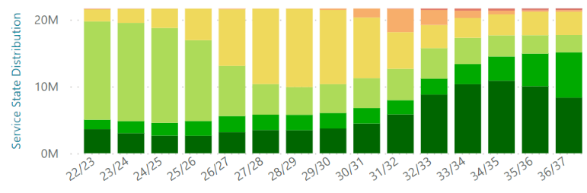

Figure 1.1 – Parks and Open Space Asset Condition Distribution
Figure 1.1. shows the expected overall condition distribution of Parks and Open Space assets throughout the duration of this plan.

Figure 1.2 – 15 Year Rolling Backlog Forecast (2021 $, millions)
Figure 1.2 shows the extent of renewals that are projected to be required but are currently unfunded. Council is actively working to address the backlog that is modelled to arise in the later years of the planning horizon.
Asset Sustainability Ratio  71%  $$\frac{Renewal Expenditure}{Annual Depreciation}$$  A measure of the sustainability of current asset renewal practice. | Asset Renewal Funding  28%  $$\frac{Funded Renewals}{Desired Renewals}$$  A measure of how much of the required renewal funding is available. | Remaining Service Potential  65%  $$\frac{Fair Value}{\begin{aligned}Current Replacement \\ Cost\end{aligned}}$$  A measure of the remaining service life of assets. | Average Annual Asset Consumption  2.49%  $$\frac{Annual Depreciation}{Replacement Cost}$$  A measure of the rate of Parks asset consumption.

Figure 1.3 – Overall Parks and Open Space Financial Indicators for 2021/22 Financial Year
Council has significantly increased the quality of Parks Asset Data and modelling in the past two years. The Asset Sustainability Ratio shows the investment into renewals, and the Asset Renewal Funding Ratio is expected to improve in coming years.

Introduction
The City of Whittlesea is committed to providing effective and efficient services to the community. Council is proactively managing its asset portfolios to ensure the level of service provided meets the community’s expectations in the most cost-effective manner and has invested in systems, processes, and personnel to achieve this. This plan gives an overview of current practices and their long-term implications on service delivery to inform decision making and resource prioritisation.
This plan is broken into four sections addressing key long term sustainability questions:
Why does Council have Parks and Open Space assets and what do we have?
Section 3 – Strategic Objectives
Section 4 – Asset Overview
Section 5 – Levels of Service and Performance Indicators
Section 6 – Asset Condition
How do we manage our assets throughout their lifecycle and what does it cost?
Section 7 – Operations
Section 8 – Maintenance
Section 9 – Capital Renewal
Section 10 – New Assets and Capital Upgrades
Section 11 – Transfer and Disposal Plan
Section 12 - Lifecycle Costings
Section 13 – Financial Indicators
What are the risks in delivering the desired services and how do we mitigate them?
Section 14 – Risk Management
How will we continue to get better at managing our Parks and Open Space assets?
Section 15 – Improvement Plan
This Parks and Open Space asset management plan is part of Council’s overall Asset Management Framework (AMF). This framework defines the overall context for the management of community assets and ensures that the asset lifecycle activities link back to the community’s desired level of service as per the Whittlesea 2040 Community Strategic Plan. The AMF is depicted in Figure 2.1.
Operational, Maintenance, & Strategic Plans
Asset Management Strategy
Whittlesea 2040
(10+ year focus)
Community Plan
(4 year focus)
Operational Plan
(1 year focus)
Informs
Informs
Asset Management System/Database
Asset Inspections
Annual Report
Planning Reports
Asset Revaluation
Resourcing Strategy
Strategic Plans/ Documents
Asset Management Plans
Asset Management Plans
Asset Management Plans
All Plans
Drives

Figure 2.1 – Asset Management Framework

Strategic Objectives
Whittlesea 2040 – A Place For All is the City of Whittlesea’s Community Strategic Plan that outlines the community’s vision for living and working in the City of Whittlesea. The Council have developed the Community Plan 2021-25 which outlines how they plan to achieve that vision during their term.
The City of Whittlesea is responsible for both urban and rural areas and therefore is considered an interface Council. The municipality will experience significant population growth over the next 20 years, increasing from approximately 242,000 to 382,900 residents and thus is also considered a growth Council. This creates unique challenges in providing the required services for both established and rapidly developing areas to address today’s needs with consideration of our community’s ultimate demographic profile.
The City of Whittlesea has a comprehensive community consultation process for the development and update of the Whittlesea 2040 and Council Plan that is validated with ongoing community surveys. This Parks and Open Space Asset Management Plan utilises the outcome of those consultation processes and has been placed on public display to ensure this plan aligns with the vision of the community. As Council’s asset management practice continues to mature the consultation process will become more rigorous.
The strategic objectives Council achieves through the operation, maintenance, renewal and upgrade of Parks and Open Space assets align with the Community Strategic Plan as follows:
2. Liveable neighbourhoods
2.2 Well-designed neighbourhoods and vibrant town centres
4. Sustainable environment
4.1 Valued natural landscapes and biodiversity
4.2 Climate ready
4.3 Leaders in clean, sustainable living
Council has developed policies, strategies and plans to assist with facilitating, providing, and advocating for these objectives. It has also adopted systems to manage the quantum of data. A summary of these documents and systems is shown in Table 3.1.

Table 3.1 – Parks and Open Space Asset Related Documents and Systems
 | Document/System | Content
Corporate Framework | Environment Protection and Biodiversity Conservation Act 1999 | Provides a legal framework to protect and manage nationally and internationally important flora, fauna, ecological communities, and heritage places.
 | Community Strategic Plan | Outlines the community’s long-term vision.
 | Whittlesea 2040 | Outlines how the Council will achieve the community’s vision during their term.
 | Council Action Plan | Outlines how the organisation will achieve the community’s and councillors’ priorities.
 | Asset Management Policy | Outlines how Council will manage assets holistically.
 | Whittlesea Planning Scheme | Defines how land can be used or developed within the municipality.
Service Provision Strategies | Open Space Strategy | Guides the future design and management of public open space and provides a framework for the planning and provision of open space across the older established urban and rural areas of the municipality.
 | Biodiversity Strategy | Provides directions to improve the management and protection of biodiversity across the municipality into the future.
 | Environmental Sustainability Strategy | Provides Council with a framework to work towards a sustainable city that supports and protects biodiversity, ecological processes and a healthy and sustainable population.
 | Roadside Management Strategy | Provides a balanced approach to the protection and sustainable management of environmental and cultural heritage values on roadsides in the City of Whittlesea, while meeting key functional and fire prevention requirements.
 | Greening Whittlesea Strategy | A strategy that outlines the approach to increasing greening in Whittlesea, specifically increasing canopy cover.
 | Established Areas Infrastructure Planning for Families , Children and Young People | Strategy for the delivery of social and physical infrastructure to enable the provision of quality services and programs for children, young people and families.
 | Play Space Planning Framework and Policy | Outlines the value and principles of play and how these can be incorporated into design and strategic provision.
 | Cycle Sports and Skate Strategy | Outlines a planned approach to the provision of skate facilities in the municipality encompassing skating, BMX, rollerblading, and scooters.
 | Sports Lighting Policy 2020 | Outlines sports clubs’ and Council direction on standard, contribution, maintenance and sustainable design of lighting systems.
 | Tennis Strategy | Guides the provision and maintenance of tennis facilities and clubs that meet community needs.
 | Whittlesea Water for All | Connects the strategic management of stormwater, potable water, wastewater, rainwater and the health of local waterways.
 | Whittlesea Walking Strategy | Identifies priority pedestrian routes and missing infrastructure.
 | Whittlesea Bicycle Plan | Identifies priority cycling routes and missing infrastructure.
 | Electricity Safety (Electric Line Clearance) Regulations 2015 | Legislated powers and requirements relating to maintaining a safe distance between vegetation and electrical transmission lines.
Operational Plans, Manuals, Guides | Line Clearance Vegetation Management Plan | Defines the methods to achieve compliance with the Electricity Safety (Electric Line Clearance) Regulation 2015.
 | Maintenance Contract Service Specifications | Levels of service for assets as defined in the specifications for Parks Maintenance Service contracts.
 | Precinct Structure Plans and Development Cons. Plans | Defines the infrastructure required from developers and Council through the delivery of new subdivisions.
 | Operational Service Standards | Defines the standards during the provision of operational services, such as frequencies and extent of works.
 | Road Management Plan | Defines the maintenance priorities and timeframes to rectify hazards within the road corridor.
 | Stormwater Management Plan | Outlines actions required to be taken to mitigate the threats from urban runoff into waterways.
 | Street Tree Management Plan 2016 | Guides how Whittlesea will choose, plant, maintain, protect and value urban street trees to 2026.
 | Engineering Design and Construction Manual (EDCM) | Sets the engineering guidelines for development in Growth Area Municipalities.
 | Guidelines for Urban Development | The specific application of the Engineering Design and Construction Manual for the City of Whittlesea.
Data Management Systems | ArcGIS | Geographic Information System that holds the spatial (location) data.
 | Assetic | Asset Information Management System.
 | CAMMS | Project management software that holds the 4/15 year new works program and current project management information.
 | Magiq | User Interface system that interacts with the financial system, plan reporting system, risk register and resource planning.
 | Authority | Financial Management System.
 | Irrinet | Central irrigation management system.
 | SharePoint | Document Management System that holds correspondence and other documentation.

Asset Overview
Council provides the municipality with extensive and diverse open space sites to meet the community’s recreational, health, and well-being needs. The number, value, and size of these sites as at 30 June 2021 is shown in Table 4.1.

Table 4.1 – Site Overview by Hierarchy ($M)
Park Hierarchy¹ | Unit (ea) | Site Area (ha) | Current Replacement Cost ($) | Fair Value ($) | Annual Dep. ($)
Major Community Parks | 5 | 40 | 12.9 | 5.8 | 0.3
Municipal Open Space | 90 | 180 | 47.2 | 28.2 | 1.4
Civic & Commercial Facilities | 34 | 21 | 5.2 | 2.4 | 0.1
Neighbourhood & Local Open Space | 440 | 765 | 195.7 | 125.3 | 5.0
Special Purpose Site | 4 | 0.05 | 0.3 | 0.1 | 0
Landscape Site | 496 | 61 | 18.5 | 15.4 | 0.3
Streetscape | 668 | 218 | 26.4 | 22.4 | 0.5
Conservation Area | 52 | 528 | 5.9 | 4.1 | 0.1
Grand Total | 1,789 | 1,812 | 312.1 | 203.7 | 7.7
Note:
- Park Hierarchy is the service hierarchy used for Parks Maintenance Service Regime. Refer to Section 4.1 for definitions.
To effectively manage each site captured in this Park Hierarchy, Council has recorded the specific infrastructure and landscaping assets in the Asset Information Management System, Assetic. These assets are grouped into subclasses to ease in their management as per Table 4.2.

Table 4.2 – Asset Subclass ($M)
Asset Subclass | Asset Types within Subclass | Current Replacement Cost
Conservation Area | Conservation Area | $-
Minor Structures | BBQ, Memorial Structure, Public Art, Shelter / Shade / Pergola, Windmill | $10.2
Landscaping | Dog Off Leash Area, Garden Bed, Parks Tree, Significant Tree, Slashing Area, Street Tree, Turf Passive, Waterbody | $33.8
Parks Infrastructure | Backflow Prevention, Boardwalk/Platform, Fence, Gate, Irrigation Controller, Irrigation Pump, Irrigation System, Irrigation Tank, Parks Light, Path, Sign, Wall, Water Meter, Weather Station | $169.9
Playgrounds and Equipment | Bike Repair Station, Drinking Fountain, Exercise/Fitness Equipment, Park Table, Playground, Playground Safety Surfacing, Seat | $77.9
Sportsgrounds | Coaches Box, Cricket Pitch, Line Marking, Skate/BMX Facility, Sporting Goal, Sports Area, Sports Light, Sports field, Tennis Court, Turf Active | $20.3
Canopy Cover | Parks Tree, Street Tree | $-
Grand Total |  | $312.1

This infrastructure interacts with other service providers such as Melbourne Water and Parks Victoria. Ownership and maintenance responsibility of Parks and Open Space assets is captured in Council’s Asset Information Management System, Assetic.
Council currently has various levels of asset data due to the accessibility, practicality, and benefit of collecting that data. Data confidence, and the frequency of collecting data, is outlined in Table 4.3.

Table 4.3 – Data Confidence and Frequency of Collection
Data Group | Data Confidence Levels¹ | Data Confidence Description | Frequency of Inspection
Park Infrastructure and Landscape Management | Medium | Complete database of all known assets including GIS data, new assets attribute data is captured upon completion of works and the network is condition assessed on an ongoing basis.  Ongoing use of the data for maintenance purposes has enabled rapid improvement of the data, but ongoing review and refinement is required. | 2-year audit cycle unless required otherwise
Tree Management | Medium | Complete database of all known assets, good GIS data, limited age data, new assets attribute data is captured upon completion of works.  There is some delay in information exchange with contractor due to current systems interaction limitations, but this is under review now and once reviewed will significantly improve the quality of data. | Varies by tree location and classification
Conservation Management | Medium | This is a complex area to manage as native flora and fauna can grow, shrink, migrate, or appear to have left an area only to be found there the next season. The asset information register thus holds the conservation zones and works can be recorded to these zones, but specific conservation assets are monitored through a living geodatabase. | Annual Audit
Note:
^{1.} Data confidence colour-coding is as follows:
Green = desired level, Orange = improvement desired, Red = improvement required

Service Hierarchy
A hierarchy has been established for Parks and Open Space assets by site to assist with their management, prioritisation, resource allocation and response times appropriate to the function of each asset. The eight hierarchies are defined as follows:
- Major Community Parks are unique sites with many values, features and facilities that attract large numbers of people. They include larger tracts of public open space generally developed with a wider range of infrastructure than other reserves. They provide for predominantly passive use for the region. Typically, they consist of large areas of maintained grass, walking trails, regional playgrounds, BBQ’s, picnic and shelter facilities, landscaped areas, and a variety of park furniture and fixtures.
- Municipal Open Space consists of larger sites used for organised sport and competition and includes the park surrounds. There is a varied degree of development and although provided by Council for general community use, there can be restrictions on usage due to seasonal tenants or other lease agreements. The sports facilities consist of maintained grassed, paved, or synthetic active sporting surfaces and their associated elements such as goal posts, perimeter fencing, drains, cricket wickets, irrigation systems, hit up walls, skate facilities, BMX tracks, and jumps. These parks also provide passive recreation for a suburban catchment and include medium sized playground and associated infrastructure.
- Civic & Commercial Facilities encompass the open space surrounding civic buildings, shopping centers, libraries, maternal and child health centers, community activity centers, and the Civic Center. They are generally of ornamental landscape quality rather than being dedicated to active or passive usage.
- Neighbourhood & Local Open Space are smaller areas of public open space focused on the varying passive recreational requirements of the local community and visitors because of their size and/or location. Their development is generally limited to areas of maintained grass, trees, and shrub planting, walking pathways, small to medium sized off the shelf playgrounds, and picnic and shelter facilities.
- Special Purpose Sites are areas that house memorials and are restricted in their use for other recreational activities.
- Landscape Sites are sites with minimal infrastructure and a focus on maintaining the natural environment and landscaped areas for passive enjoyment.
- Streetscapes predominately provide landscape value within road reserve, and include all landscape areas on traffic treatments, roundabouts, verges/nature strips, medians, and main roads.
- Conservation Areas are sites set aside, managed, and maintained for the protection and enhancement of native flora and fauna.
The Park Hierarchy is shown in Figure 4.1.
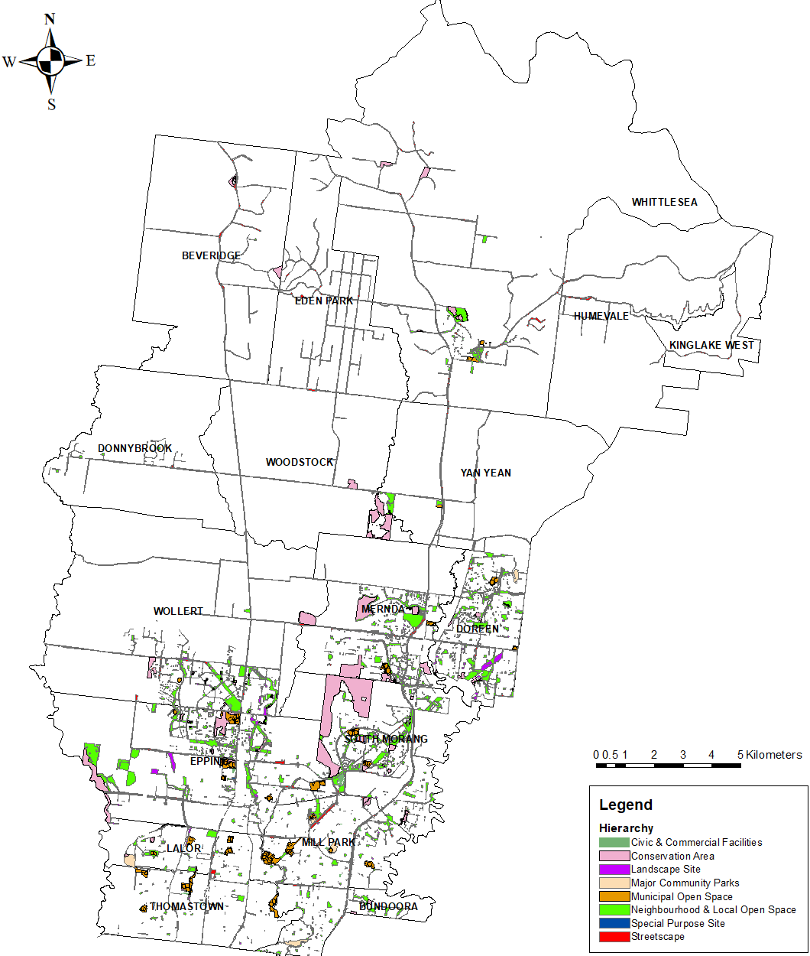

Figure 4.1 – Map of Park Hierarchy

Levels of Service and Performance Indicators
A key objective of asset management planning is to match the levels of service (LoS) the organisation delivers with the level of service expectations of customers. Council therefore looks at level of service through the following perspectives:
- Community Level of Service: Relates to the service or experience expected by the community utilising the asset. This covers attributes such as quality, reliability, responsiveness, sustainability, timeliness, accessibility, and cost effectiveness; and
- Technical Level of Service: Relates to how the Council delivers or assesses performance on meeting the desired community level of service.
Council recognises that the ongoing development of the municipality requires not just the provision of, but also the advocacy for and facilitation of Parks and Open Space assets to deliver these services. This includes, but is not limited to, upgrade of the existing Parks and Open Space sites and the provision of new Parks and Open Space assets and services. The Victorian State Government specifies that “A better service, not a better asset, is a key indication of successful asset management”, thus Council’s levels of service consider service delivery through advocacy and facilitation, in conjunction with asset performance.
The levels of service align with the organisation’s Strategic Objectives in section 3, specifically the Whittlesea 2040 goals as follows:
2. Liveable neighbourhoods
2.2 Well-designed neighbourhoods and vibrant town centres
4. Sustainable environment
4.1 Valued natural landscapes and biodiversity
4.2 Climate ready
4.3 Leaders in clean, sustainable living
The number references for these goals have been cited in Table 5.1 to ensure the measured levels of service relate to the Community’s 2040 vision.

Table 5.1 – Levels of Service
 | W2040 Goal | Community Level of Service | Technical Level of Service | Score
Condition | 2.2, 4.2 | Parks assets are maintained in an acceptable condition for my active and passive use. | Assets are maintained at condition 3 (average) or better. | 95.9%
 | 4.1 | Roadside slashing and weed control keep the weeds down and the grass short so it looks good and there’s no fire hazard. | Our community reports a satisfaction level of average or higher on slashing and weed control in the annual satisfaction survey. | 75%
 | 4.1, 4.2 | Parks and Open Spaces are maintained in a way that is aesthetically pleasing. | Our community reports a satisfaction level of average or higher on the appearance of public areas in the annual satisfaction survey. | 85%
Capability | 2.2, 4.2 | Recreational Facilities are appropriate for supporting my sporting or active needs. | Our community reports a satisfaction level of average or higher on recreation facilities in the annual satisfaction survey. | 83%
 | 4.2 | My local area is resistant to climate change and its impacts. | The tree canopy cover throughout the municipality is increasing. | 19.7%
 | 4.1, 4.3 | Conservation actions preserve  and promote a thriving native  flora and fauna. | Habitat and environmental improvement targets met on Council managed conservation land | 88%
Capacity | 2.2, 4.2 | Accessible passive open space areas are within easy and safe walking distance. | The proportion of urban residential properties within 400m of Neighbourhood and Local Open Space Park sites. | 89.7%

Asset Condition and Service Lives
Council collects asset specific condition and degradation indicators to assess asset performance throughout their lifecycle. For valuation, reporting, and overall network monitoring these indicators are aggregated into a standard condition rating as shown in Table 6.1.

Table 6.1 – Condition Descriptors
Assetic Condition Index | Condition Descriptor
0 | New or as new asset - under defect liability period.
1 | Excellent - minimal maintenance may be required.
2 | Good - minor maintenance work may be required.
3 | Average - standard maintenance work required.
4 | Poor - renewal required. Asset provides poor level of service.
5 | Very Poor - urgent renewal required. Asset is unsafe or unusable.
6 | Failed – asset has reached end of life and cannot be used.
The intent of Council is to undertake renewal works on an asset at the most cost-effective point in the asset lifecycle to deliver the community’s desired level of service. The intervention level of service (LoS) as per Table 6.1 and their associated lives are shown in Table 6.2.

Table 6.2 – Asset Lives and Intervention Levels
Asset Type | Intervention Level (LoS) | Service Life (yrs) ¹ |  | Asset Type | Intervention Level (LoS) | Service Life (yrs)¹
Backflow Prevention | 4 | 25 |  | Path | 4 | 15-66
BBQ | 4 | 15 |  | Playground | 4 | 15
Boardwalk/Platform | 4 | 40 |  | Safety Surfacing | 4 | 10
Coaches Box | 4 | 20 |  | Seat | 4 | 15
Cricket Pitch | 4 | 15 |  | Shelter/Shade/Pergola | 4 | 15-60
Drinking Fountain | 4 | 12 |  | Sign | 4 | 10
Exercise Equipment | 4 | 20 |  | Skate/BMX Facility | 4 | 15-80
Fence | 4 | 25-40 |  | Sporting Goal | 4 | 25
Garden Bed | 4 | 20 |  | Sports Light | 4 | 20
Gate | 4 | 25-40 |  | Sports field | 4 | 25
Irrigation Controller | 4 | 15-25 |  | Tennis Court | 4 | 12
Irrigation Pump | 4 | 12 |  | Turf Active | 4 | 10-25
Irrigation System | 4 | 25 |  | Wall | 4 | 60-75
Irrigation Tank | 4 | 15-60 |  | Water Meter | 4 | 25
Memorial Structure | 4 | 80 |  | Waterbody | 4 | 20
Park Table | 4 | 15 |  | Weather Station | 4 | 10
Parks Light | 4 | 14-18 |  | Windmill | 4 | 25
^{1.} Service life is the time an asset is expected to be available at the desired level of service before renewal.
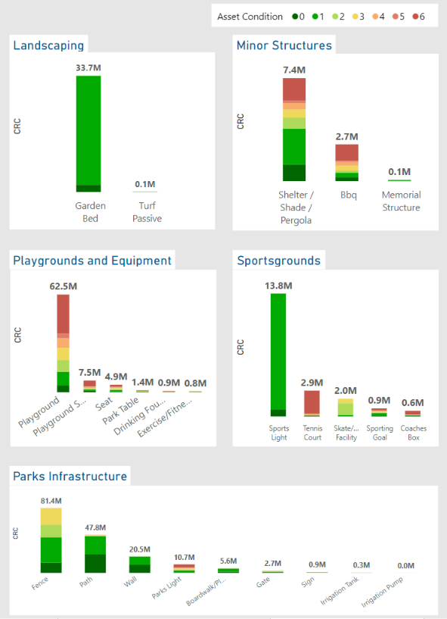

Figure 6.1 – Current Condition By Component, Asset Type, and Hierarchy

Operations
Operational activities are the ongoing, day to day activities and overheads required for the asset to operate effectively and safely in delivering the desired level of service. This includes utility charges, management expenses, condition inspections and other associated overheads.
Current annual expenditure on operational activities is shown in Table 7.1.

Table 7.1 – Operational Activities and Expenditure (2021 $,000)
Activity | Activity Description | Cost
Park Inspections | Inspections of Parks and Open Space assets, including playgrounds, for safety and compliance to service standards. | 186
Water Utility | Water charges associated with irrigation systems for sports fields and decorative gardens. | 819
Power Utility | Energy charges associated with lighting in parks and reserves and operation of irrigation systems. | 138
Conservation Management | Management of native flora and fauna within Conservation Areas. | 853
Tree Management | Management of Street Trees and Parks Trees including customer service, watering and establishment of new trees, inspections, and maintenance activity. | 2,996
Total |  | 4,992

Maintenance
Maintenance activities are the ongoing, day to day actions that are necessary to ensure the assets provide the level of service desired and reach their anticipated useful life. It is noted that as assets degrade, maintenance activities and their associated costs increase. This is as poorer condition assets require additional intervention to maintain the desired level of service. Maintenance activities are demarcated into two categories budgeting purpose:
- Planned Maintenance: Programmed or cyclic works that have an ongoing program such as pruning, replanting, fertilising, mulching and pest control etc. It also includes the renewal of living or minor hard assets which have not been included in the capital renewal plan; and
- Reactive Maintenance: Reactive maintenance works are undertaken in response to inspections, assessments, or customer service requests where an asset is identified as non-functional, damaged or partially destroyed. Typical reactive maintenance activities for Parks and Open Space assets include repairing a damaged boardwalk or removing a falling tree branch.
Council’s Parks and Open Space assets are maintained by Council’s Parks maintenance contractors. These contracts are managed through both monitoring outcomes and works frequencies with the goal of ensuring a high-quality service delivery to the community. These are fixed annual maintenance rates reported by park hierarchy for planning purposes as shown in Table 8.1.

Table 8.1 – Maintenance Activities Costs (2021 $,000)
Asset Hierarchy | Total Site Area (ha) | Annual Cost
Major Community Parks | 40.3 | 295
Municipal Open Space | 233.1 | 2,531
Civic & Commercial Facilities | 11.8 | 96
Neighbourhood & Local Open Space | 767.7 | 4,127
Special Purpose Site | 0.6 | 41
Landscape Site | 72.2 | 416
Streetscape | 209.6 | 1,578
Conservation Area | 55.7 | 89
Total |  | 9,173
Where possible, Council intends to manage assets in such a way that maximises planned maintenance and minimises reactive maintenance. This provides the best service for the community with the fewest disruptions, provides the best maintenance cost throughout the lifecycle of the asset and mitigates risk.

Capital Renewal
Capital renewal refers to any works required to replace or restore an existing asset to a new or as new condition. Council set the capital threshold as $3,000 for the Parks and Open Space asset portfolio. Replacement values below this level are considered as operating expenses. Council renews assets by whole site where possible. Where assets require renewal, but the site does not require renewal, they are replaced through a minor renewal budget. Council undertakes renewals to meet the desired levels of service defined in Table 5.1 by undertaking works at the end of service life as per Table 6.2.
An analysis has been undertaken to assess assets that will degrade to their intervention level and are unable to be funded in the year their renewal is modelled to be required. This is defined as backlog and is shown in Table 9.1.
Note, for Parks and Open Space Assets both Renewal and Upgrade budgets have been used for the modelling of the renewal gap and 15-year backlog given the close nature of these works in parks sites. Further information is provided in Appendix A.

Table 9.1 – Renewal Expenditure, Requirements and Backlog (2021 $,000)
Asset Hierarchy | Annualised Upgrade and Renewal Budget¹ | Annualised Required Works¹ | Average Gap¹ | Current Backlog | 15 Year Backlog²
Major Community Parks | 11,632 | 716 | 138 | 169 | 3,763
Municipal Open Space |  | 4,992 | 1,063 | 6,770 | 20,458
Civic & Commercial Facilities |  | 255 | 138 | 108 | 2,660
Neighbourhood & Local Open Space |  | 8,414 | 2,794 | 11,453 | 53,764
Special Purpose Site |  | 14 | 6 | 1 | 121
Landscape Site |  | 374 | 51 | 163 | 987
Streetscape |  | 608 | 56 | 299 | 1,075
Conservation Area |  | 540 | 34 | 314 | 656
Total | 11,632 | 15,913 | 4,280 | 19,277 | 83,484
Note:
^{1.} 15 year averaged annual figures
^{2.} Council utilizes a works budget for discrete renewal of assets. This can be at any hierarchy, as per asset performance and reactive needs.

New Assets and Capital Upgrades

Overview
New assets are defined as assets that are created to meet an additional or previously unaddressed service level requirement, such as infrastructure in a new subdivision or a new pathway along a creek. Capital upgrades are defined as works that are undertaken to enhance the level of service delivered by an existing asset, such as upgrading the surface of an existing sporting area or replacing an existing playground with more appropriate play equipment.
The City of Whittlesea has three primary ways new assets and capital upgrades are undertaken:
- Private Developments: When private development of land parcels occurs, the required infrastructure is constructed by the developer or their representative. This is completed in alignment with Precinct Structure Plans/Development Plans under the supervision of Council’s Engineering Design & Construction Department and handed over to Council once Council Officers are satisfied it complies with Council’s requirements, standards, and development specific conditions.
- Infrastructure Contributions Projects: Private developments increase the demand on the wider Parks and Open Space network through more residents desiring the use the infrastructure. Precinct Structure Plans/Development Plans contain an infrastructure contribution plan which specifies the contribution that each development must make towards upgrading the wider infrastructure. Council is then required to undertake or facilitate the delivery of these works and is liable for managing any shortfalls.
- Council 4-15 Year New Works Program: Council has a New Works Program that addresses the need for new or upgraded assets throughout the municipality. This is primarily funded by Council with the opportunity to source additional funding via grants.
Precinct Structure Plans, Development Plans and Infrastructure Contribution Plans can be accessed at the Victorian Planning Authority Website: https://vpa.vic.gov.au/about/project-list/

Private Developments
Given the rapid development occurring in the municipality, most new assets are handed over to Council by developments. Council has received an average of 44.7 ha of Parks and Open Space related infrastructure per year for the past 5 years, and it is anticipated that this will continue over the next five years. It is difficult to predict development beyond this due to the uncertainty of market conditions, however it is anticipated significant growth will continue through to at least 2040 when the anticipated population of approximately 382,900 is realised.
In addition to ensuring the design and construction of these assets is in accordance with Council requirements, Council monitors the addition of new assets via a series of interactive dashboards for strategic asset planning, reporting, and service delivery. An example of a dashboard monitoring asset growth is shown in Figure 10.1.

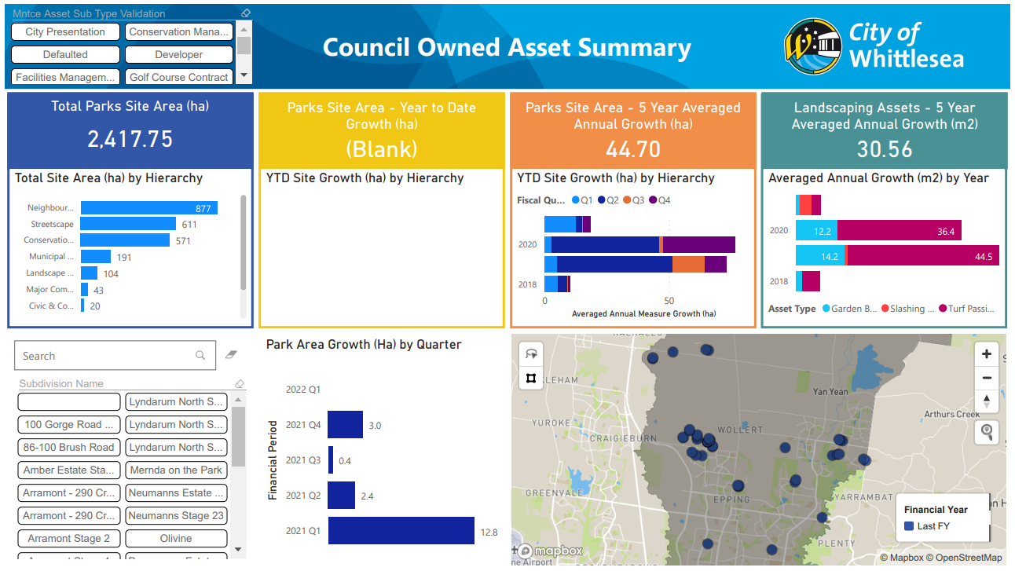

Figure 10.1 – PowerBI Asset Growth Dashboard

Infrastructure Contributions Projects
Infrastructure Contributions Projects are identified in Precinct Structure Plans (PSP) with a defined scope of works. These projects include a cost estimate determined by the Victorian Planning Agency (VPA) as at the time the PSP is adopted, and Council collects this from the developments as part of their development process.
Council plans for Infrastructure Contributions Projects in the New Works Program alongside prioritised capital works on an as needs basis or, if deemed beneficial to the community, will negotiate the delivery of this infrastructure by developers whilst they are on site constructing their own works.
It is noted that there is a significant liability to Council that has been identified within the Infrastructure Contributions Projects. This is caused by the contribution amounts being determined when the PSPs were adopted and changing design standards and construction costs increase the current day cost of the required works. The extent of this and the risk posed to Council is under review.
Further details are available on Council’s website: https://www.whittlesea.vic.gov.au/building-planning-development/building-and-construction-approvals/development-infrastructure-and-open-space-contributions-to-local-suburbs/

Councils 4-15 Year New Works Program
The 4-15 Year New Works Program covers the next 15 years and is assessed and reviewed in conjunction with the annual budget review process. Available funding is balanced between all asset classes on an as needs basis per year.
The major projects that Council is currently undertaking are listed on Council’s website available at Major Council projects - Whittlesea Council.
The distribution of this funding for Parks and Open Space assets between Expansion, Renewal, Upgrade, and New throughout the first 10 years of the program is as per Figure 10.2.

Figure 10.2 - Capital Expenditure

Transfers and Disposal Plan
Council’s Parks and Open Space assets have been constructed and developed in response to Parks and Open Space needs within the municipality. It is estimated that 50% of the Parks and Open Space assets have been constructed since 2005 due to rapid urban development, and as such have been constructed on an as needs basis for commercial benefit by private developers. The remaining 50% (approx.) is in the established areas and has responded to the needs and demands of the community over time. As such, there are no redundant Parks and Open Space assets identified for decommissioning at this stage.

Lifecycle Costs - Annualised
To ensure effective planning of future capital works and that the additional operational and capital costs generated from vested assets is understood and accounted for, Council undertakes an assessment of the annual cost of managing the current asset portfolio. Operational and Maintenance expenditure is reviewed against the current portfolio to determine a unit rate per unit of each asset. Council’s parks and open space areas are in a variety of conditions, from near-new to approaching need for renewal, so the existing costs give an indicative estimate of the future costs new parks will impose on Council throughout their lifecycle.
Depreciation is used as a proxy assessment for capital renewal requirements. With service lives ranging between 10-80 years, and useful lives being up to 100 years, the assessment period for future renewals can have a significant impact on the lifecycle renewal requirements. Depreciation is applied consistently throughout the life of the asset and gives Council the capacity to calculate future financial ratios for different long term financial plan and capital delivery scenarios.
Table 12.1 shows the current assessment of the transport asset lifecycle costing.

Table 12.1 – Indicative Annual Lifecycle Costings (2021 $)
 | Annual Costs, per ha
Asset | Ops and Mtce | Depreciation Cost | Total Cost
Major Community Parks | 7,320 | 7,565 | 14,885
Municipal Open Space | 10,858 | 5,983 | 16,841
Civic & Commercial Facilities | 8,136 | 8,335 | 16,470
Neighbourhood & Local Open Space | 5,376 | 6,522 | 11,898
Special Purpose Site | 68,333 | 7,682 | 76,015
Landscape Site | 5,762 | 4,693 | 10,455
Streetscape | 7,529 | 2,207 | 9,736
Conservation Area | 1,598 | 1,778 | 3,376

Financial Indicators
Council uses financial indicators to reflect on its past year’s performance of its current asset management practices. This assists with identifying if there are specific areas that need attention or if the current practice is appropriate for the organisation and community.
Asset Sustainability for 2021/22:
$\frac{\$5.45M}{\$7.70M}$ = 71%
The Asset Sustainability ratio is a financial estimate if assets are being replaced at the same rate that they are deteriorating. It is calculated by dividing the renewal expenditure by annual depreciation and is generally targeted around 100%.
Asset Renewal Funding for 2021/22:
$\frac{\$5.45M}{\$19.28M}$ = 28%
The Asset Renewal Funding ratio is a measure of how effectively Council is currently funding renewals by comparing the available renewal funding against the currently identified deliverable bank of works within the Asset Management Plan. It is calculated by dividing the Net Present Value of the funded renewal works by the Net Present Value of the desired capital renewal works.
Remaining Service Potential for 2021/22:
$\frac{\$201.6M}{\$308.8M}$ = 65%
The Remaining Service Potential is a financial estimate of the overall aged condition of a local government’s assets. It gives an approximate percentage remaining life of the network and is calculated by dividing the Written Down Value by the Current Replacement Cost.
Average Annual Asset Consumption for 2021/22:
$\frac{\$7.70M}{\$308.8M}$ = 2.49%
The Average Annual Asset Consumption assesses the rate at which assets are being consumed and are losing their service potential. It is calculated by dividing the annual depreciation by the depreciable replacement cost.

Risk Management
Council is committed to providing and maintaining a healthy and safe environment for the internal and external community. Council has determined a Hazard Identification, Risk Assessment and Control (HIRAC) Procedure to outline how to assess and mitigate risks. In this plan’s context, the risks relate to business planning, management, service delivery and physical asset failure; that is, the risks in the Parks and Open Space assets achieving the desired strategic objectives discussed in Section 3 and levels of services discussed in Table 5.1. The key strategic risks are outlined in Table 14.1.

Table 14.1 – Critical Strategic Risks
Risk | Consequence | Severity | Control Measures | Residual Severity
Failure to meet Levels of Service | Resident unrest and frustration, reputational damage, economic loss within municipality, health and safety risk. | Medium | Ongoing monitoring of delivery of service levels and community expectation, prioritisation of actions to meet levels of service. | Low
Insufficient funding allocated to asset renewals | Service levels decline, unprotected assets degrade faster than anticipated, user safety declines, resident unrest. | High | Review conditions and funding annually, monitor network performance, investigate Special Rate Variation.  Increase emphasis on renewal works and prompt response to hazards within the asset stock. | Low
Vested asset quality doesn’t meet Council standards. | Increased cost liability, user safety declines, reputational damage. | High | Suitably resource vested asset supervision, determine minimum designs. | Low
Construction costs of Development Contributions Plan projects exceed collected funds. | Construction of development required infrastructure at Council’s cost, limited ability to fund other required works. | High | Identify projects, update project costs, manage construction timings, limit out of sequence development. | Medium
Insufficient places and spaces for community to participate in activities | Resident unrest, failure to meet community service levels. | Medium | Advocate for Parks and Open Space options, proactively provide capital upgrades for Parks and Open Space assets. | Low

In assessing the key strategic objective risks, critical assets or asset components are able to be identified. Critical assets are defined as those which have a high consequence of failure, be it in service delivery directly or through the economic impact of premature asset failure.

Table 14.2 – Critical Assets
Critical Asset or Component | Consequence of Failure | Control Measures
Boardwalk, Viewing Platform, Pedestrian Bridge | Structural defects resulting in injury or fatality. | Closer monitoring of the asset condition to optimise the renewal timing.  Inspected by suitably qualified professional every 2 years.
Shelter, shade, and pergola | Structural defects resulting in injury or fatality. | Closer monitoring of the asset condition to optimise the renewal timing.  Inspected by suitably qualified professional every 2 years.
Sports Lighting (ground structural component, pole structure, cross arms, and lighting attachments.) | Structural defects or noncompliance with laws, standards, and codes, resulting in injury or fatality. | Perform safety audit every five years after installation, as required from Sports Lighting Policy (2013).
Play Equipment (Playground) | Structural defects or noncompliance with laws, standards, and codes, resulting in injury or fatality. | Inspected by qualified inspector every 6 months.

Improvement Plan
The City of Whittlesea recognises that there is opportunity to improve the asset management processes to ensure that the services provided by Council matches the services desired by the community in the most effective means. Council has adopted an iterative, continual improvement approach to its asset management processes in order to achieve this.
General improvement actions have been outlined in the Asset Management Strategy. Further to these, Parks and Open Space asset specific improvement actions are listed in Table 15.1.

Table 15.1 – Parks and Open Space Asset Management Improvement Plan
Opportunity/Action | Responsibility | Timeframe | Progress (%)
Review the Asset Management Plan in conjunction with service delivery activities and customer service requests to ensure relevance and accuracy. | Assets Team | Ongoing | -
Review and update Modelling upon receipt of updated condition assessment data and delivered renewal works. | Assets Team | Ongoing | -
Review planning and future subdivision information to estimate future transport asset acquisitions rather than using the historic rate of acquisition to forecast future funding requirements. | Assets Team  Planning Team | June 2023 | 0%
Incorporate the Sports Infrastructure Plan (SIP) in future modelling projections and identification of works. | Assets Team | June 2023 | 0%
Continue review of assets, specifically the size of garden beds and passive turf areas to manageable sizes. | Assets Team  Service Provider  Maintenance Contractor | June 2023 | 15%

City of Whittlesea
Civic Centre: 25 Ferres Boulevard, South Morang
Office Hours: Monday to Friday, 8.30am to 5pm
Mail: Locked Bag 1, Bundoora MDC 3083
Telephone: 9217 2170 (24 hours)

TTY: 9217 2420 Fax: 9217 2111 Email: info@whittlesea.vic.gov.au
Web: www.whittlesea.vic.gov.au

Appendix A: Parks and Open Space Assets 15 Year Financial Plan (2021 $,000)
Year | 2022/23 | 2023/24 | 2024/25 | 2025/26 | 2026/27 | 2027/28 | 2028/29 | 2029/30 | 2030/31 | 2031/32 | 2032/33 | 2033/34 | 2034/35 | 2035/36 | 2036/37 | 15 Year Average
Operations Budget¹
Parks Inspections | 186 | 189 | 193 | 197 | 200 | 204 | 208 | 211 | 215 | 219 | 223 | 228 | 232 | 236 | 240 | 212
Water Utility | 819 | 834 | 850 | 865 | 881 | 898 | 914 | 931 | 948 | 966 | 984 | 1002 | 1021 | 1039 | 1059 | 934
Power Utility | 138 | 141 | 143 | 146 | 148 | 151 | 154 | 157 | 160 | 163 | 166 | 169 | 172 | 175 | 178 | 157
Conservation Management | 853 | 869 | 885 | 901 | 918 | 935 | 952 | 970 | 988 | 1006 | 1025 | 1044 | 1063 | 1083 | 1103 | 973
Tree Management | 2,996 | 3051 | 3108 | 3165 | 3224 | 3284 | 3344 | 3406 | 3469 | 3533 | 3599 | 3665 | 3733 | 3802 | 3873 | 3,417
Total | 4,992 | 5,084 | 5,178 | 5,274 | 5,372 | 5,471 | 5,572 | 5,675 | 5,780 | 5,887 | 5,996 | 6,107 | 6,220 | 6,335 | 6,453 | 5,693
Maintenance Budget¹
Major Community Parks | 295 | 300 | 306 | 312 | 317 | 323 | 329 | 335 | 342 | 348 | 354 | 361 | 368 | 374 | 381 | 336
Municipal Open Space | 2,531 | 2,578 | 2,626 | 2,674 | 2,724 | 2,774 | 2,825 | 2,878 | 2,931 | 2,985 | 3,040 | 3,096 | 3,154 | 3,212 | 3,271 | 2,887
Civic & Commercial Facilities | 96 | 98 | 100 | 101 | 103 | 105 | 107 | 109 | 111 | 113 | 115 | 117 | 120 | 122 | 124 | 109
Neighbourhood & Local Open Space | 4,127 | 4,203 | 4,281 | 4,360 | 4,441 | 4,523 | 4,607 | 4,692 | 4,779 | 4,867 | 4,957 | 5,049 | 5,142 | 5,238 | 5,334 | 4,707
Special Purpose Site | 41 | 42 | 43 | 43 | 44 | 45 | 46 | 47 | 47 | 48 | 49 | 50 | 51 | 52 | 53 | 47
Landscape Site | 416 | 424 | 432 | 440 | 448 | 456 | 464 | 473 | 482 | 491 | 500 | 509 | 518 | 528 | 538 | 474
Streetscape | 1,578 | 1,607 | 1,637 | 1,667 | 1,698 | 1,729 | 1,761 | 1,794 | 1,827 | 1,861 | 1,895 | 1,931 | 1,966 | 2,003 | 2,040 | 1,800
Conservation Area | 89 | 91 | 92 | 94 | 96 | 98 | 99 | 101 | 103 | 105 | 107 | 109 | 111 | 113 | 115 | 102
Total | 9,173 | 9,343 | 9,516 | 9,692 | 9,871 | 10,053 | 10,239 | 10,429 | 10,622 | 10,818 | 11,018 | 11,222 | 11,430 | 11,641 | 11,857 | 10,462
Renewal and Upgrade Budget²
New Works Program – Renewal | 5,446 | 11,046 | 10,221 | 9,083 | 10,705 | 13,222 | 11,378 | 9,813 | 3,373 | 3,113 | 8,740 | 9,069 | 8,872 | 8,737 | 8,702 | 8,768
New Works Program – Upgrade | 4,130 | 4,577 | 4,362 | 2,702 | 2,502 | 602 | 4,322 | 2,942 | 2,552 | 852 | 2,954 | 2,837 | 2,663 | 2,493 | 2,472 | 2,864
Total | 9,575 | 15,623 | 14,583 | 11,785 | 13,207 | 13,824 | 15,700 | 12,755 | 5,925 | 3,965 | 11,694 | 11,906 | 11,534 | 11,230 | 11,174 | 11,632
New Assets Budget²
New Works Program – New and Expansion | 5,135 | 7,973 | 8,848 | 17,395 | 15,884 | 16,888 | 20,976 | 24,551 | 27,392 | 18,087 | 16,313 | 17,431 | 18,377 | 19,330 | 19,523 | 16,940
Total | 5,135 | 7,973 | 8,848 | 17,395 | 15,884 | 16,888 | 20,976 | 24,551 | 27,392 | 18,087 | 16,313 | 17,431 | 18,377 | 19,330 | 19,523 | 16,940
Grand Total Expenditure | 28,875 | 38,022 | 38,124 | 44,146 | 44,334 | 46,237 | 52,488 | 53,411 | 49,719 | 38,758 | 45,022 | 46,666 | 47,561 | 48,536 | 49,006 | 44,727
Rolling Backlog | 19,277 | 7,989 | 4,255 | 6,685 | 15,647 | 7,902 | 7,128 | 33,862 | 50,571 | 71,141 | 86,095 | 87,919 | 89,333 | 83,034 | 83,484
Note:
^{1.} Operations and Maintenance budgets include the anticipated additional costs for the new building assets in Section 10 as per the lifecycle costs in Section 12.
^{2.} Categorisation of works in the New Works Program between Renewal, Upgrade, Expansion, and New is not currently available for 32/33 to 36/37. These years use an average of the preceding 10-year period to ensure that renewal and backlog projections are visible outside of the 10-year Long Term Financial Planning Period.

International Infrastructure Management Manual, IPWEA, 2020.
Guidelines for Developing an Asset Management Policy, Strategy and Plan, Department for Victorian Communities, 2004.

