Cat Consultation
Engagement Summary Report

July 2022

Executive Summary

Overview
From February to May 2022, the City of Whittlesea (Council) engaged Conversation Co to design and support the delivery of a community engagement program to understand community perspectives on the proposed cat confinement and mandatory desexing rules.

Council is considering cat confinement and mandatory cat desexing due to feedback provided during the recent Domestic Animal Management Plan consultation in 2021, which called for stronger cat management. Council will use this information to develop a cat management strategy to enhance the welfare and safety of cats, respond to reports about nuisance cats, reduce environmental impacts of cats and attacks on wildlife.

This report summarises the engagement activities and outcomes from the cat management consultation. It will provide Council with an understanding of community sentiment towards introducing a cat curfew, mandatory desexing of newly registered cats and the support required by the community, should these rules be introduced.

Methodology
Engagement activities consisted of an online survey hosted on Council's engagement portal, 10 place-based community pop-ups, 10 key stakeholder interviews and an online information session.

Key Findings
A total of 1833 people who live, work or visit the City of Whittlesea participated in the engagement consultation, participating in various engagement activities. The engagement plan sought to gather informed community feedback and found majority support for Council’s proposed actions.

Community support for a cat curfew
A total of 80.3% of participants supported some form of curfew, including 44.9% in favour of a 24 hour curfew and 35.6% in favour of a dusk to dawn curfew. Those opposed to a curfew made up 16.6%. Figure 1 demonstrates this level of support.

Figure 1: Level of community support to the proposed cat curfew
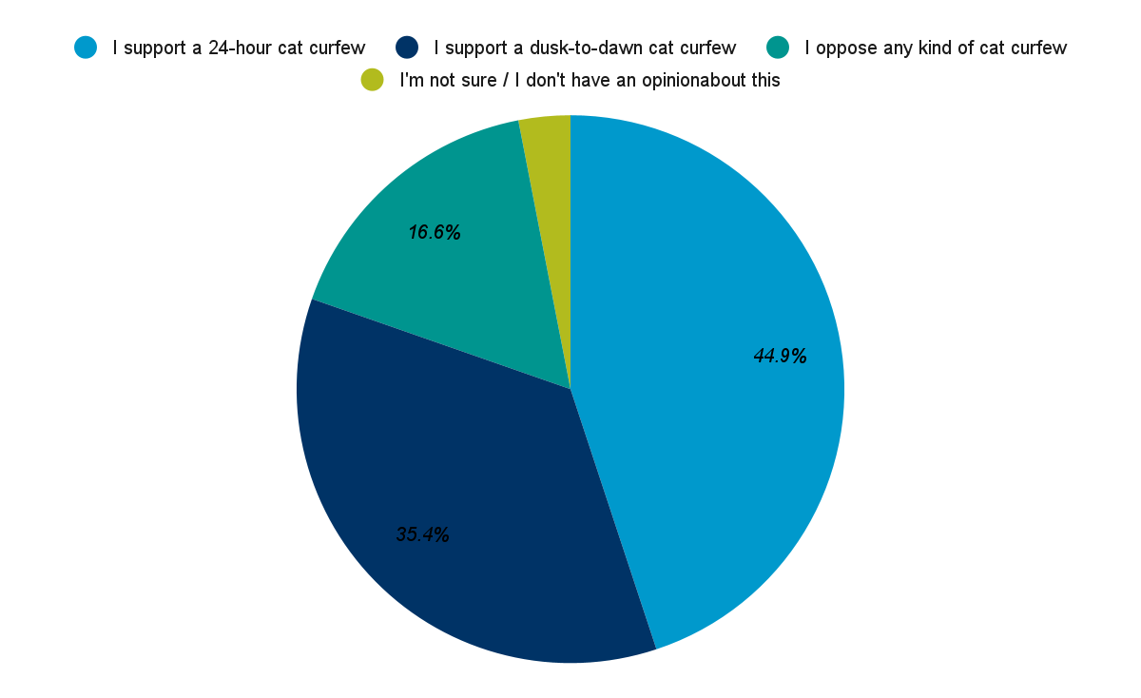

Community support for mandatory desexing of newly registered cats
There was strong community support for mandatory desexing of cats with 64.1% supporting and 18.5% supporting if the cost is subsidised. Those opposed to mandatory desexing made up 10.6%. Figure 2 demonstrates this level of support.

Figure 2: Level of community support to desexing newly registered cats

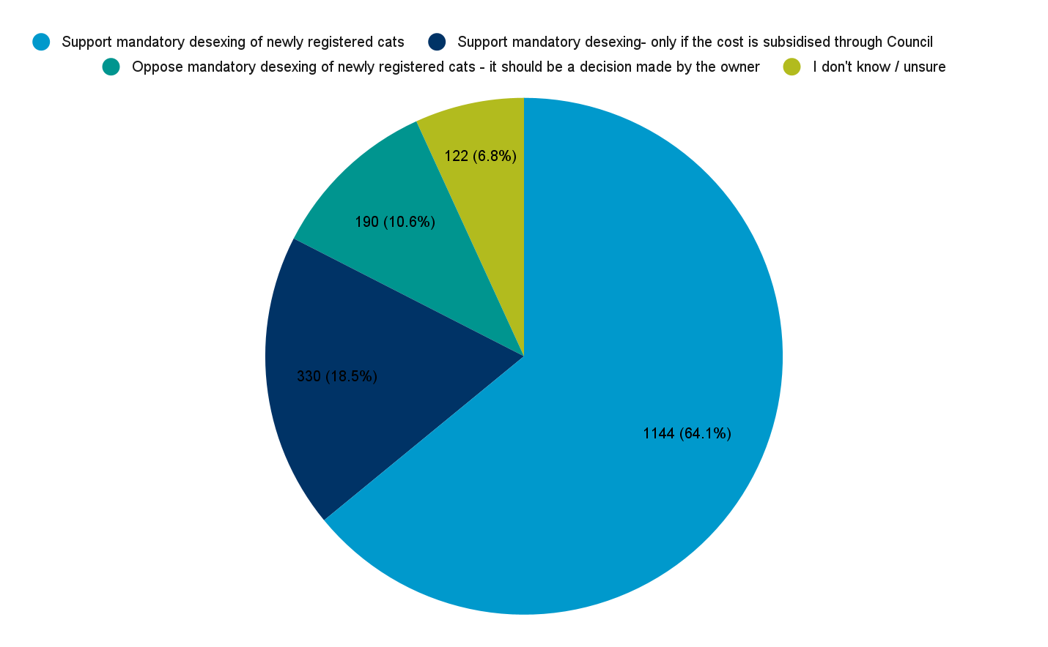

Support needed by the community to transition to new cat management rules
Participants felt they needed support to understand the changes required and practical advice on preparing their home to transition their unconfined cat to a confined lifestyle, along with material resources and financial support and time to adjust.

Participants identified a need for clear and accessible communication that reaches all cat owners including those who do not use social media or who do not speak English at home.

Industry Stakeholder Findings
Stakeholders focussed on the need for long-term, community-wide solutions. Stakeholders highlighted the need for measures that educate and support the community to be responsible pet owners and transform the perception of cats as a low-maintenance pet. Participants expressed that these benefits would come from long-term community compliance, not enforcement. Stakeholders stressed the importance of maintaining a positive relationship between Council and residents and supporting cat owners to make change. Stakeholders saw the benefits of cat confinement as reducing the cat population to a manageable level, however did not see the proposed rules as addressing the impact of cats on wildlife and natural areas.

Key recommendations
Transition to a 24 hour cat curfew
The findings of this report support the introduction of 24 hour curfew in the City of Whittlesea in line with consultation with the community and key stakeholders. The transition to a 24 hour cat curfew will require considerations and support from Council as well as time for cat owners to prepare for the change.

Transition to mandatory desexing
The findings of this report support the introduction of mandatory cat desexing for new cat registrations in the City of Whittlesea. We recommend supporting households by subsidising desexing for low-income households.

Table of Contents
Introduction 7
Project Context 7
Engagement Purpose 9
Methodology 10
Mixed method approach 10
Timeframe 13
Strategies to support participation 13
Who Participated? 14
Demographic Identifiers 16
Cat and dog ownership 16
Local government area lived in 17
Home postcode 18
Age 19
Connections with animal businesses or organisations 19
Household type 20
Data Analysis 21
Sentiment observed by facilitators 21
Community response to Cat Confinement 21
Support for cat confinement in Whittlesea 23
Unsure sentiment about Cat Curfews in Whittlesea 31
Opposition for Cat Curfew in Whittlesea 33
Support and resources required 39
Community response to mandatory desexing of newly registered cats 42
Support for mandatory desexing of newly registered cats 43
Opposition to mandatory desexing 48
Key Stakeholder Interviews 51
Recommendations 56
Introducing a cat curfew 56
Introducing mandatory desexing 59
Policy recommendations 60
Closing the loop 60
Appendix 61
Appendix 1 61

Introduction
Conversation Co was engaged by the City of Whittlesea (Council) to design and support the delivery of a community engagement program about proposed cat confinement and mandatory desexing rules. Participants were provided with information about the limitations of curfews, and the role community members play to elicit more informed responses.

Project Context
Late last year, Council adopted a new Domestic Animal Management Plan 2021-25, that outlines how Council will manage cats and dogs in the local community. The plan was informed by more than 3,000 pieces of feedback and balances community and environmental needs. During this consultation period a significant amount of feedback was received asking for more investigation around management of cats.
The Domestic Animals Act 1994 requires that all dogs be confined to their owner’s property unless under effective control (i.e. on a leash) or in a designated off-leash area. However, the Act does not require the same confinement of cats. Research demonstrates a lack of confinement contributes to nuisance complaints, maimed wildlife, injuries from cat fights and traffic incidents, the spread of feline diseases and overpopulation.
It is up to individual councils to decide whether to introduce a Domestic Animals Order requiring cats to be confined to their owner’s property. Councils can also introduce an Order requiring dogs or cats to be desexed before accepting registration.
Council is considering cat confinement and mandatory cat desexing of new registrations due to the following factors:
- Feedback provided at the recent Domestic Animal Management Plan consultation and reports about nuisance cats.
- To enhance the welfare and safety of cats.
- To reduce attacks on wildlife.

The results of this engagement project will assist Council to decide whether to introduce a cat curfew, whether to introduce mandatory desexing of new registrations and how Council can support residents and cat owners.

Figure 3: City of Whittlesea Domestic Animal Management Plan 2021-2025
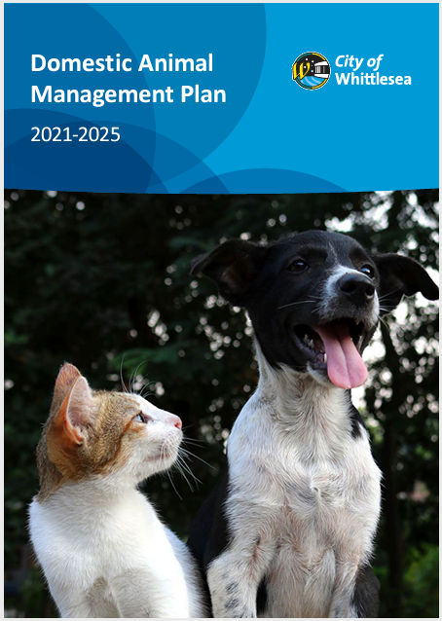

Benchmarking
The City of Whittlesea undertook a benchmarking exercise across 79 Councils in Victoria to understand how many Councils had cat curfews or mandatory cat desexing in place. This benchmarking exercise demonstrated that:
- 10 Councils have a 24 hour cat curfew
- 27 Councils have a sunset to sunrise cat curfew
- 17 Councils are considering introducing a cat curfew
- 25 Councils do not have plans to introduce a curfew
- 24 Councils have mandatory cat desexing.

Engagement Purpose
The purpose of this engagement was to:
- Determine if there is informed support for the introduction of a cat curfew.
- Understand why people are or are not supportive of introducing a cat curfew and mandatory cat desexing.
- Understand community preferences for either a dusk to dawn or 24-hour curfew.
- Determine the level of support for mandatory cat desexing for new registrations.
- Understand what resources and support residents would need to transition to a cat curfew if introduced.

Communication
In this project communication was used to:
- Promote the project to encourage participation in all engagement activities.
- Provide evidence-based information about the impact of curfews and desexing on cats and surrounding ecosystems.
- Inform people regarding the practicalities of introducing a cat curfew i.e. capturing roaming cats in cat cages.
- Provide education about the management of ‘semi-owned’ cats.
- Manage expectations of the limitations of a cat curfew.

Methodology
This section outlines the methodology used to conduct the engagement for this project. Conversation Co employed a range of different methods to gather both quantitative and qualitative data from a representative cross-section of the Whittlesea community.

Mixed method approach
This project used a variety of engagement methods to reach a greater number of participants, method used:
- Community pop-ups (intercept surveys held at public events across Whittlesea).
- An online survey hosted on Engage Whittlesea.
- Q&A online session.
- Telephone Interviews with industry stakeholders.

Community pop-ups
In partnership, Conversation Co and Council's Animal Management Officers facilitated 10 place-based community pop-ups held across Whittlesea at different locations and times. The following locations were chosen because of their community appeal:
- South Morang Farmers Market, South Morang.
- March Council Meeting, Whittlesea Township.
- Whittlesea Community Festival, South Morang.
- Westfield Plenty Valley, Mill Park.
- Pacific Epping Shopping Centre, Epping.
- *Laurimar Town Centre, Doreen
- *Bundoora Square, Bundoora.
- *May Road, Lalor.
- *Mill Park Stables, Mill Park.
- *Aurora Village, Epping North.
* Delivered by City of Whittlesea

Participants were asked to respond to five questions, and conversation facilitators scribed their responses into an online version of the survey:
- What is your response to the proposal of a cat curfew in your local area?
- Why do you support or oppose a cat curfew?
- If a cat curfew is introduced by Council in the future, what should they do to support residents?
- What is your response to the idea of mandatory desexing of newly registered cats?
- Why do you support or oppose mandatory desexing of newly registered cats?
Survey and online respondents were asked to provide demographic information including: age, postcode and household structure, affiliation with special interest groups as well as if they owned or regularly fed cat/s or dog/s.

Figure 4: Images of community pop-ups and materials
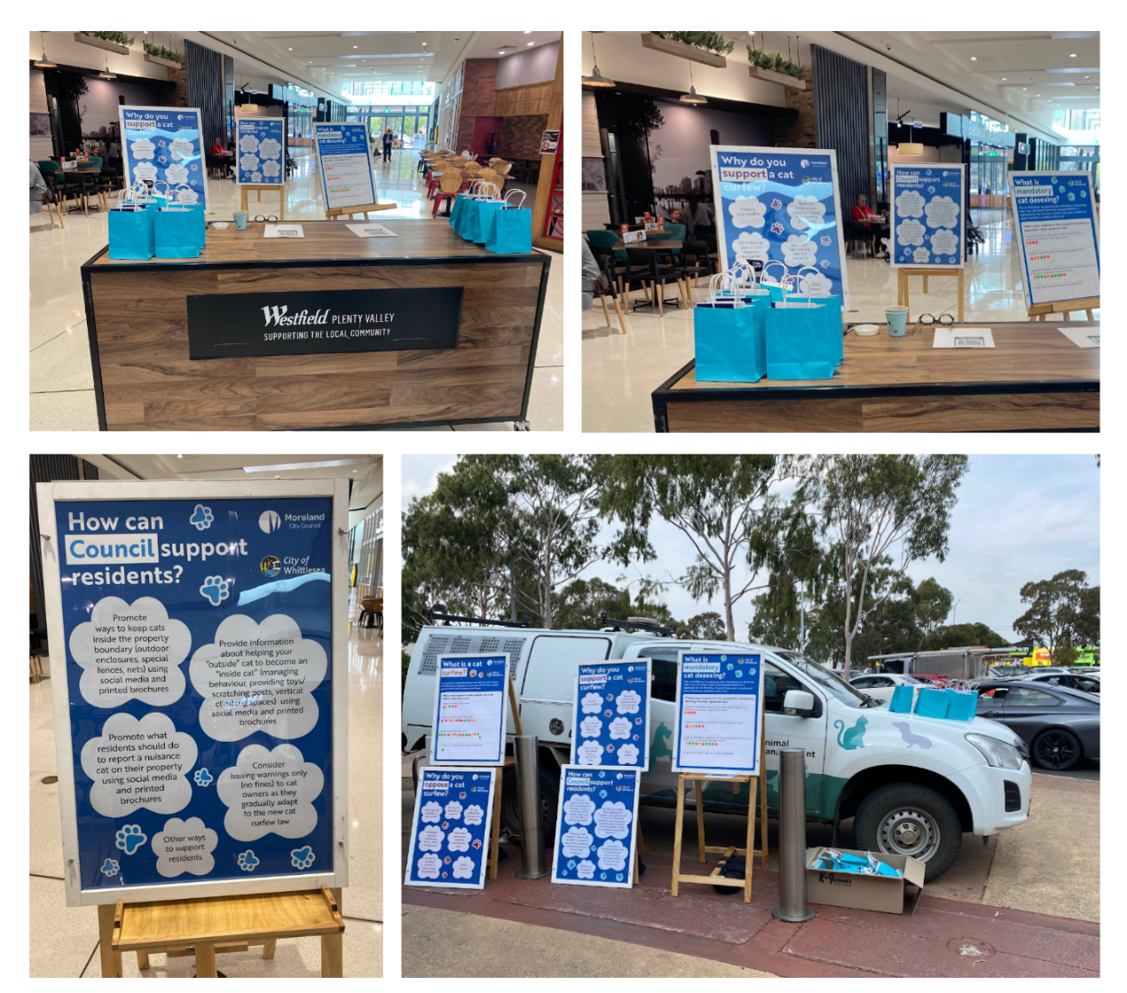

Online Survey
A survey was provided online and promoted via the project page. The survey was open from 10 March to 2 May 2022. The survey focused on the key engagement questions outlined above.

Online Q&A session
Council’s Animal Management team hosted an online information session on Thursday 28 April 2022 to discuss the proposed cat confinement and mandatory desexing of newly registered cats and answered questions submitted by community members.

Key Stakeholder Interviews
Interviews were used to gain a deeper understanding of issues and consider the benefits and limitations of different options. The interviews undertaken will also help inform Moreland City Council’s upcoming cat consultation, hence some Moreland-based stakeholders were interviewed. Interviews were focused on the stakeholder's area of expertise to better understand how cat management impacts their work and to understand the opportunities, limitations and challenges associated with the proposed changes.

Interviews were guided by the following questions:
- In your experience, what are the main concerns with the management of cats?
- What do you see as the benefits of the introduction of a cat curfew?
- Do you think a dusk until dawn curfew or a 24 hour curfew is the most effective? Why?
- What services and support could Council provide for the community if a cat curfew was introduced?
- What services and support could Council provide for the community if mandatory cat desexing was introduced for new registrations?
- What education could be provided to the community regarding the benefits of cat curfews?
- What education could be provided to the community regarding the benefits of cat desexing?
- In your experience, what do you see as the main barriers to community members desexing their cats?
- How can the Council support the community to take responsibility for ‘semi-owned’ cats beyond feeding them?
- Understanding that a cat curfew won’t address the community’s concerns with stray cats, how can the Council address this issue?
- Are there any partnership opportunities to support the introduction of mandatory cat desexing for new registrations?
- Are there any partnership opportunities to support the introduction of a cat curfew if it is introduced?

Phone interviews were conducted with the following key stakeholders:
- Cat Protection Society
- Merri Creek Management Committee
- Maneki Neko Cat Rescue
- Wildlife Victoria
- Brunswick Communities for Nature
- Bundoora/Mill Park Vets
- RSPCA
- Westside Community Desexing
- Second Chance Animal Rescue
- Darebin Creek Management Committee.

Timeframe
10 March to 2 May 2022

Strategies to support participation
Community participation was supported through the following initiatives:
- Communications Campaign: This included promotion on Council’s corporate channels (image right), and social media, an email to all residents on the pet registration database, as well as signage in customer service centres, and community events.
- Engagement Portal: A project page was created and hosted on the Council’s community engagement portal, Engage Whittlesea. Engagement portals provide a consistent location for the community to access information about the project and upcoming pop-ups, and to participate via the online survey. The page content can also be translated to 109 languages.
- Leveraging Council’s Connections: Council Officer connections and
existing networks were used to increase uptake and participation in the
project. Council Officers attended community pop-ups to increase
presence and support of the project.
- Incentivisation: Incentives were used at the pop-ups in the form of a showbag for participants completing the pop-up questions. Showbags contained information about cat ownership and a cat toy.
- Going to where people enjoy gathering: Pop ups were held at locations
across Whittlesea that typically attract foot traffic and a cross-section of the community.

Who Participated?
The engagement program attracted participation from 1833 respondents. This included 1459 online surveys, 344 participants at pop-up events, 20 participants at a Q&A session and 10 stakeholder interviews: including four nature conservation groups, four cat rescue groups and two cat desexing providers. Figure 5 and Table 1 show this breakdown across engagement activity.

Figure 5: Participation across engagement methods
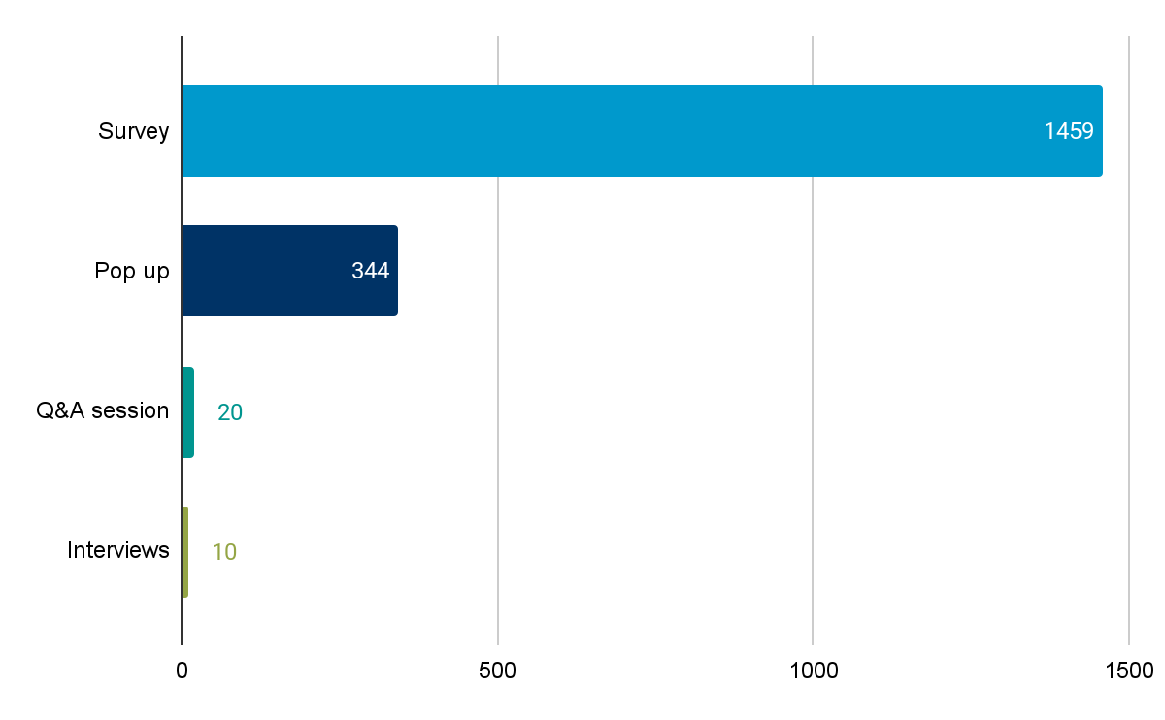

Table 1: Participation across all methods
Location or method | No. engaged | Level of participation
Online survey | 1459 | 2,662 visitors to the page, with 168 followers of the project.
Stakeholder interviews | 10 | Interviews lasted around 30 minutes each and were completed by phone or video conference (zoom)
South Morang Farmers Market pop-up March 19 | 124 | 4 hours of facilitated conversation time
Before Council Meeting March 21 | 13 | 2 hours of facilitated conversation time
Whittlesea Community Festival pop-up March 26 | 72 | 6 hours of facilitated conversation time (2hrs by CC)
Westfield Plenty Valley pop-up April 6 | 65 | 2 hours of facilitated conversation time
Epping Pacific Shopping Centre pop-up April 6 | 49 | 2 hours of facilitated conversation time
Laurimar Town Centre pop-up April 8 | 2 | 2 hours of facilitated conversation time
Bundoora Square pop-up April 19 | 1 | 2 hours of facilitated conversation time
May Road, Lalor pop-up April 21 | 6 | 2 hours of facilitated conversation time
Mill Park Stables pop up April 26 | 8 | 2 hours of facilitated conversation time
Aurora Village, Epping North pop-up April 28 | 4 | 2 hours of facilitated conversation time
Online Community Information Session April 28 | 49 registrations, 20 attended, responded to 70 questions | 1 hour online with facilitated questions, run by the Animal Management Team

Figure 6: Engage Whittlesea cat management page
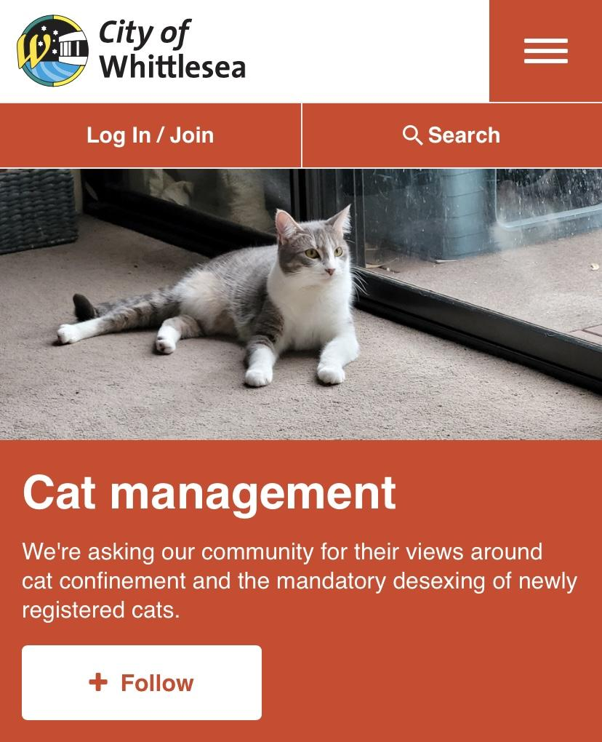

Demographic Identifiers
Participants at community pop-ups and of the online survey were asked a series of demographic questions:
- if they own or regularly mind cats or dogs
- what Council area they live in
- home postcode
- age group
- connections with animal businesses or organisations
- household structure.
Interviewees and Q&A session attendees were not asked for demographic information.

Cat and dog ownership
A total of 928 participants owned or regularly minded a cat, with 857 reporting they did not. A larger total of 1009 participants reported owning or regularly minding a dog, with 777 reporting they did not. Figure 7 shows this breakdown.

Figure 7: Number of households who own or regularly mind cat(s) or dog(s).
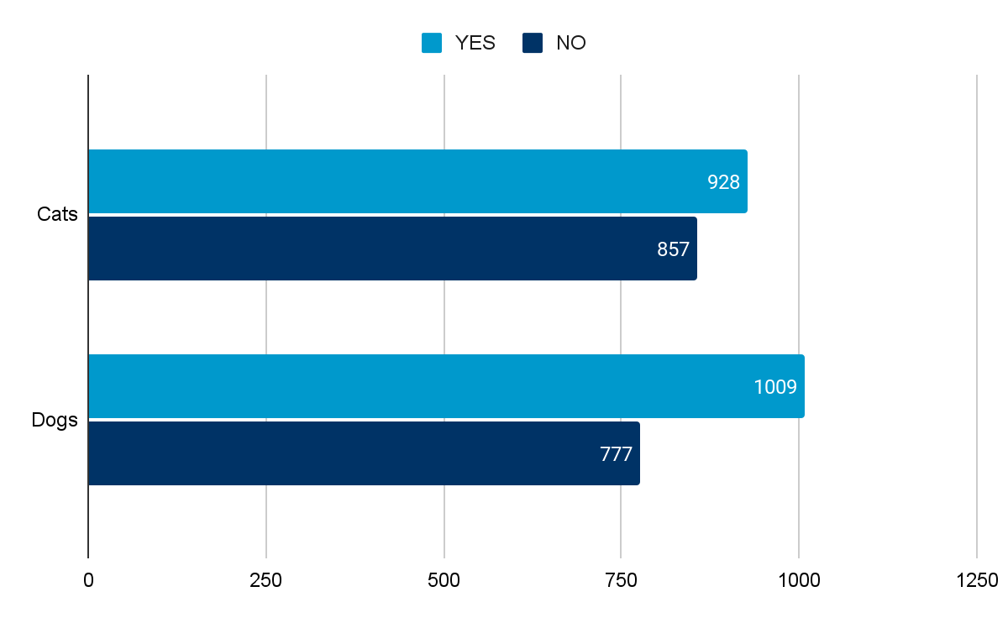

Local government area lived in
Majority of participants (92%) lived in Whittlesea, with (8%) residing in other local government areas, most commonly: Hume, Darebin, Nillumbik and Banyule. Figure 8 shows this breakdown.

Figure 8: Participants by local government area
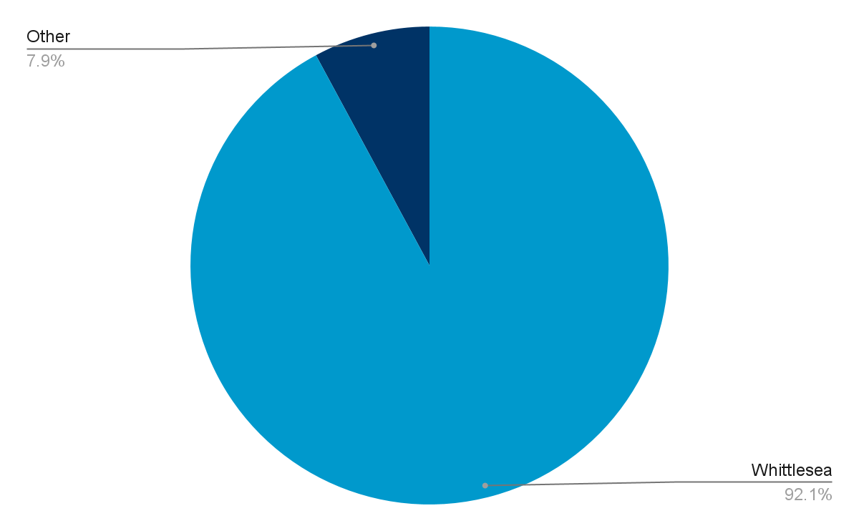

Home postcode
Residents of Doreen and Mernda had the highest rate of engagement with 572 participants, followed by South Morang with 231 participants. In the suburban centres of Mill Park and Epping there were 224 and 200 participants, respectively. There were 119 participants from the rural northern area of Whittlesea, Kinglake and Eden Park, followed by evenly spread participation rates across Lalor, Thomastown, Wollert and Bundoora. Table 2 shows this breakdown.

Table 2: Participant's postcodes
 | Postcode | Number of participants
Doreen; Mernda | 3754 | 572
South Morang | 3752 | 231
Mill Park | 3082 | 224
Epping | 3076 | 200
Eden Park, Humevale, Kinglake West, Pheasant Creek, Whittlesea | 3757 | 119
Lalor | 3075 | 83
Thomastown; Wollert | 3074, 3750 | 73
Bundoora | 3083 | 66
Craigieburn; Donnybrook; Kalkallo; Mickleham; Roxburgh Park | 3064 | 20
Beveridge | 3753 | 6
Reservoir | 3073 | 5
Briar Hill, Greensborough; St Helena | 3088 | 4
Woodstock; Wattle Glen | 3751, 3096 | 3
Other | 3058, 3059, 3071,3012, 3057, 3095, 3106, 3523, 3658, 3759, 3761, 4064, 3570 | 3
Prefer not to say |  | 23

Age
Most online survey and pop-up participants provided their age, with a small number of participants preferring not to answer. This representation can be seen in Figure 9. The 45-59 years age group in this engagement had the highest rate of participation with 538 participants (31%), followed by the 35-44 age group with 489 participants (28%). Participants aged between 15-19 years had the lowest representation with 14 participants (1%). A small number of children under 15 years participated and their ages were not recorded due to the limitations of the survey.

Figure 9: Number of participants in each age group
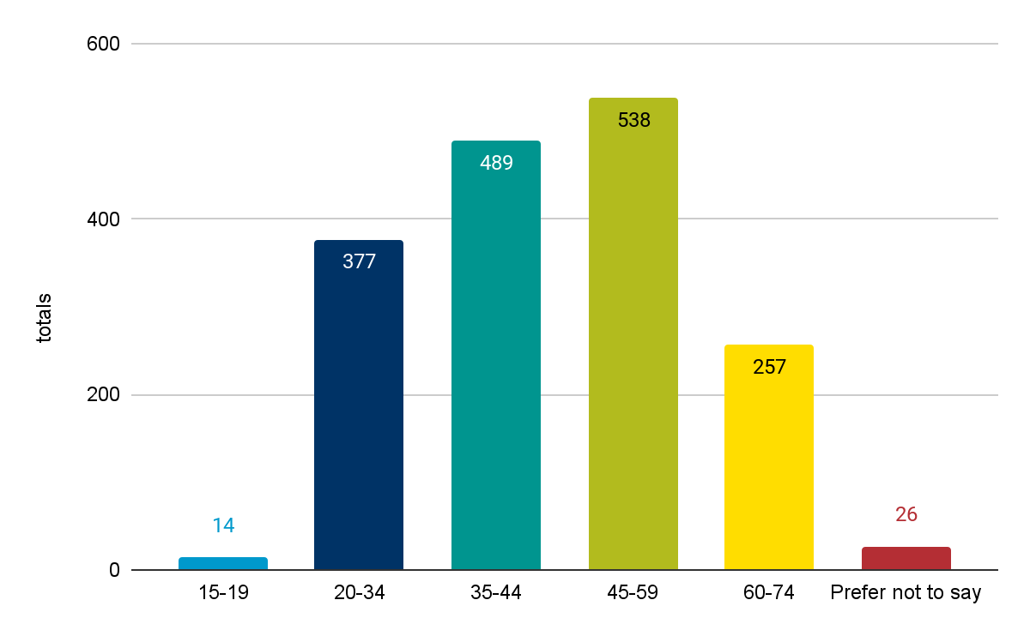

Connections with animal businesses or organisations
Figure 10 shows the number of participants with a connection to a special interest group. The most common affiliation was member of a wildlife/environmental group (96 participants), followed by member of an animal advocacy/rescue group (91 participants) and registered dog or cat breeder (52 participants).

Figure 10: Participants connections to animal businesses or organisations
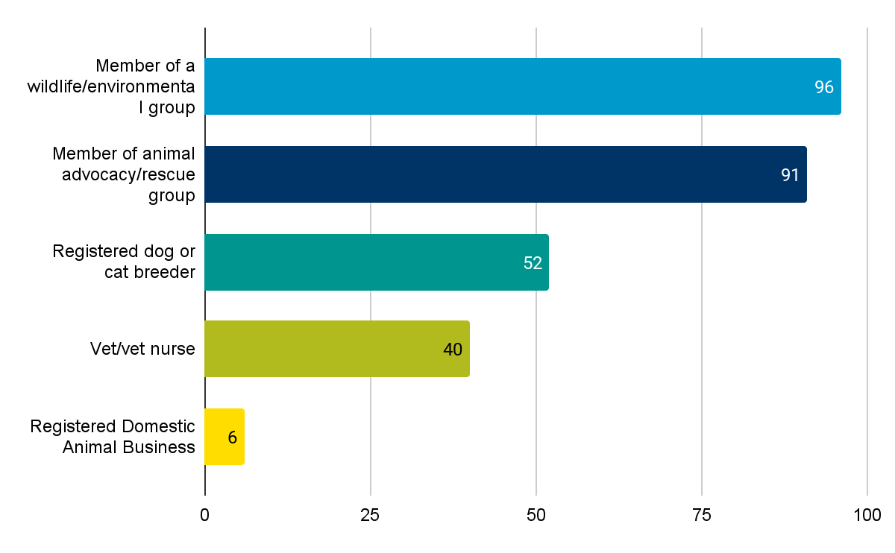

Household type
Figure 11 shows the number of participants per household type. Couple or sole parent family with children aged 0-17 years was the most common household type with 624 (36%), followed by a couple only household with 473 (27%) and Couple or sole parent family with adult children living at home with 273 (15%).

Figure 11: Participants’ household types
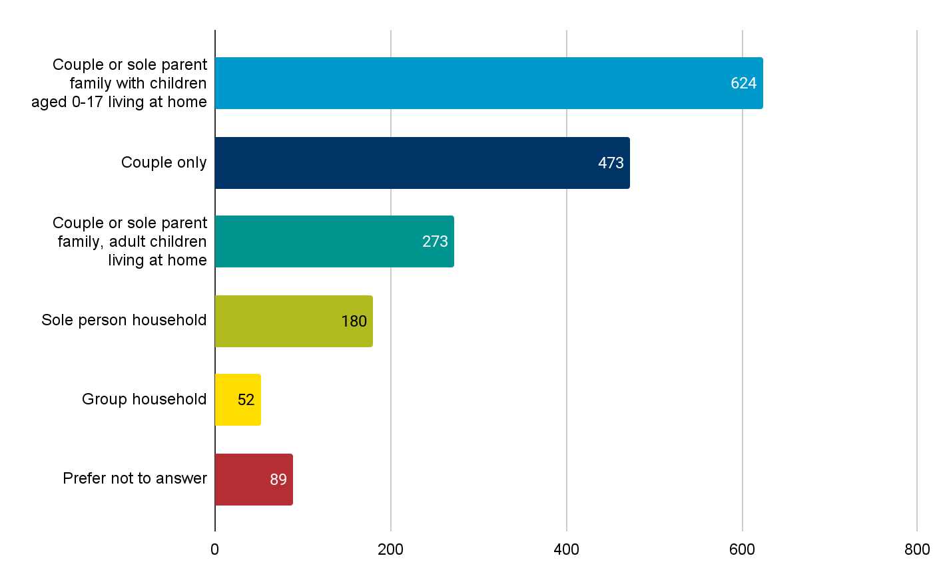

Data Analysis
Data from the pop ups and survey were analysed together. Open ended feedback was analysed using a coding process to identify key themes. Stakeholder interviews were analysed separately.

Sentiment observed by facilitators
Facilitated pop up engagement and longer stakeholder interviews provide an opportunity to explore the reasons, feelings and dilemmas participants consider when responding. Our facilitators noticed some general trends among participants:
- Wishing to promote “responsible pet ownership” more broadly. Specifically, that the proposed cat management measures should be considered a normal part of responsible pet ownership.
- A desire for alignment between rules for dogs and cats. “If dogs have to be confined, then cats should be too.” This sentiment was challenged by industry stakeholders, who highlighted that dogs and cats have widely differing needs and abilities and require tailored management plans.
- Participants shared experiences of cats negatively impacting other pets in their own backyards, including upsetting or attacking pet dogs and cats.
- A strong concern for the welfare of native wildlife, particularly birdlife. Interestingly, participants at pop-ups who were informed about the limitations of curfews often went on to say protects native wildlife was their primary reason for supporting a curfew.
- Concern that adding more cat management rules would negatively affect relationships between neighbours, could reinforce a punitive perception of Council and could create additional financial burden through the use of infringements.
- That industry stakeholders were not aware of an evidence base or case study that demonstrates cat curfews have been effective at reducing cat populations or improving wildlife outcomes in other areas.

Community response to Cat Confinement
This section will present the community response to proposed cat confinement rules. Participants who attended a pop-up were asked to consider some information about cat curfews before responding. This information included:
- That enforcement of a cat curfew would only occur on private property through the supply of a cat cage for returning captured cats to their owners or taking them to the pound.
- Due to the limited level of enforcement, any introduced cat curfew is unlikely to have a significant short term impact on local wildlife or local stray cat populations.
Participants who completed the online survey were given this information and a more detailed list of Frequently Asked Questions (see Appendix 1). Following this information, participants were asked ‘How do you feel about the proposal for a cat curfew in your local area?’ and were provided with the following options to choose from:
- I support a 24 hour cat curfew
- I support a dusk-to-dawn cat curfew
- I oppose any kind of cat curfew
- I am not sure/ do not have an opinion about this.

There were a total of 1801 responses to this question. Figure 12 shows a 24-hour cat curfew was the most supported option with 809 selections, followed by a dusk-to-dawn curfew with 638 selections. There were 299 people who said they opposed any form of cat curfew and 55 people that were unsure or did not have an opinion.

Based on demographic data collected from online surveys and at community pop ups, we know that of the 929 participants with a connection to cats (owner, minder, feeder):
- 28% supported a 24 hour curfew
- 43% supported a dusk to dawn curfew
- 26% are opposed cat curfews
- 3% are unsure.

Based on demographic data collected from online surveys and at community pop ups, we know that of the 1009 participants with a connection to dogs (owner, minder, feeder):
- 48% supported a 24 hour curfew
- 36% supported a dusk to dawn curfew
- 15% are opposed to cat curfews
- 1% are unsure

Analysing these statistics alongside feedback, we can assume that higher support for a curfew by dog owners is due to night time cat encounters (on roofs, fighting) and the impacts of cats on dogs (dogs barking, neighbour complaints). Lower levels of support for a 24 hour curfew, and higher levels of feeling unsure amongst cat owners, can be traced to concerns about being able to adapt to change or challenging the need for any curfew. The higher levels of comfort with a dusk to dawn curfew shown by cat owners align with the fact that many have already adopted this routine or feel it is more achievable.

Figure 12: Community response to the proposal of a cat curfew
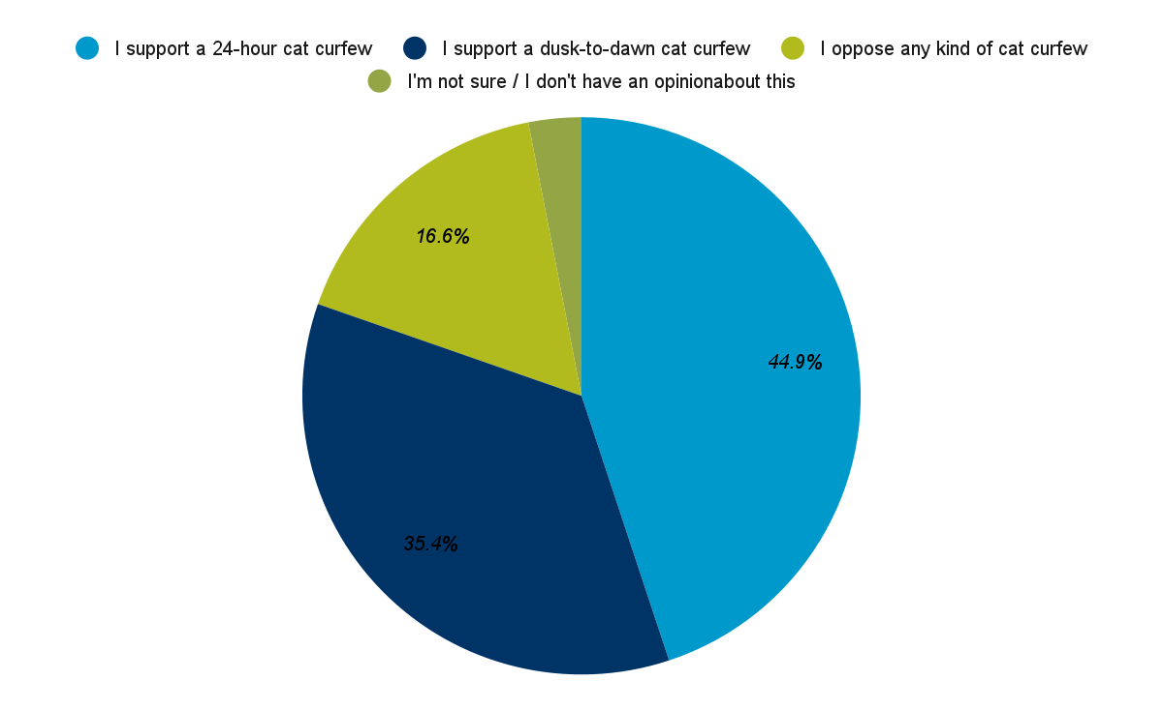

Support for cat confinement in Whittlesea
This section outlines community responses that support cat confinement in Whittlesea. Participants were asked to provide a reason for their response to a proposed cat curfew. When asked why they support a cat curfew, respondents were provided with the following options to select:
- Protects local wildlife.
- Reduces noise in our neighbourhood (cats howling or fighting).
- Don’t like cat faeces or cats digging in our garden.
- Don’t like cats coming onto our property.
- Protects cats from being lost, or injured by cars.
- Other (free text).

Participants were able to choose one or multiple responses including an ‘other’ option to provide an open-ended response. Where possible, open-ended responses were coded to align to the options provided and later added to those categories. There were 1447 respondents that supported some form of cat curfew.

Figure 13 shows the reasons participants gave to support a cat curfew. The most selected option was Protects local wildlife with 1225 selections. This was followed by Protects cats from being lost or injured by cars with 994 selections.

Figure 13: Reasons participants support a cat curfew (from options)
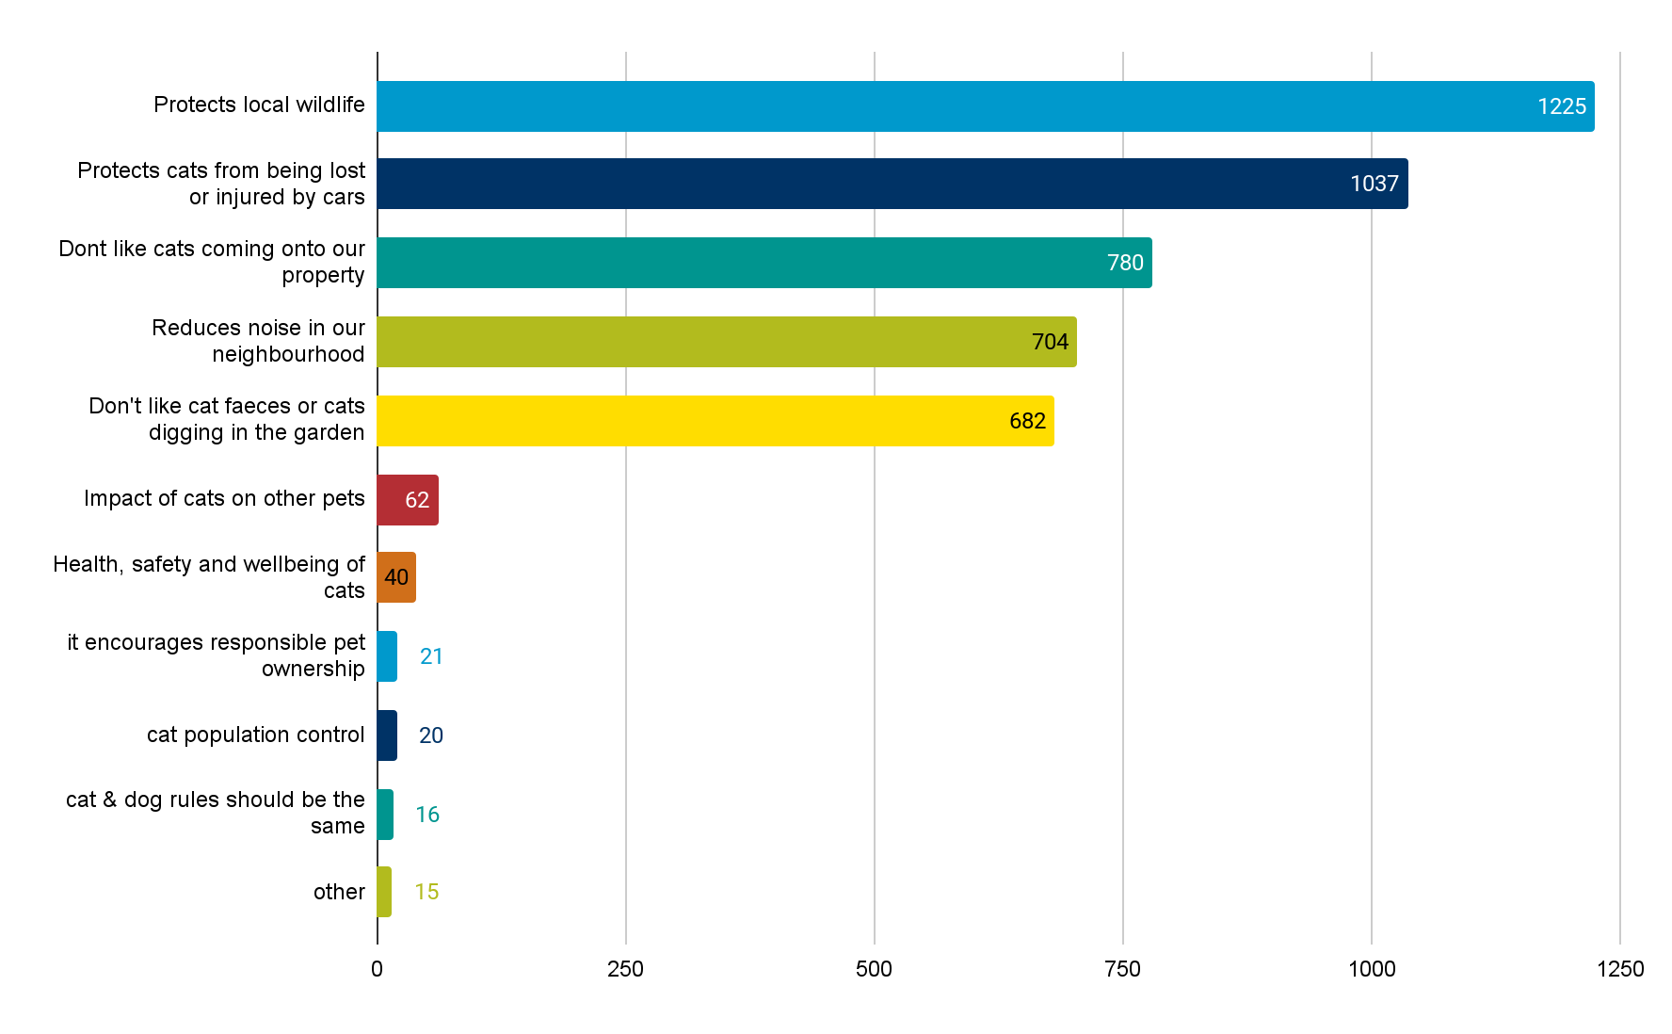

There were a number of other categories that emerged from coding the free text comments provided by participants. Responses were organised into three themes:
- Impacts of cats on human health and wellbeing (9 comments).
- Comparing options (3 comments).
- Relationships with neighbours (2 comments).

Profile of those in support of a cat curfew
Presented in table 3 are demographic profiles of people that participated in the online survey and community pop ups. We can see that the dusk to dawn cat curfew is most supported by cat owners (63%, 400); whereas a 24 hour curfew is more supported by dog owners (59%, 480). Most household types had higher levels of support for a 24 hour cat curfew, with the exception of couple or sole parent households with children under 17, suggesting that this group faces barriers. Support for any curfew (refer to table 3 & 5) was lowest among group households and households with adult children living at home. Though subjective, we could assume from our conversations and higher SEIFA Index (Profile Id, 2022) across parts of the municipality that this could be in part due to:
- time available to care for a cat inside (working multiple jobs)
- disposable income available for investment in cat infrastructure (cat run, securing backyard)
- number of people living in a household and pressure if animals are to be kept inside also.

Not surprisingly, the introduction of a curfew was supported by those with a connection to animal welfare. Support for a 24 hour curfew, over dusk to dawn was at least 33% higher across all animal management categories.

Table 3: Demographics of those in support of a curfew
Demographic identifier | Dusk to Dawn Curfew (638) | 24 Hour Curfew  (809)
Cat ownership status
Owns or regularly minds a cat | 400 | 260
Owns or regularly minds a dog | 360 | 480
Housing type/tenure
Sole person household | 24 | 85
Couple only household | 159 | 239
Couple or sole parent family, children aged  0-17 living at home | 401 | 281
Couple or sole parent family, adult children living at home | 98 | 99
Extended or multiple families | 15 | 17
Group household | 12 | 22
Prefer not to answer | 32 | 42
Location within City of Whittlesea | 611 (12 prefer not to say, 7 outside of CoW) | 785 (10 prefer not to say, 14 outside of CoW)
Age
15-19 years | 7 | 5
20-34 years | 126 | 22
35-44 years | 169 | 246
45-59 years | 203 | 202
60-74 years | 99 | 119
75 years and over | 10 | 15
Prefer not to say | 11 | 14
Connection to animal management
Veterinarian/Vet Nurse | 11 | 15
Member of an animal advocacy/rescue group | 28 | 43
Member of a wildlife/environmental group | 29 | 50
Registered dog or cat breeder | 18 | 25
Registered Domestic Animal Business | 0 | 5

Following is a detailed analysis of findings presented by coded themes.

Protecting Local Wildlife
A total of 1225 mentions supported a cat curfew to assist in protecting local wildlife in Whittlesea. In pop ups and the online survey, participants described cats as a threat to native species such as birds, lizards and possums. Other participants spoke about the importance of protecting wildlife corridors, parks and green spaces in their neighbourhoods or suggested cat confinement would bring more wildlife back into their gardens. Other comments discussed the impact of cats on ecosystems and native vegetation. As part of the communication exercise, participants were briefed on the uncertainty of a cat curfew improving outcomes for local native wildlife but selected this option anyway. Conversations revealed that participants felt any step to remove cats from local wildlife areas would have some benefit, which aligns with sentiments expressed in stakeholder interviews.

“...if we don’t we risk losing the little wildlife we still have in our area. We have planted a bird attracting garden which puts birds at risk due to wandering cats”

Reducing cat population
A further 20 mentions understood a cat curfew as having a positive impact on managing high cat populations in Whittlesea. Participants saw a curfew as useful to identify and manage stray or feral cat populations, reducing the number of unwanted litters of kittens and unowned cats.

Protecting cats
Participants felt that cat confinement would protect cats from being lost or injured by cars with a total of 1037 selections. Responses described the importance of keeping cats confined to the property to reduce road accidents, protecting cats from other people and animals, and protecting cats from being lost or stolen. Other comments supported a curfew because they felt it would improve the health, safety and wellbeing of cats in other ways, like preventing unwanted litters, cat abandonment, reducing feline HIV and other diseases or injuries from cat fights.

“It also protects the cats from being hunted: owls (in S. Vermont we had one that culled cats) and foxes, etc.”

“My friends’ cats that stay inside are very healthy and happy. I've had a cat get hit by a car”

“Indoor cats live twice as long as outdoor cats on average”

Cats causing a nuisance in neighbourhoods
Introducing a cat curfew was considered a way to manage some of the neighbourhood and household nuisance, including:
- Stopping cats coming onto the property.
- Impact of cats on other pets.
- Reduce noise in the neighbourhood.
- Cat faeces and digging on private property.

Following is a detailed analysis of findings presented by coded themes.

Stopping cats coming onto their property
There were 773 comments that supported cat confinement because they did not like cats coming onto the property. Common feedback in this category mentioned cats triggering sensor lights at night, disturbing children or residents who did not want animals, disturbing dogs, cats and other pets, entering residents’ homes, spraying and causing damage to property or having unwanted litters or leaving dead animals on residents’ properties.

“Don’t like neighbours cats killing rabbits and leaving their bits and pieces in our back yard for our kids to see”

Impacts of cats on other pets
A further 60 comments specifically supported a curfew because they felt it could minimise the impact of cats on other pets. Participants reported cats coming into their property and being a threat to other pets, including smaller pets such as rabbits and chickens. While these comments were not as numerous as other options, they represented higher levels of distress due to the personal nature of the impact.

“It protects my smaller pets - rabbits and chickens from being attacked by cats”

“Cats have come into our yard and attacked my dog. He almost lost his eye”.

Reduces noise in the neighbourhood
Participants felt cat confinement would reduce neighbourhood noise, as shown by 700 selections. Comments in this category described nuisance cats climbing on roofs and fighting, disturbing residents’ sleep and risking injury. Noise was noted typically as a night time complaint, with 6 of free text responses noting night time noise.

“…We get woken at all times when they howl and bang on the window….”

Don't like cat faeces or cats digging in our garden
Participants did not like cat faeces or cats digging in the garden, demonstrated by 682 selections, with general comments surrounding offensive odours, damage to property, gardens and plants.

“I do not own pets but the cats coming to my property at all times, pooping and digging the garden. I am unable to do regular gardening and maintain due to the same”

Changing community attitudes and behaviours
Introduction of a cat curfew was seen as a way to educate cat owners on responsible pet ownership, narrowing the gap between what responsible pet owners already see themselves doing. Another advantage of cat curfews was aligning policy to existing domestic dog rules and regulations.

A curfew would support responsible pet ownership
Participants felt the introduction of curfew (21 mentions) was a positive step towards improving responsible pet ownership. The mentions in this section described a cat curfew as something that responsible pet owners already adhere to. This sentiment was echoed during conversations at pop ups. Residents felt that introducing a curfew would make it fairer for pet owners who are doing the right thing with their animals, preventing neighbourly disputes. The comments provided described it as unfair that residents had to deal with issues like breeding, cat health and property damage caused by cats owned by other people.

“It's unfair that those of us who actually keep our cats safe & inside are subjected to cats roaming outside our property riling up our cats & leaving their stench around our houses”

Dog and cat rules should be the same
A further 16 comments felt the introduction of a curfew would make the rules fairer between cats and dogs with mentions stating the rules or management strategies should be consistent for both.

“If our dogs are required to be confined to the home/property boundaries, then I feel cats should be as well”

Other comments
Three themes were analysed from the ‘other comments’:
- Three mentions reflecting on the different curfew options and enforcement or relating a cat curfew to mandatory desexing.
- Nine comments citing the impacts of cats on human health and wellbeing regarding health effects of cat urine, faeces, vicious cats and cat allergies.
- Two comments in support of a cat curfew as helping to manage neighbourly disputes.

“Desexed cats shouldn't need a curfew”

“Cats in the area keep trying to get under my house and have kittens, has happened before and they are pests”

“I as choose not to own a cat due to cat allergy but am forced to endure the presence of a neighbour's cat on my property causing allergy flare”

Unsure sentiment about Cat Curfews in Whittlesea
The following section presents community responses from participants who were unsure about the introduction of cat curfews in Whittlesea. Presented in table 4 are demographic profiles of people that participated in the online survey and community pop ups, as participants needed to provide their demographics alongside data.

Though not comparable to demographics for those in support or opposed to a cat curfew, the percentage of those unsure with a connection to cats is 3% (27) from a sample of 929.

Couple or sole parent family with children aged 0 - 17 living at home is 19. Though a small number comparably, we know that families (couple or sole parent) with children aged 0 - 17 have the highest poverty rates (Australian Council of Social Services, 2022). Again, the concern shown could be around the investment in infrastructure needed to create a secure environment for a cat.

Table 4: Demographics of those in unsure about curfew
Demographic identifier | Unsure (55)
Cat ownership status
Owns or regularly minds a cat | 27
Owns or regularly minds a dog | 15
Housing type/tenure
Sole person household | 4
Couple only household | 9
Couple or sole parent family, children aged 0-17 living at home | 19
Couple or sole parent family, adult children living at home | 9
Extended or multiple families | 0
Group household | 3
Prefer not to answer | 1
Location within City of Whittlesea | 45 (remaining 7: no response)
Age
15-19 years | 1
20-34 years | 7
35-44 years | 7
45-59 years | 10
60-74 years | 1
75 years and over | 1
Prefer not to say | 0
Connection to animal management
Veterinarian/Vet Nurse | 1
Member of an animal advocacy/rescue group | 2
Member of a wildlife/environmental group | 2
Registered dog or cat breeder | 0
Registered Domestic Animal Business | 0

Opposition for Cat Curfew in Whittlesea
The following section presents community responses that oppose the introduction of any cat curfew. When asked why they oppose a cat curfew, participants were provided with the following options to select:
- Don’t see the need for a cat curfew.
- Will be too difficult to enforce.
- It’s too difficult to change cats’ behaviour.
- Domestic cats are blamed for things done by feral cats.
- Don't have the current setup to confine my cat(s).
- Not fair to penalise owners if cats escape the property.
- Other (free text).

Participants could select multiple responses including an ‘other’ option with an open-ended response. Where possible, open-ended responses were coded to align to the options provided and were added to those categories. There were 299 respondents who opposed any form of cat curfew.

Figure 14 shows the 855 responses to why participants were opposed to a cat curfew in Whittlesea. The most common response was that It is too difficult to change a cats’ behaviour with 208 selections. This was followed by participants who do not see the need for a cat curfew with 188 selections.

Figure 14: Reasons participants oppose a cat curfew
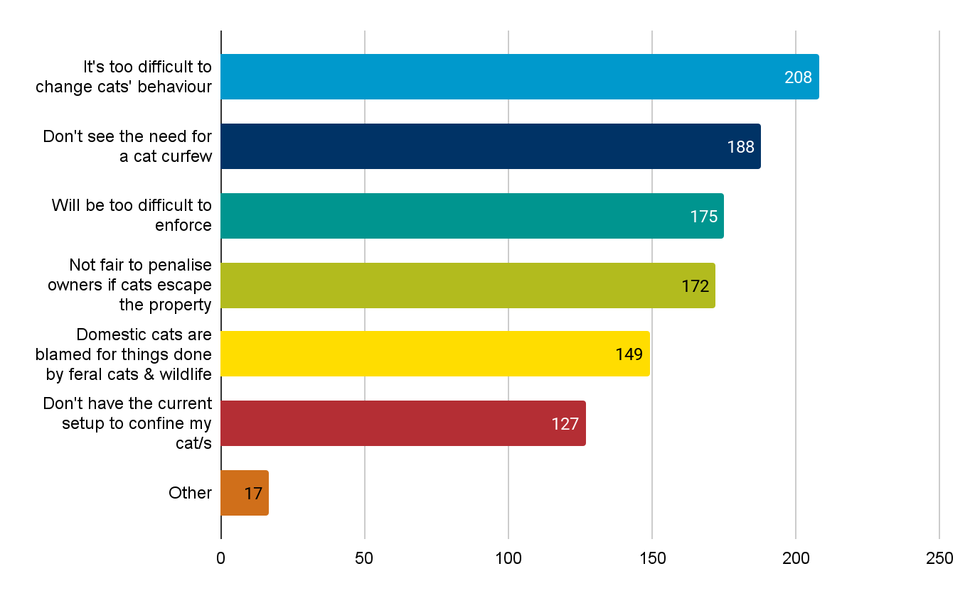
The other category received 17 free text comments. mentions. This data has been organised into the following themes:
- Overpopulation of other species (6 comments).
- Too many/strict rules (6 comments).
- Distrust of council (3 comments).
- Impacts on neighbours (2 comments).

Profile of those opposed to a cat curfew
Presented in table 5 are demographic profiles of participants from the online survey and community pop ups who were opposed to the introduction of any cat curfew. Of the 299 participants who opposed cat curfews of any type in the City of Whittlesea 80% were cat owners and 51% were dog owners. Of the 40 participants who identified as a veterinarian or vet nurse 30% (12) opposed the introduction of a cat curfew, compared to 20% (18) of members of an animal advocacy or rescue group and 16% (16) of members from a wildlife or environmental group.

Table 5: Demographics of those opposed to any cat curfew
Demographic identifier | In opposition to a cat curfew (299)
Cat ownership status
Owns or regularly minds a cat | 242
Owns or regularly minds a dog | 154
Housing type/tenure
Sole person household | 21
Couple only household | 66
Couple or sole parent family, children aged 0-17 living at home | 92
Couple or sole parent family, adult children living at home | 67
Extended or multiple families | 7
Group household | 15
Prefer not to answer | 17
Location within City of Whittlesea | 283 (13 prefer not to answer, 3 outside of CoW)
Age
15-19 years | 1
20-34 years | 61
35-44 years | 58
45-59 years | 118
60-74 years | 37
75 years and over | 4
Prefer not to say | 8
Connection to animal management
Veterinarian/Vet Nurse | 12
Member of an animal advocacy/rescue group | 18
Member of a wildlife/environmental group | 16
Registered dog or cat breeder | 9
Registered Domestic Animal Business | 1

Following is a detailed analysis of findings presented by coded themes.

Adaptation issues
The most commonly cited concerns were connected to the ability of the owner and animal to adapt to a change in conditions, and steps needed to be taken if the cat curfew was introduced.

It’s too difficult to change change cat behaviour
Participants felt it was too difficult to change a cats’ behaviour, shown by 208 selections, suggesting that participants (and their cats) were unable or unwilling to adapt to a cat curfew. Comments in this section described roaming outside or beyond property boundaries as being good for cats, part of a cat’s nature and impossible to stop. There were general comments about cat freedom, the importance of having a cat as a companion and that a curfew might discourage cat ownership. Further mentions specifically understood cat confinement to be detrimental to cat health and wellbeing. Key stakeholder interviews challenged some of these ideas by indicating that cats can live happy enriched lives while confined to property, that confined cats are healthier and live longer, and that most cats can be trained to return home at night within a few weeks.

“…it's impossible to stop the cat from jumping over the fence and wandering outside the property”

“I think people regularly forget cats are in their natural habitat outdoors, not indoors. It’s cruel to have a curfew. It’s even more cruel to try and “convert” an outdoor cat to indoor cat”.

Don’t have the set up to confine my cat
There were 127 mentions that expressed participants were not prepared or did not have the resources to confine their cats. Mentions in this section described the task of cat confinement as impractical, costly or difficult for renters or low-income groups. A number of mentions specifically talked about the precarity of cat ownership and rental agreements if a curfew was introduced. Others suggested a subsidy or help to purchase confinement materials. Further comments discussed the cost of enclosures and potential fines may dissuade cat owners from registering their animals. Conversation facilitators at pop up events noticed a trend of participants selecting a dusk to dawn curfew rather than the 24-hour option to avoid the need for home modifications, showing that this type of concern was also relevant for those who support the introduction of a curfew.

‘Properties are very small these days and people don’t have yard space to erect enclosure and confine cats’

“Renovations to property are expensive and renters are not able to make alterations to property”.

Don't see the need for a cat curfew
The second most common reason given for opposing a cat curfew was that participants do not see the need for a cat curfew. Comments in this section discussed whether it was appropriate to have a cat curfew in terms of its impact on; local wildlife, wild cat populations, numbers in pounds or rescue organisations. Others compared the treatment of cats to dogs or suggested that each cat is unique so a blanket rule could not apply. Others discussed the lack of wildlife in their area and the cost or practicalities of enforcing a cat curfew.

“Doreen has become built up now so we don’t have many rural areas containing native wildlife anymore…. I don’t see the need to enforce restrictions on cats providing they have not been repeat offenders or caused any damage to anyone or anything”

It's unfair to penalise owners if cats escape
There were 172 mentions that described a cat curfew as unfair to ‘penalise owners if cats escape the property’. Comments in this section discussed a willingness of participants to manage their cats but stressed they were unable to supervise them all the time.

“Some nights I can’t get them in till very very late or not at all. Is not fair to issue a fine to owners. You tell me how I can catch the cats in this instance”.

Governance and administration
A common concern of participants was the administration required to enforce a cat curfew by Council and the cost implications for doing so.

A cat curfew would be too difficult to enforce
There were 175 mentions that described how a cat curfew would be too difficult to enforce. Mentions in this section explored the cost in terms of efficiency, affordability and return on investment. Other comments suggested a curfew would reduce cat registrations and therefore the accountability of cat owners. Some comments focussed on the difficulty of managing the various groups involved in catching cats and impoundment. Key stakeholders also identified that enforcement can be difficult and costly, and suggested that communicating the benefits of cat confinement is more cost efficient and impactful for community behaviour change than the enforcement of curfews.

“WCC will end up penalising those responsible owners that register their pets. Irresponsible 'owners' do not register or control their pets, this will encourage non-registration”.

“Council works on a theory that everyone who owns/ semi-owns a cat will pay to get it out the pound if it is impounded, this is not the reality of the situation. Cat management will still cost a fortune to Council because the real issue is with overpopulation and desexing is a greater investment”

Domestic cats are blamed for issues caused by feral cats and other wildlife
Other participants reflected that a cat curfew would result in domestic cats being blamed for issues caused by feral cats or other wildlife with 149 mentions. The comments in this section reported foxes and possums were responsible for perceived cat issues.

“Cats get blamed for wildlife attacks actually committed by possums”

Other
Three themes were analysed from the ‘other’ comments:
- 6 comments felt that there just were too many rules on an individual's behaviour.
- 6 comments celebrated the fact that cats helped to deal with pests.
- 3 comments felt the introduction of a cat curfew and therefore fining people was an excuse for Council to raise revenue.
- 2 comments felt having a curfew would create neighbourly disputes.

Support and resources required
The following section presents community responses on support Council could provide in the first few years, should a cat curfew be introduced. Participants were provided the following options to select:
- Promote ways to keep cats inside the property boundary (outdoor enclosures, special fences, nets) using social media and printed brochures.
- Provide information about helping your “outside” cat to become an “inside cat” using social media and printed brochures.
- Promote what residents should do to report a nuisance cat on their property using social media and printed brochures.
- Consider issuing warnings only (no fines) to cat owners as they gradually adapt to the new cat curfew law.
- Other suggestions, please specify (free text).

Participants were able to choose one or multiple responses including an ‘other’ option with an open-ended response. Where possible, open-ended responses were coded to align to the options provided and were added to those categories. There was a total of 4,513 responses to this question as many respondents provided more than one selection, with many selecting all four options.

Support required was:
- Promote ways to keep cats inside the property boundary (outdoor enclosures, special fences, nets) using social media and printed brochures with 1304 selections (29%).
- Provide information about helping your “outside” cat to become an “inside cat” using social media and printed brochures 1217 selections (27%).
- Consider issuing warnings only (no fines) to cat owners as they gradually adapt to the new cat curfew law 1027 selections (23%).
- Promote what residents should do to report a nuisance cat on their property using social media and printed brochures 837 selections (18.5%).

With 129 comments for other support required.

There were a number of other categories that emerged from coding the free text comments provided by participants. Responses were organised into four themes:
- Financial or material assistance (60 comments).
- Issue fines in a consistent way (45 comments).
- Community education (17 comments).
- Other comments (66 comments)

Financial or material assistance
The need to provide financial or material assistance for confining a cat to a property was mentioned 60 times, which is significant given that this option was not provided within the survey. Participants reported the need for support beyond education to make the transition, including rebates and subsidies for cat enclosures, cat leashes, as well as a discount on registration fees for residents obeying the cat curfew. Stakeholder interview responses echoed this sentiment, with several interviewees suggesting that providing financial or material support would improve sentiment about the cost of cat registration by demonstrating a tangible value for cat owners.

“Offer incentives for responsible cat management - rebates on equipment such as cat leashes or yard enclosures.”

“Providing monetary support to cat owners to support the transition. i.e. partner with a cat enclosure building company.”

“Temporary discount to pet registration for people obeying the curfew.”

“Provide low cost items to transition outdoor cats to indoor like council subsidised cat runs or other equipment.”

Issue fines in a consistent way
A total of 45 mentions used the ‘other’ option to respond saying they feel fines should be issued for a number of reasons; to be consistent with dogs at large incurring fines, to enforce compliance and change current behaviour, and because warnings do not work. One key stakeholder endorsed an early and firm approach to issuing infringements as a way to hasten compliance.

“I think owners should be fined, as I would be if my dog went on a property of others.”

“Fine people straight away it's the only way they'll learn.”

“Fine them as they will not change their behaviour otherwise”

Community education
Community education was mentioned 17 times, covering the need to provide facts and figures on the impacts of roaming pets, illustrating the walking of cats on leashes and tips to encourage cats to come home at dusk such as making that feeding time. Stakeholder interviews provided detailed guidance on effective community education which is detailed in the Stakeholder Interview Findings section of this report.

“Promote ways to habituate cats to come home before curfew. E.g. feeding or treat time.”

“Push facts and figures about the negatives of free roaming pets - how many are being hit by cars, spreading FIV, adding to the amount of unwanted kittens etc.”

“Show cats being walked.”

Other comments
The ‘other’ option was used by participants to express actual or perceived difficulties with keeping cats indoors or transitioning cats from being outdoors to indoor cats, to support harsher and/or consistent rules for cats and dogs, or to reaffirm their opposition to introducing a cat curfew.

Community response to mandatory desexing of newly registered cats
The following section outlines the community response to proposed mandatory desexing in Whittlesea. Participants at pop ups were asked to consider some information about mandatory desexing before responding to questions. Facts provided included:
- There is a significant overpopulation of cats including domestic, stray and feral cats.
- Mandatory desexing would not be enforced retroactively; cats that are already registered would be exempt from the new law.
- There will be logical exceptions and postponements from desexing, such as for registered breeding animals, animals with relevant medical conditions or animals that need more time to mature.

Participants were then asked How do you feel about the proposal for mandatory desexing of newly registered cats? Figure 15 shows the vast majority of participants supported mandatory desexing with 1144 selections, followed by support for mandatory desexing if it is subsidised by Council with 330 selections. Pop up facilitators noted that participants were most interested in Council providing subsidies for low-income households, rather than expecting universal access to subsidies for everyone.

Figure 15: Response to mandatory desexing of newly registered cats

Support for mandatory desexing of newly registered cats
Participants in the surveys and pop-ups were asked to provide their reasons why they supported mandatory desexing for newly registered cats in Whittlesea. This was an open-ended question and participants were able to fill in a free-text response. A wide range of common themes emerged from the feedback data which are presented in Figure 16. There were 780 respondents to this question.

The most common reason given was to reduce the cat population with 407 comments. This was followed by 267 comments that saw mandatory desexing as a way to improve the health, safety and wellbeing of cats. An additional 167 comments outlined desexing as part of responsible cat ownership and 128 comments focussed on desexing as a way to support breeding regulation and registration.

Figure 16: Reasons for supporting mandatory desexing
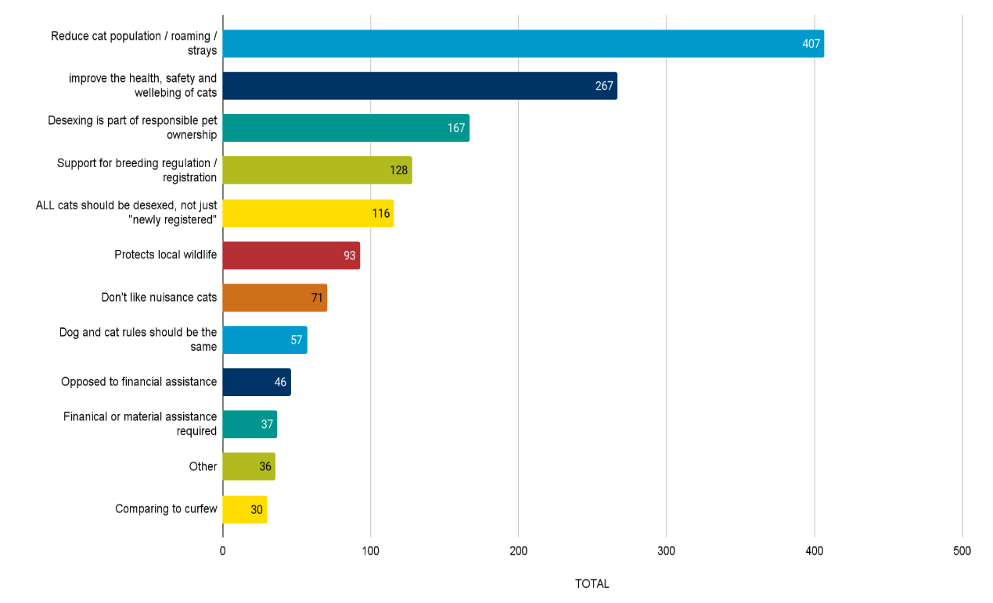
Following is a detailed analysis of findings presented by coded themes.

Reduce cat population
The most common reason for supporting mandatory desexing was that this would reduce the cat population (407 mentions). Mentions in this category focussed on the need to bring the cat population and numbers of feral or roaming cats down. Comments in this section focused on the high number of unwanted cats that become stray or wild and the impacts of this on local neighbourhoods, wildlife and cats themselves. Participants also mentioned the reduced capacity of organisations and community members to care for or manage the current number of cats in Whittlesea. Others mentioned that it was ‘easy enough’ or ‘no need not to’ to desex cats and it should be the norm with the exception of cat breeders.

Key stakeholder interview responses support these sentiments, reinforcing that all cat populations need to be better managed, including domestic, unowned and feral. Cat rescue stakeholders also strongly advocated for medical and behavioural solutions for domestic cats to reduce euthanasia rates.

“I work as a vet nurse in a shelter and see way too many un desexed cats. There is no need for the general public to own entire cats, they should all be desexed. This is to help decrease the feral population and decreasing the amount of homeless cats”.

Improve the health safety and wellbeing of cats
A total of 267 mentions related mandatory desexing to the health, safety and wellbeing of cats. Respondents expressed their support for desexing as it might reduce: the number of lost, stolen or dumped cats. Others felt desexing may prevent unwanted litters and the resulting health effects on mother cats and abandoned kittens. Further mentions criticised the capacity of animal shelters and euthanasia of unclaimed cats. Others saw desexing as a positive way to manage the spread of cat diseases or unwanted cat behaviours resulting in injuries like fighting or wandering on roads.

“Having worked in the shelter of a large organisation and witnessing the overwhelming number of unwanted cats which continue to be brought in, I feel the time is right for all cats to be desexed. People need to be educated about the sadness of this issue…”.

Desexing is part of responsible pet ownership
Many participants understood desexing as central to being a responsible pet owner (167 mentions). Participants in this section wanted accountability for cat owners and cited the negative impacts to wildlife and cat wellbeing as reasons for owners to “step up” to the task of desexing. Comments in this section made concessions for breeders and discussed making desexing more affordable for low-income groups however, others felt that desexing should not be subsidised for pet owners. Key stakeholders reinforced that cat desexing should be promoted by Council as a normal and expected part of responsible pet ownership.

“It’s incredibly important to desex pets, it reduces strays and stops shelters from overflowing. I wish it was a legal requirement when adopting/owning a pet…’

Support for breeding regulation
A total of 130 mentions related to breeding regulation. The majority showed general support for mandatory desexing of cats with the exception of licensed breeders. Other mentions supported stronger regulation of breeders including restrictions on the number of registered breeders within each council area and the number of cats allowed to be bred, and which breeds should be exempt from desexing. Participants commented on reducing the number of backyard breeders or the selling of cats on social media. Others suggested strict confinement rules for un desexed breeding cats. Further mentions described desexing of cats to be the job of the breeder and the price of desexing to be incorporated in the cost of buying a new cat.

Key stakeholders built on this sentiment to explain that widespread cat desexing tends to increase the cost of kitten adoption and the perceived value of cat ownership. While increased prices will make kitten ownership less accessible, stakeholders who work with cats felt that higher kitten adoption costs correlate with higher levels of investment into the animal’s care over its lifetime. They also indicated that the cost and availability of adult cat adoption is not likely to be significantly impacted by mandatory cat desexing.

“All pet cats should be desexed. The only reason not to is for registered breeders. The price of desexing should be built into the cost of buying a cat…”

“All cats should be desexed unless they're specifically for pedigree breeding”.

“Too many kittens being sold on social media not desexed contributing to the problem”.

All cats should be desexed not just newly registered
A total of 119 mentions suggested that all cats should be desexed and that any introduced desexing rule should be enforced retrospectively. Participants in this section outlined the issues surrounding the breeding of stray cats and wild cats in Whittlesea. Participants mentioned the number of unregistered or partially owned cats still able to breed as the main cause of problems or felt that focussing on newly registered cats only, would not combat the issues surrounding high cat populations. Other mentions focussed on the benefits of desexing on cat behaviour, health outcomes and life span as applying to all cats not just newly registered ones.

Protects local wildlife
There were 93 mentions surrounding wildlife protection as the reason for supporting mandatory desexing. Comments in this section were similar to those in response to cat curfew questions but understood desexing as crucial to managing wild cat populations which were seen as the biggest threat to wildlife and native ecosystems. Many mentions described the impacts of undesexed cats or wild cats as a big issue in peri-urban Whittlesea and protected areas such as Plenty Gorge and Serle Wetlands.

“I see so many cats in parks and bushland / walking paths. We need to stop feral cats. They kill [our] wildlife and annoy home owners. We need to be respectful of native wildlife and plants …”

Don’t like nuisance cats
There were 71 mentions that supported desexing as a way to reduce cat population and therefore unwanted cat behaviour or nuisance in the neighbourhood. Participants suggested mandatory desexing may diminish the instance of cats coming onto their property, damaging their gardens and belongings and reduce noise in the neighbourhood. Many participants felt that undesexed cats were more likely to have disagreeable tendencies and were mainly responsible for nuisance.

“there are many health benefits, it reduces the amount of feral cats and also discourages wandering. It would also stop my neighbour’s cat from meowing all night for weeks every time she is on heat”

Dog and cat rules should be the same
Some participants expressed support for cat desexing because they felt that cat management should be more consistent with dog management (57 mentions). Many comments expressed the wish that cats were well cared for in the same way that dogs were, or that cat owners should take the same amount of responsibility for their animals as dog owners. Many mentions in this section were opposed to Council subsidised desexing of cats or felt it should reflect the subsidy given for dogs.

“If Dog owners have to register and keep dogs confined to your own property, so should cat owners.”
Financial assistance for desexing
Participants who mentioned financial assistance were quite evenly split over Council funded assistance for desexing; 46 mentions were in opposition with 37 mentions in support. Those opposed felt it was not the responsibility of Council to support cat owners in desexing, as they should do so at their own expense. Other comments expressed it should be the responsibility of breeders to desex animals, or the cost of desexing should be built into purchasing or registering a cat.

Those in support felt, if it was a mandatory, it would be necessary to subsidise desexing for low-income groups. Many pointed out the benefits of owning a pet, and companionship and that should be accessible to everyone. Others suggested partnering with local vets to establish a system or subsidy to encourage cat owners to opt in.

During the pop ups we found that those initially opposed subsidies were supportive of subsidies, where it assisted low income groups and pensioners.

“Shows commitment to maintaining the pet. If you can't afford the cost, should you have the animal?”

“Council should help Low income and pensioners to subsidise costs”.

Comparing to curfew
There were 30 mentions comparing the mandatory desexing to cat confinement. Most mentions felt it necessary to have both with many comments seeing desexing as a “safe bet” if cats do escape. However, some participants felt if a 24 hour curfew was introduced mandatory desexing may not be required.

Other Comments
A total of 36 mentions were grouped as ‘Other’. In this group a few common themes emerged: 20 mentions included general comments agreeing with mandatory desexing. Others outlined worries that mandatory desexing would be too difficult to enforce or monitor; that some cat owners would not follow the rules and get their cats desexed or refuse to register and microchip their cats (13 mentions). An additional 2 mentions suggested Council could consider allowing concessions for some cats or allowing cats to have one litter before being desexed.

Opposition to mandatory desexing
This section presents community response in opposition to mandatory desexing in Whittlesea. Participants in the surveys and pop-ups were asked to provide their reasons why they oppose mandatory desexing for newly registered cats in Whittlesea. This was an open-ended question and participants were able to fill in a free-text response. Some common themes emerged from the feedback which will be discussed in terms of the categories shown in Figure 17. There were 172 respondents to this question.

Of the 172 respondents to this question, the most common reason given was the belief that desexing should be a decision made by the owner with 91 comments. This was followed by 28 mentions opposing desexing because of the cost/affordability of desexing.

Figure 17: Reasons for opposing mandatory desexing
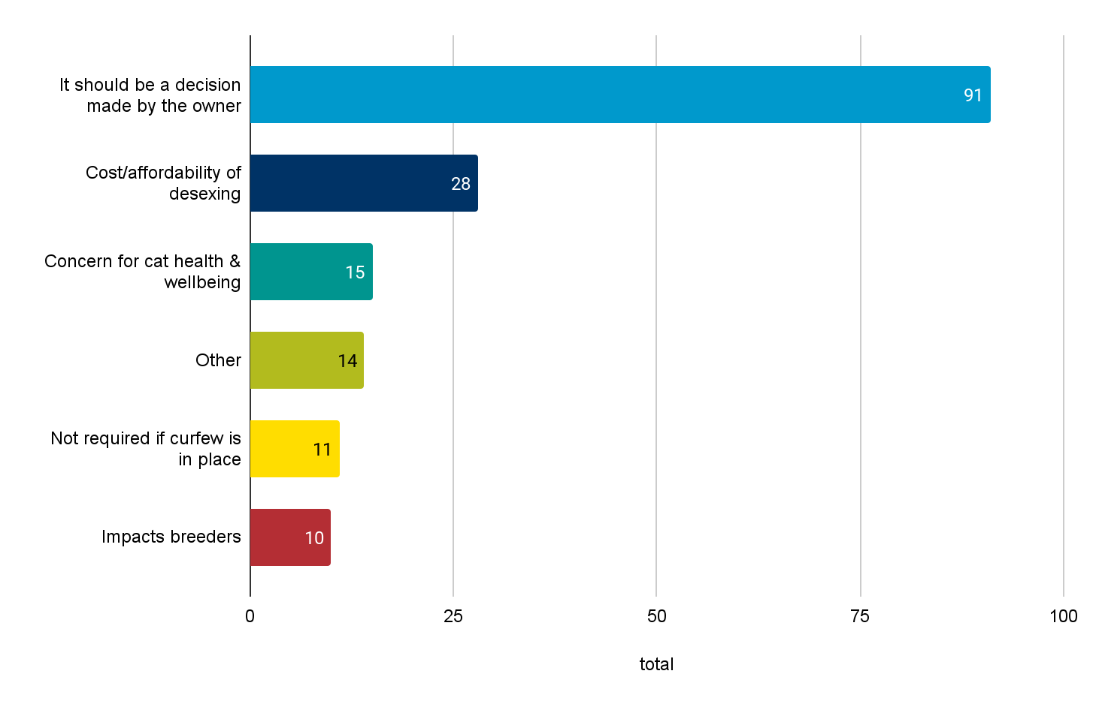
Following is a detailed analysis of findings presented by coded themes.

It should be a decision made by the owner
The majority (91 mentions) of those opposed to mandatory desexing felt this decision should be made by the owner. Mentions in this section mostly agreed with cat desexing in general but felt the owner of the animal was best placed to decide if it were appropriate based on knowledge of the cat's health, behaviour and wellbeing. Others felt it was either not necessary, or the role of Council, to intervene with people and their pets’ freedoms. Further mentions described the difficulty and cost of enforcing the proposed rule and felt this could be better invested elsewhere or felt the Council could educate, subsidise and support rather than mandate desexing. Others compared cat confinement to desexing and felt either one or the other should be mandated, not both.

“I think a decision such as this should be left up to the owner, not a government department. However I believe the council should definitely try to encourage it by contributing or subsidising the fee to desex both cats and dogs”

“Unnecessary rules are a nuisance. You're already set enough limits already. The council should be spending its time on more important things instead of creating more work for itself to do which will lead to higher council rates. I'm strongly against this even though I always desex my pets. Educating people is much better than creating unenforceable rules.”

Cost and affordability of desexing
There was a total of 28 mentions related to the cost of desexing. Many of these comments agreed with desexing in general but reflected that making desexing mandatory would exclude people on low incomes from having pets or registering their cats. Most mentions in this section suggested introducing a subsidy for desexing, microchipping or registration if desexing becomes mandated.

“Registration fees act as a de facto incentive to desex. If you make it mandatory, some people may avoid registering pet”.

Concern for cat health and wellbeing
There were 15 comments that understood mandatory desexing as detrimental to cat health or wellbeing. Comments in this section focused on impacts of early desexing on health, the rights of cats to reproduce, the natural instincts of cats should not be diminished or that cats should not be punished for having irresponsible owners.

“If you wish to save wildlife, perhaps mandate that cats wear bells.
Cats are as entitled to breed as you or I”.

Not required if a curfew is in place
A total of 11 mentions suggested mandatory desexing should depend on cat confinement laws and was not needed if a curfew was in place. Some comments suggested that desexing should only be mandatory for problem/escaping cats and others pointed out that desexing would only manage population but not the other issues like property damage, killing wildlife and was therefore not as essential as a cat curfew.

“I support imposing a curfew on cats. If cats were kept inside the owner’s property then it is up to the owner as to whether they are desexed”.

Impacts breeders
Mentions in this section mostly agreed with mandatory desexing on the condition that breeders were excepted from the rule. Other comments suggested you should not have to be a registered breeder to have a litter of kittens.

Other
There were 14 comments grouped into ‘Other’. This included responses such as ‘no’ or ‘not applicable’ and responses that discussed cat confinement only. There were 5 mentions in this section suggesting dog and cat rules should be the same, a further 2 comments suggesting Council was interested in raising revenue from infringements and 1 comment suggesting that desexing should be handled by a different organisation.

Key Stakeholder Interviews
This section synthesises the conversations, ideas and sentiments discussed during key stakeholder interviews. Telephone interviews were conducted with the representatives of 10 stakeholder groups. Interviews were used to gain a deeper understanding of issues and consider the benefits and limitations of different options. The stakeholders included:
- Three nature conservation groups
- Four cat rescue groups
- Three cat desexing providers.

Interviews were focused on the stakeholder's area of expertise to better understand how cat management impacts their work and to understand the opportunities, limitations and challenges associated with the proposed changes. Ideas raised in earlier interviews were tested with participants of subsequent interviews to better understand the range of views. Interview responses are not quantified due to the total number conducted.

Following is a detailed analysis of interview findings presented by coded themes.

Community wide impact
Stakeholders focussed on the need for long term community wide solutions.
- Support for measures that encourage responsible pet ownership and which raise community expectations of what responsible pet ownership means.
- A desire to improve community perceptions of cat ownership. Cats are often seen as low-cost low maintenance pets which correlates with the resources and finances owners are prepared to invest in their care. When people value cats and cat ownership more, they will be more willing to invest in their care.
- A desire to reduce cat populations to more manageable levels, this includes domestic, unowned and feral populations.
- That the benefit of introducing new cat management rules comes from widespread community compliance and long term behaviour change, not from enforcement.
- That additional cat management rules risks deteriorating the relationship between Council and cat owners, and between cat owners and their neighbours.
- That the proposed changes do not address the impact of cats entering natural areas such as parkland reserves.

Cat curfews
Benefits identified by interview participants
- Cats confined to their property live longer healthier lives, cause less disturbance to neighbouring properties and cause less disruption of natural ecosystems.
- Cat curfews encourage more consideration before choosing to adopt a new pet cat.
- Introducing cat curfews is one supporting action for long term behaviour change to promote responsible pet ownership.

Risks identified by interview participants
- The cost of various confinement options is a concern for cat owners.
- The introduction of a cat curfew may dissuade residents from taking ownership of semi owned or stray cats as they can be difficult to safely confine with existing domesticated pets.
- “Working cats” programs which place cats who are not suitable for home adoption at worksites and rural properties to help manage rodent pests would no longer be able to operate.
- Introduction of new rules may increase the surrender of pet cats for a period of time following the change. This has been seen by cat rescue organisations when changes have been made in other areas.
- The introduction of a cat curfew may discourage some cat owners from registering their pets.
- Introducing rules and fines may negatively impact the relationship between Council and cat owners.
- Owners may be concerned about cat health and wellbeing if they live in high-density housing, with concerns about total living space available and the cat’s access to fresh air.
Limitations identified by interview participants
- Stakeholder interviewees noted that a cat curfew is unlikely to have any significant impact on cat populations or natural ecosystems, but that removing cats from native ecosystems is a positive step.
- Cat owners may not have the resources to build enclosures or the ability to bring cats indoors, for example, those living in a share house or feel at risk of their rental agreement not being renewed if they keep a pet indoors.

Opportunities identified by interview participants
- To improve community understanding of the benefit of safe confinement to the health and well-being of cats.
- There is an opportunity to add value to the cost of registration for cat owners through subsidised cat enclosures and community workshops about responsible cat ownership.
- Anecdotally, stakeholders reported that messaging which focuses on the health, safety and wellbeing of cats is more persuasive to cat owners than a discussion about the impact on local native ecosystems.
- The introduction of Council managed trapping in larger natural areas would assist with population numbers.
- Use of messaging that respects and values the individual personalities of each cat; not assuming all cats behave in the same way. For example, some cats love to cuddle and sunbake and others like their personal space or are very energetic.
- When speaking about the protection of native wildlife, messaging that focuses on native birds was recommended because birds are widely enjoyed and valued by residents.

Mandatory cat desexing for new registrations
Benefits identified by interview participants
- Cat desexing is a permanent effective way to manage population size and prevent unwanted litters of kittens being born.
- Mandatory cat desexing supports registered and regulated cat breeding. Registered breeders typically arrange for desexing, vaccinations, microchipping and registration which improves health outcomes for pet cats and encourages owners to continue with follow up vaccinations and health checks.
- A reduction in accidental or unregulated breeding is likely to improve the value of pet cats by increasing the cost of adoption.

Barriers and Risks identified by interview participants
- The cost of desexing is an issue for many cat owners with prices varying widely
- Mandatory desexing is likely to drive up the cost of pet cats by reducing the rate of unregulated breeding, which in turn improves the community value of cats.
- Some cat owners perceive the ability to reproduce as an essential animal right they do not want to take away.

Limitations identified by interview participants
- The inability to desex unowned community cats is an ongoing problem that is hindering progress to reduce cat populations.

Opportunities identified by interview participants
- To promote regulated cat adoption, which ensures adopted cats are desexed
- For Council to support behavioural and medical solutions to reduce rates of cat euthanasia.
- Subsidised desexing programs are offered across Victoria by many Councils and these programs tend to have very good uptake from communities.
- Subsidised desexing programs support low-income households to adopt pet cats and enjoy the benefits of pet ownership.

Encouraging registration and ownership of cats
While cat registration was not a targeted area of discussion, it featured in many interviews as an interrelated area of discussion. Interviewees raised the following points

Barriers and Risks identified by interview participants
- Many cat owners do not perceive value for the cost of registration in the same way dog owners do (through the provision of parks, bag stations and walking tracks). This creates negative sentiment about cat registration and positions the relationship with Council as being unbalanced; where Council takes from cat owners and doesn’t give anything back.
- A need to demonstrate the value of registering their cats to cat owners.
- Suggestions to demonstrate value including subsidised enclosures, subsidised or free desexing, and special interest community events for cat owners
- Stakeholders raised concerns that residents would be discouraged from formally adopting semi-owned and community cats if they would be expected to keep it confined with existing pets, noting that semi-owned cats may not be safe to keep confined with other pet cats.

Opportunities identified by interview participants
- To consider allowing a larger number of animals to be registered for each household to encourage ownership of semi-owned cats.
- To consider tiered registration pricing or lifetime registration of cats to encourage ownership of semi-owned cats.
- There is an opportunity for Council to advocate for aged care facilities to allow established pet cats to stay with their owners when they first move in. Moving into retirement housing or aged care is a key trigger for the surrender of animals.

Other areas discussed
Protecting wildlife was seen as a key driver of support for a cat curfew, and stakeholders made suggestions for other ways the community can protect local wildlife in addition to confining their cats.

- Planting several indigenous species of plants near each other, rather than lining a street or fence line with one species of plant.
- Multi-storey native planting which includes tree canopy, mid-story planting and groundcover.

Supporting a consistent approach to cat management
This was mentioned by several stakeholders including:
- Considering matching how other Councils manage domestic cats to improve consistency across municipal boundaries.
- Communicating with Councils who have introduced similar rules to learn what worked well and what needed refining.
- The state government has announced funding for a state-wide approach to cat management and the project team may want to consider how this may impact any current or future cat management rules.

Community Education and Support
Interviewees provided some ideas and guidance on providing effective community education. This included suggested content, presentation of information and overall approach to the task of community behaviour change.
- Cat owners enjoy and value the unique personality of their pet cat, and communications should therefore avoid generalising cat behaviour. Messaging that respects cat owners’ knowledge of their pet’s individual character and abilities was recommended.
- Helping communities visualise the impact of cats on the local environment with infographics to show cat population growth, cat predation of other animals and average distances travelled by domestic cats. “It’s hard to get a sense of the scale”
- When illustrating the impact of cats on wildlife, consider that native birds are widely enjoyed and valued and that many owners of unconfined cats have lived experience of their cat catching birds.

Recommendations
Following are our recommendations based on conversations with community members and stakeholders. We acknowledge that our expertise lies in community and social research, not in the technical components of implementing domestic animal management policy.

Introducing a cat curfew
There is strong community support (80.3%) for cat confinement in Whittlesea with more participants in favour of a 24 hour curfew (44.9%) than a dusk-to-dawn curfew (35.4%). The major reasons the community gave for supporting cat confinement were protecting wildlife, protecting cats and reducing nuisance cat behaviour.

In May 2022 the State Government announced funding for a state-wide cat management approach. Due to the very strong community support for a curfew and uncertainty on what the funded Plan may include and when it may be developed, this report supports action now.

R1: Transition to a 24/7 cat curfew
The findings of this report support the introduction of 24 hour curfew in the City of Whittlesea in line with consultation with the community and key stakeholders. The transition to a 24 hour cat curfew will require considerations and support from Council as well as time for cat owners to prepare for the change.

Supports needed to transition to new cat management rules:
- Leniency and time to adjust to new rules, with the acknowledgement that some groups will simply not be able to comply with new laws and ensuring penalties are appropriate to people’s living situations.

R2: Raise community awareness for the change
As with any new change, Council will need to communicate the reason for the change (the why), what it means for the community (how) and when it will come into effect. The participants who engaged in this project understood the role of the Council to inform, educate and support. Participants felt support was most needed for cat owners and education and information must extend beyond social media communications to reach the broader community.
- Clear communication of the cat reporting and collection process and what this will look like in practice, including how and when penalties will apply. This could include a step-by-step guide of what to do to respond to a nuisance cat and case studies or examples that illustrate where enforcement will occur to reassure worried owners of their rights and responsibilities.
- Written communication in plain English and translated into key local languages. Printed material in larger font sizes.

Raise awareness repeatedly, get buy in:
- Targeted, mixed-methods communication: flyers, social media, workshops. Consider options for direct mail to all cat owners to announce and explain any changes.
- Use a community behaviour change approach to promote cat confinement as good for the health, safety and wellbeing of cats.
- Illustrate the impact of cats on their local environment with infographics, for example, the rate at which cats can reproduce, hunt and travel at night.
- Connect enforcement of the cat curfew to complaints about cats on private property, behaviour over a period of time.
- Consider proceeding with a behaviour change and community education approach while awaiting more information from the State Government about a future state-wide cat management plan.
- Public education about the benefits of cat confinement, helping people to understand the ‘why’ for these new laws: to understand the value of cats, to protect local wildlife, to minimise nuisance cat behaviour, to promote responsible pet ownership.

Reduce fear, reiterate support:
- Share examples of when enforcement is likely to occur, and examples of infringements to reduce fear in cat owners. For example, using phrasing like “repeated nuisance” or “after a number of complaints” to reassure cat owners that a cat who escapes once or twice is not likely to be impounded.
- Provide practical advice and information on how to retrofit their house and train their cat for confinement. Running community workshops or creating video content on how to prepare your home (single, multi storey).

Recognise the nuanced circumstances:
- Create materials for cat owners that respond to people’s unique situations and unique cat personalities. By circulating friendly, personalised messaging, owners can identify their situation and understand what changes they need to make, avoiding a one size fits all approach.
- Avoid generalising all cat behaviour as being the same.

R3: Give cat rescue and rehoming services ample notice
Work with cat rescue and rehoming services prior to any curfew being announced as the introduction of curfews is likely to trigger a short term increase in cats being surrendered and services will benefit from having some preparation time. Industry stakeholders have advised that rates of cat surrendering increase when cat management laws are brought in.

We recommend that Council work alongside these groups to plan the timeframe, community education and rollout so that they are prepared and can play a meaningful role in the transition.

R4: Explore financially supporting low income households
Community members sought support to transition to new rules, particularly for low income groups, who face barriers to cat confinement and desexing. Low income groups; pensioners, students, renters, households experiencing time poverty or sharing space with large households have less access to retrofitting options or retraining cats and would be disproportionately affected by enforcement or fines. These groups need considerable support to be able to comply. We recommend that Council work with these groups to lower barriers by:
- Working with tenants and landlords to find affordable, outdoor and temporary options for cat confinement, to lower risk of housing insecurity.
- Investigating opportunities to demonstrate the value of cat registration through subsidised cat enclosures or netting.
- Consider subsidised desexing, to prevent surrenders or non-registration.

R5: Carry out additional research
While there are high levels of support for the introduction of a cat curfew, we believe any decision needs to be contextualised to the conditions of the Whittlesea social and demographic profile. We suggest doing additional research and a comparison of the impacts on:
- change to animal registrations levels
- change to voluntary surrender rates
- change to illegal animal dumping.

Three metro Councils (Knox City, Casey, Cardinia) have had a 24 hour cat curfew in place for greater than a year, it would be advantageous to understand any changes in the impacts listed above.

Introducing mandatory desexing
Statistically, there was overwhelming community support for mandatory cat desexing in Whittlesea with 82.6% in favour. The discussions surrounding this topic grew into ‘how’ the City of Whittlesea might implement this new law, with many (18.5%) of the participants stating if this law was introduced it must include subsidies to avoid financial hardship, cat surrendering and a decline in cat registration.

R1: Transition to the introduction of mandatory desexing
The findings of this report support the introduction of mandatory cat desexing in the City of Whittlesea. It also supports the provision of subsidised desexing for low-income households.

Consider proceeding with the introduction of mandatory cat desexing of new registrations while awaiting more information about the proposed State Government Cat management plan.

Breeders exempt from the policy:
- Mandatory cat desexing should not apply to registered breeders for animals they intend to breed or intend to sell to another registered breeder, but should apply to all animals offered for adoption to prospective pet owners.

Incentivise desexing, by offsetting costs:
- Consider a time limited subsidised desexing program when first announcing the changes.
- Consider ongoing or seasonal subsidised desexing programs for low income households.

Communicate the change widely:
- Explain the health benefits of desexing pet cats, the expected recovery time, and typical costs.
- Reinforce desexing as a normal and expected part of responsible pet ownership.
- Reinforce that there are logical exceptions and postponements for registered breeders, and cats with medical conditions or lack of maturity.

Policy recommendations
The Victorian State Government has planned to introduce a Cat Management Strategy in 2022, to be introduced in the following years. This will be a 10-year cat management strategy for the state of Victoria including $1.3 million in funding, education, campaigns and grants to encourage responsible cat ownership and cat containment. At this stage, it is unclear what this policy will include. It is important to demonstrate to communities that they are heard and the Council is taking action in the direction of their feedback.

R1: Understand impacts on renters
Work with tenants and landlords to find a solution for cat confinement. Current Victorian tenancy rules allow for pets, but conversations from this engagement surrounding tenants’ lived experience suggests having an indoor pet could result in discrimination in the rental market. Council could advocate on behalf of these groups and provide suitable assistance: rental friendly outdoor confinement options, low cost, temporary or removable confinement options.

R2: Align this policy change to other causes
Protection of native wildlife was a clear priority for participants in this engagement program. Consider timing communications about how to protect and support native wildlife in urban areas to precede and coincide with the announcement of new cat management rules.

Closing the loop
Keeping participants informed in engagement and the project is called ‘closing the loop’ - the information loop is currently open. Participants have shared their ideas and their feedback through the engagement process and are waiting to see what happens next.

A new requirement of the Local Government Act 2020 requires councils to share the information that has been collected and inform the community as to how this will shape thinking.

R1 Keep people updated
Issue a statement from Council and update the Council project page thanking participants for participating in the project and for sharing their ideas. As we move into the next phase of the project we need to keep the wider community updated about the progress of this project.

R2: Share the data
Consider ways you can share this data such as creating a snapshot of the engagement data, to bring the data to life with infographics to help participants digest the information in an easy form.

Appendix

Appendix 1
Cat Confinement Consultation
Frequently Asked Questions (FAQs)
Below is a list of pre-emptive questions that may be asked as part of this project.
This list will be updated as new questions are added.

 | Questions | Answers
1 | What is a cat curfew?  (Dusk until dawn and 24 hours) | A cat curfew is a specified time when cats are not allowed outside of your property or in the case of a 24 hour curfew, are secured to your property at all times.
 | Can I take my cat for a walk on a lead if there is a 24 hour curfew? | Yes, as long as you have effective control in a securely fitting harness or the cat is in a carrier
2 | Why is council considering introducing a cat curfew? | Council are considering a cat curfew due to feedback provided at our recent Domestic Animal Management Plan consultation, reports about nuisance cats, reports of environmental impacts of cats in parks and reserves and reports of attacks on wildlife
3 | How will it be enforced? | If a curfew is introduced, and residents have issues with cats trespassing during curfew, the resident can request a cat trap from their Council. If a cat is caught during curfew hours then enforcement action can be taken against the cat owner.
 | Will cat owners be fined if their cat is caught off their property during the curfew hours? | Cat owners may be fined as part of any cat curfew if their cat is caught out during the hours of curfew. Officers will educate cat owners for a period of time as part of the introduction of any curfew.
4 | What happens if my cat is caught outside during curfew? | If officers contain any cats during curfew then the cats will either be returned to the owners or taken to the EAWF. Once reclaimed, owners may face enforcement action as above and may be required to pay reclaim fees when collecting their cat from EAWF.
5 | Will the introduction of a cat curfew manage ‘semi-owned’ or stray cats? | Cat curfews will not deal with the “semi-owned” cat population, but it may assist with these cats if they are deemed a nuisance by property owners and are able to be contained via cat traps.
6 | How can I train my cat to stay indoors? | Resources will be available to assist in the transition to acclimatizing your cat to an indoor (or in an outdoor enclosure) lifestyle, such as some simple methods such as:  Feed your cat indoors. Instead of letting your cat back outside as soon as they're finished eating, keep them inside for increasing periods of time. If you're starting your cat's retraining during the winter, a warm, dry bed to snuggle in may be just the ticket to convince them to stay inside.
 | Is my cat allowed outdoors on my property? | Yes, your cat is allowed outdoors, providing it remains on your property. Various forms of enclosures are available and we will have resources available for people to assist them.
7 | How can I keep my cat active? | Enrichment activities such as cat towers, keeping plenty of cat toys for them to play with, taking your cat outside on a harness and leash. We will provide owners with other resources which will have more information about keeping your cat active.
8 | How can you tell the difference between a pet, stray or feral cat? | It is often hard to tell the difference between a pet, stray or feral cat, as some pet cats will display different behaviours depending on their characteristics. Quite often stray and feral cats will disappear around people, unless they have built up trust with people. Cats are always given time to settle if taken to a shelter.  It’s important that pet cats are microchipped and registered so we can distinguish them from unowned cats.
9 | Will I have to use a cat trap on my property to catch a nuisance cat? | If a cat is able to be contained without the use of a trap then officers will collect it, otherwise a trap will be provided and officers will collect any cats caught in council traps.
 | How will cats on council property be caught? Who needs to catch them? | Generally cats will only be collected from private residences. In some circumstances Council officers will assist with the collection of cats on council property (parks), however this will be done under supervision.
10 | Where will I have to take the captured cat? | Council officers will collect any cats from properties that are contained, however cats can also be taken to the Epping Animal Welfare Facility (ensuring the cat is transported in a safe way).
 | Who do I contact if I suspect my cat has been trapped? | Council your local council
 | Do cats get injured if they are captured in a cat trap? | It’s important that cats are trapped only in approved traps issued by Council and that the instructions provided by Council are followed.
11 | Will keeping my cat inside impact its mental health? | If a cat is kept active and given enrichment toys, then keeping your cat indoors will have little effect on its mental health. Some products are available if your cat has increased stress from being indoors.  Indoor cats are less susceptible to disease and injury.
 | What happens to cats that are captured? | If the cat is registered with Council we will reunite you with it. If a cat is unowned/stray/feral it will be transferred to the EAWF where it will undergo behavioural assessment to determine suitability for adoption.
 | Is it legal for my neighbour or Council to trap my cat? | Yes, it is legal for someone to trap a trespassing cat.
12 | What resources are there to keep our cats indoors? | Council will provide a range of resources for cats, including information from Safe Cats, Safe Wildlife, RSPCA and other organisations.
13 | Will Council support costs associated with building a cat enclosure? | At this stage council will provide resources for owners to find the easiest and most cost effective way to contain cats to their property, and this may include workshops, but at this stage Council will not be subsidising enclosures.
14 | Will a curfew make any difference to overall levels of predation or to the threat of wildlife? | Several reports indicate that cats are natural predators to native wildlife, whether or not they are owned or stray/feral. Containing your cat to your property (especially at a young age) will lower its natural predation and will assist in the protection of local wildlife.
 | Do other Councils have a curfew? | Some but not many Councils have a cat curfew.  The City of Darebin introduced a night-time cat curfew (from 7pm to 7am) on 1 Jan 2021, Yarra Ranges has a 24/7 curfew and the Knox City Council 24-hour curfew comes into effect on 10 April 2022.  The Cities of Whittlesea and Moreland are both engaging their community on the possibility of introducing a cat curfew.
 | If my cat is made to be indoors 24 hour a day will I still need to register them? Why? | Yes, all cats over the age of three months are required to be registered under state law. If your cat escapes your property then these fees will assist in returning your cat to you, and also assists in running the Epping Animal Facility, which cares for all cats that are brought into the facility, whether they are owned or not.  Registering your pets helps Council reunite you with them as we will be able to quickly trace them back to you.
 | If a curfew is introduced will the cost of cat registration be reduced? | At this stage no changes are being looked at in relation to registration fees, however we are looking at advocating to the state government for standard fees across all councils.

Mandatory Desexing

 | Questions | Answers
1 | What are the benefits of desexing my cat? | There are many health benefits of desexing your cat, as well as getting to the source of the overpopulation that we face in the City of Whittlesea.
2 | How does desexing my cat benefit the community? | Desexing your cat will help to address the overpopulation of cats within the City of Whittlesea and will also assist in nuisance complaints as desexed are less likely to roam.
3 | What does desexing involve? | Desexing involves the removal of reproductive organs.
4 | What is the cost of desexing your cat? | Cat desexing starts from $150, but does vary according to sex, age and other factors
5 | Does the Council cover any of the costs? | Council may cover a portion of costs if funding is available at the time.
 | What if I’m intending to breed my cat? | Need to be a registered breeder
 | If I’m a registered breeder am I exempt from the mandatory desexing? | If you are a registered breed with an applicable organisation you are exempt from mandatory desexing.
 | What age is it recommended that a cat is desexed? | The RSPCA recommends the desexing of cats at a young age (under 4 months) before they reach puberty.
 | Is early desexing harmful to my cat? | No, reports suggest that the health benefits of early age desexing far outweigh any possible side effects of early age desexing.

