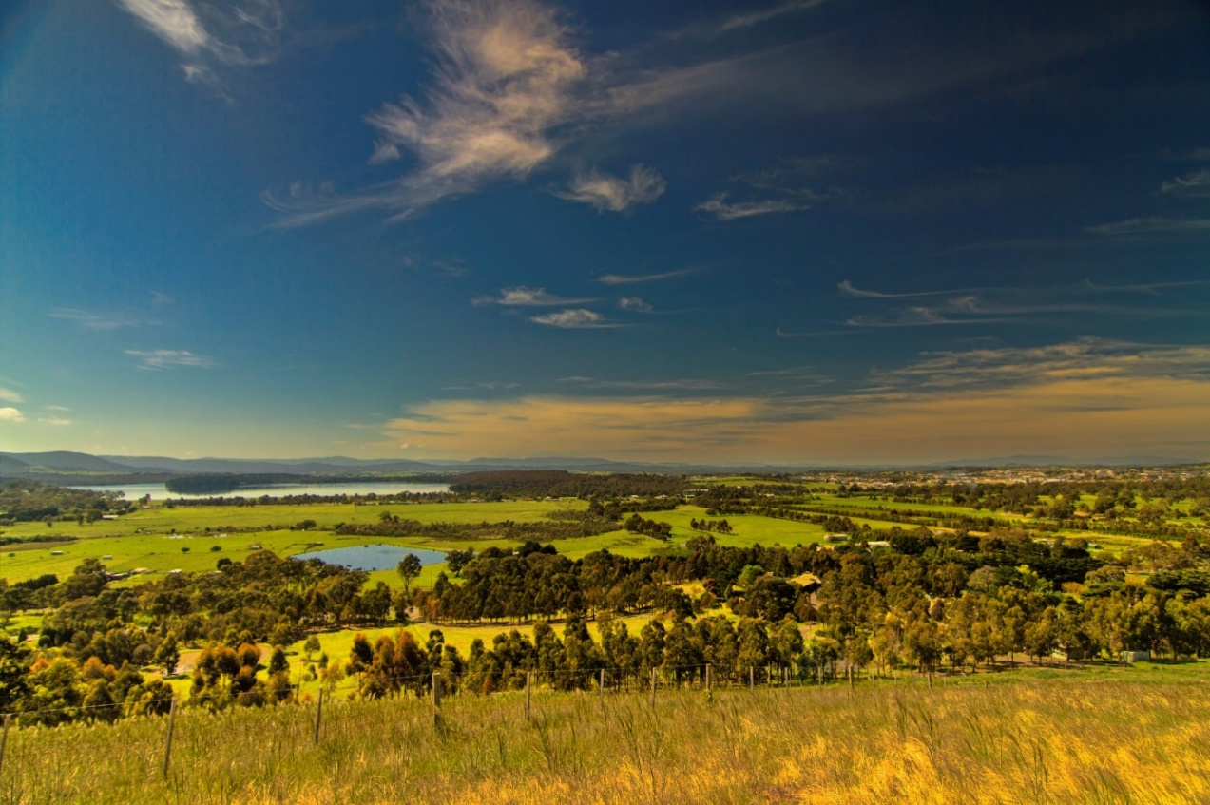
Green Wedge Management Plan – Issues and Opportunities

The Green Wedge Management Plan (GWMP) sets the vision and objectives for the Green Wedge in the City of Whittlesea – this is the non-urban land that sits outside the Urban Growth Boundary that is currently protected from urban development.

Council is developing a new plan to manage these areas over the next 10 years. We want to hear your thoughts on the key challenges and opportunities of managing these important areas.

A summary of these challenges and opportunities is outlined below and are discussed in more detail in the GWMP Discussion Paper which can be viewed at https://engage.whittlesea.vic.gov.au/green-wedge.

Council is seeking your feedback on these identified challenges, opportunities, or any other issues you would like to raise.

Challenges facing our Green Wedge

The development of the GWMP 2022-2032 provides an opportunity for Council to develop key strategies for managing the Green Wedge in response to the key challenges identified. The key challenges are listed below – they are grouped under each of the Whittlesea 2040 goals.

Whittlesea 2040 Goal 1: Connected Community:

- Potential lack of regeneration of community groups due to minimal population growth and an ageing population
- Lack of broader community awareness of the important role rural landowners play in caring for our Green Wedge in terms of sustainable land management, environmental conservation and regenerating scenic rural landscapes
- Limited community connection to cultural heritage places in the Green Wedge
- Limited interaction with traditional landowners restricts understanding and preservation of Aboriginal heritage places
- Limited connection between our Green Wedge and residents living in our urban areas
- Uncertainty about how the pandemic will impact settlement patterns in the Green Wedge

Whittlesea 2040 Goal 2: Liveable Neighbourhood:
- Manage the intensity of the development size to protect Green Wedge values
- Managing existing rural living settlements located in areas subject to environmental risks and hazards such as bushfire, erosion and flooding
- Managing emerging issues associated with the presence of structurally unstable soil across our Green Wedge
- Risk of land banking and fragmentation of properties close to the Urban Growth Boundary
- Land use conflicts - especially those that cause incremental and irreversible loss of agriculturally productive land or land that has other important non-urban uses
- Property value growth displacing farming with rural living

Whittlesea 2040 Goal 3: Strong local economy:
- Competing land uses leading to incremental land fragmentation, rising land values and land use compatibility issues
- Changing demographics and lifestyle of our Green Wedge residents due to a lack of farming succession plans or opportunities for new entrants to gain access to the land
- Climate change and land degradation
- Rising ‘on farm’ costs such as rates, water, employees, soil and crop improvements, remediation works
- Market pressure from pricing competition as a result of the increasing dominance of a larger, more intensive farming industry
- Unequal treatment of farmers in peri-urban areas as opposed to regional areas (e.g. restricted funding opportunities, lack of support from industry bodies)
- Lack of tourism opportunities linked to the values of the Whittlesea Green Wedge and limited branding recognition of agri-tourism

Whittlesea 2040 Goal 4: Sustainable Environment
- Climate change impacts such as bushfire, drought and other extreme weather events that threaten the environmental health, social stability and economic viability of the Whittlesea Green Wedge
- Environmental pressures including incremental loss of native vegetation and biodiversity, introduction of pest plants and animals, altered water quality and flows
- Community expectations - the broader community’s level of understanding of the environmental, social and economic values of Green Wedge are varied as is the community’s level of commitment to Green Wedge values

Opportunities for our Green Wedge

The Discussion Paper proposes the following key opportunities in the context of the four overarching goals of Council’s Community Plan - Whittlesea 2040: A place for all:

Whittlesea 2040 Goal 1 - Connected Community

- Support a rural community of diverse needs
- Empower community on community-led initiatives
- Connect the Green Wedge with urban neighbours

Whittlesea 2040 Goal 2 - Liveable Neighbourhoods

- Protect and enhance landscape amenity and rural character
- Provide for safer settlement
- Manage sodic and dispersive soils
- Improve management of urban & rural interface including discouragement of land speculation
- Finalise and start implementation of the new Whittlesea Township Strategy

Whittlesea 2040 Goal 3 - Strong local Economy

- Support a stronger local food economy for local jobs and healthier community.
- Plan for sustainable, diverse and innovative farming practices
- Support Agritourism in the Green Wedge
- Protect and manage existing extractive industry and landfill in the Green Wedge

Whittlesea 2040 Goal 4 - Sustainable Environment

- Improve the management and protection of biodiversity
- Support local agriculture and improve water management
- Our residents and our environment benefit from a diverse, colourful, and healthy City Forest

You can provide your feedback and ideas to us in a range of ways including a face-to-face workshop, an online session, at a drop-in sessions or fill out our survey. Find out more at https://engage.whittlesea.vic.gov.au/green-wedge.

We are committed to ensuring we are inclusive in our consultation so if you have a particular need to enable you to participate fully, please contact us via email at strategic.planning@whittlesea.vic.gov.au or call us on 9217 2170.

