Contents
Acknowledgement of Traditional Owners 2
INTRODUCTION 3
Our promise to our community 3
Purpose of this Policy 3
About our Council 5
WHAT IS COMMUNITY ENGAGEMENT 6
Our commitment 6
Principles 6
OUR APPROACH TO COMMUNITY ENGAGEMENT 7
How we engage 7
Types of community engagement 8
Levels of community engagement 11
WHY WE ENGAGE 12
WHO WE ENGAGE 13
Our diverse community 13
WHEN WE ENGAGE 18
IMPLEMENTATION, MONITORING AND REPORTING 20
Keeping in touch with our community 20
SUPPORTING INFORMATION 21
Definitions 21
Roles and responsibilities 24
Related Policies, Strategies and Guidelines 26

Acknowledgement of Traditional Owners
The City of Whittlesea recognises the rich Aboriginal heritage of this country and acknowledges the Wurundjeri Willum Clan as the traditional owners of this place.

INTRODUCTION
“In 2040 the City of Whittlesea is a place that opens its arms to every resident, where all walks of life are celebrated and supported. Our community is compassionate and welcoming. We are healthy and can easily access the support services we need. People of all backgrounds, ages and abilities feel that they are an essential part of the community. We work together, making our community a better place for all.”
Whittlesea 2040 Community Vision, Page 13
Good community engagement is central to realising our Whittlesea 2040 community vision to work together to make our community a better place for all.
Community is the heart of our City and everything Council strives to achieve is done to improve the lives of those who live, work, study and visit here.
This includes providing meaningful opportunity for our community to provide input into Council’s decision-making processes and hear their views, ideas and feedback about activities and issues that are important to them.
There has never been a more vital time for Council to engage well with local communities. A number of significant global and local factors have informed Whittlesea’s approach and are summarised in the diagram below.

Our promise to our community
In adopting the Policy, Council commits to engage its community in a deliberative, proactive and flexible way. This will ensure the decision-making of Council is fully informed of our community’s views ideas and suggestions, and all options have been carefully considered.

Purpose of this Policy
This Community Engagement Policy outlines our commitment to actively involve the community in decision-making so we can deliver better quality outcomes and reach our Whittlesea 2040 Vision for:
- A connected community
- A sustainable environment
- A strong local economy
- Liveable neighbourhoods
- A high performing organisation.
The policy is built on a set of core principles and commitments that will help guide the planning, development, implementation, evaluation and continuous improvement of our community engagement processes, tools and activities.
It describes our approach to community engagement (why, who, what, when, how) to help us meet our responsibilities to include the community in decision-making and adhere to legislative requirements under the Local Government Act 2020 (it’s the law!)
The City of Whittlesea has a strong network of community and volunteer organisations and we want to build on what’s working to improve our engagement practice.
Over the next few years our community will be recovering from the impacts of the COVID pandemic. Evidence identifies that communities who recover best from emergencies do so when efforts are community led.
We want to foster new governance models and support citizen leadership and participation for now and in the future. This is particularly important while our Council is made up of a Panel of Administrators who are committed to fostering and elevating the voice of citizens as part of the City of Whittlesea’s decision-making and engagement.

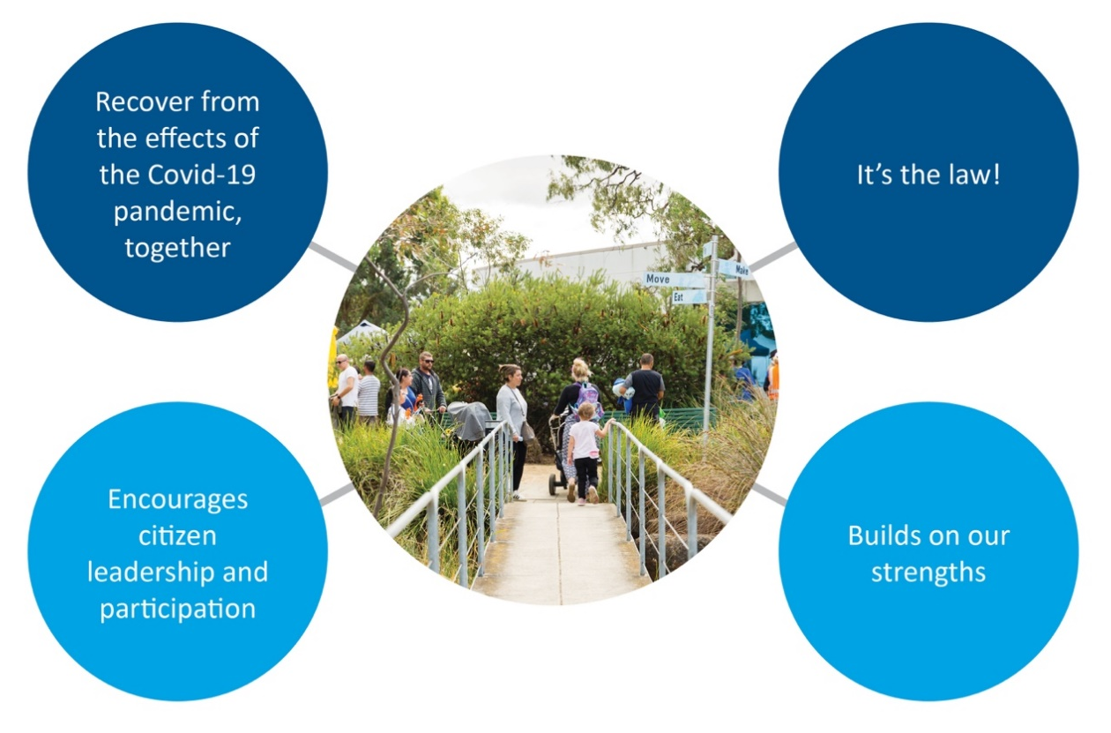

About our Council
The City of Whittlesea is governed by a Panel of Administrators, appointed by the Victorian Government on 19 June 2020.
Led by the Chair of Administrators, Ms Lydia Wilson, and Administrators Ms Peita Duncan and The Hon Bruce Billson, the Panel carries out the role, responsibilities and functions of councillors as set out in the Local Government Act and therefore undertakes the role of the Council.
Our Administrators are community-focused and committed to their role as community representatives.
They actively participate in community engagement activities and respond to feedback.
The Panel of Administrators remains in place at the City of Whittlesea until the October 2024 local government elections.
Our Administrators are committed to playing a strong representational role and establishing governance arrangements that foster local community leadership, representation and trust.

WHAT IS COMMUNITY ENGAGEMENT
We believe community engagement is at the core of good governance and leadership and empowers our community to play an active part in decision-making for their City.
It is defined as a planned process that provides a range of opportunities for public involvement in Council’s decision-making, relationship building and community strengthening. Community engagement is essentially based on two-way conversations.
The City of Whittlesea will seek the needs, views and ideas from its community into activities and issues that affect them.

Our commitment
We believe good community engagement leads to better decision-making, helping foster the long-term relationship between community and Council and ultimately quality outcomes for our City.
This Community Engagement Policy is our commitment to actively involve the people who matter the most – those living, working, studying and doing business with the City of Whittlesea.
Through a range of approaches and opportunities, we will seek to empower our community to play a role in influencing the future planning of our City, and the delivery of our services.
To do this, we will engage in a meaningful way when it is convenient for you, in a safe and accessible environment, where you feel heard.

Principles
The City of Whittlesea embraces the Charter for Human Rights and Responsibilities and goes beyond the five principles set out in the Local Government Act. Our community engagement will:
- where appropriate, be planned and delivered in a coordinated way
- have a clearly defined objective and scope
- give participants access to objective, relevant and timely information to inform their contributions
- provide the community with reasonable support and adjustments so that they can meaningfully participate
- be conducted with persons/groups that are representative of the persons/groups affected by the matter with which Council is engaging the community
- inform participants of how community engagement will influence Council decision-making on the matter that is the subject of the engagement
- specify how the community will be informed of the outcome and how their input has influenced a decision
- be evaluated to improve future engagements
- always be open and welcoming of input through structured opportunities, programs and processes or less structured via views and aspirations expressed when engaging with Council
- close the loop with participants.

OUR APPROACH TO COMMUNITY ENGAGEMENT

How we engage
Council uses the Engagement Triangle (below) as a way of defining the intent and purpose of our community engagement at the beginning of every process. Based on the overarching objectives of informing decisions, building capacity and strengthening relationships, it allows us to identify key stakeholders and determine the best methods for engagement.

How we engage is important to ensure as many people as possible can have their say.
We will use a range of community engagement methods to suit different situations, issues, settings and communities based on:
- the engagement purpose – for example to inform, improve a strategy, or generate support
- the scale of the engagement such as individual, small group, large group or community-wide
- equity, access and inclusion – who is most affected or if there are harder to reach community members that need different channels to be implemented
- context – for example, investigate if there is already low trust, high complexity, high emotion or low interest in the issue or project
- any legislative requirements.
Sometimes different engagement methods will be applied at different project stages. We might consult to gather ideas at an early stage of a design project, and then involve or collaborate with community to finalise priorities.
Examples of the types of engagement methods we apply for different levels of engagement are outlined below.

Types of community engagement
Council undertakes a range of community engagement activities which can be broadly defined as consultative or deliberative engagement practice.
Engagement can occur at multiple stages throughout a process and can include both types of engagement providing the community with an opportunity to participate at different levels throughout the process.
Under the Victorian Charter for Human Rights and Responsibilities, Council is committed to ensuring that all forms of engagement are accessible, safe and inclusive.
Consultative engagement
Consultative engagement occurs when views, opinions or ideas are invited on a specific project, draft policy, plan or document.
Participation at this level usually includes a broad range of community members and stakeholders.
Examples of consultative engagement include:
- surveys
- polls
- ideas boards
Partnership engagement
Partnership engagement includes how Council engages with community in an on-going way through the hundreds of local community advisory committees, groups and networks we engage in. Examples include Council’s Youth Advisory Committee, Whittlesea Reconciliation Working Group, Whittlesea Disability Network and Whittlesea Community Futures forum.
Deliberative engagement
Deliberative engagement is an approach that encourages community members to critically test, weigh up and consider a range of information, perspectives, inputs and evidence to reach a consensus or make recommendations.
Deliberation can be scaled to suit a project based on its scope, complexity or impact and may require independent facilitation to ensure a fair and equitable process.
Under the Local Government Act 2020 a Community Engagement Policy is required to give effect to deliberative engagement practices that can be applied when Council develops a draft Community Vision, Council Plan, Financial Plan, Asset Plan, and any new law.
Unstructured engagement
The City of Whittlesea welcomes feedback anytime, anywhere. Our range of communications channels exist to hear your views whether they come via social media, our website, phone calls or provided verbally to an Administrator/Councillor or officer.
Submission processes
The submission process generally applies to legislative requirements such as the Victorian Government land-use planning applications or Council processes such as service requests or complaints.
This policy does not apply to community engagement processes prescribed for these functions.
However, wherever possible, Council will go beyond legislative requirements for consultation on those matters.
We will consider the Victorian Charter of Human Rights and Responsibilities and make reasonable adjustments to our engagement processes and methods to ensure that people of all abilities and backgrounds can participate.
Statutory requirements
Under the Local Government Act 2020 Council has a statutory obligation to develop four key strategic plans: a long-term community vision, financial plan and asset plan, as well as a four-year Council Plan.
In addition, Council has a statutory requirement to develop a four-year Municipal Health Plan as prescribed in the Public Health and Wellbeing Act 2008.
More broadly, Victorian local government is also governed by the Victorian Charter of Human Rights and Responsibilities that sets out the basic rights, freedoms and responsibilities of all people in Victoria. It is about the relationship between government and the people it serves; and ensures that we take relevant human rights into account when making decisions and ensuring that our processes are inclusive and accessible.
Council invites the community to participate in the development of strategic plans under the guiding principles set out on page 7 of the Community Engagement Policy.
Beyond planned engagement
Council will always respect, gather and be receptive to unstructured community input and insights that come via multiple channels including, but not limited to, the website, social media and inbound customer service calls.

Levels of community engagement
Council’s approach to community engagement is guided by the International Association of Public Participation (IAP2) Spectrum of Engagement, which is recognised world-wide as the best practice tool for community engagement.
The IAP2 Spectrum identifies five levels of engagement with corresponding goals and actions. It makes clear the role of the community in decision-making at each level.
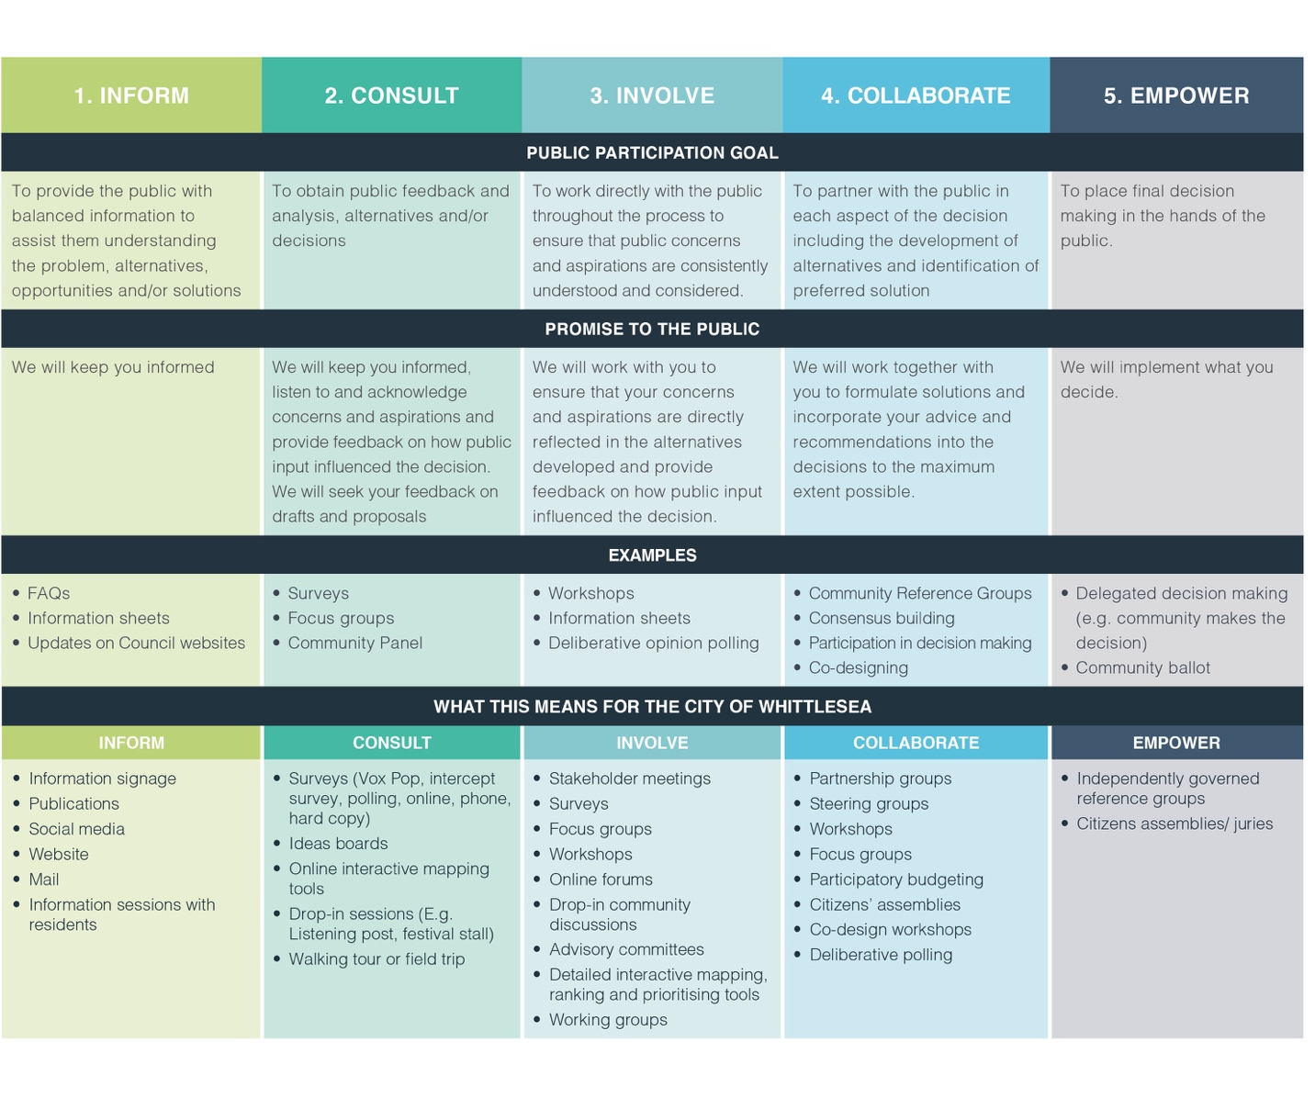

WHY WE ENGAGE
Understanding our community’s needs, priorities, concerns and ideas leads to better outcomes.
Research and practice indicate increasing social connections, civic participation and social cohesion in communities directly contributes to a broad range of positive health, social and economic outcomes.
Council's decisions and actions impact on the lives of all people who live, work and study in the City of Whittlesea. Citizen participation in decision-making can influence not only the planning and delivery of Council services, but it can also inform many of the determinants of health and wellbeing.
This is essential to achieving the Whittlesea 2040 community vision of a place for all. The benefits of good community engagement are grouped under Whittlesea 2040 ‘Participating Community’ key directions below.
Well informed
- more informed communities and more good ideas and potential solutions shared
- better understanding of the needs and priorities of our diverse community
- community awareness about Council’s scope of work and decision-making powers and processes
- informing and assisting advocacy priorities
Local decision making, volunteering and leadership
- greater transparency in Council’s decision-making
- genuine and meaningful conversations between Council and the community
- building community resilience and capacity that leads to empowerment
Vibrant community groups
- stronger relationships with our community and stakeholders
- creating better public value and social capital
- enhancing social cohesion

WHO WE ENGAGE
People who live, work and play in the City of Whittlesea are entitled to provide input into decisions that affect them.
To deliver great projects for the community we need to understand community needs and aspirations and what is important to them to lead a happy and healthy life in the City of Whittlesea.
The City of Whittlesea is one of Melbourne’s largest and most diverse municipalities. Our neighbourhoods span metropolitan suburbs, growth areas and rural communities. Our population is fast-growing, and is expected to almost double by 2040, with an extra 55,823 homes built across the municipality.
Our community is proud of its diversity. We have the second largest Aboriginal and Torres Strait Islander population in Metro Melbourne and almost half of our residents speak a language other than English at home.
More and more families are calling the City of Whittlesea home. Over half of our households are families with children and there are about 71 babies born every week. While the population is ageing, our community will continue to mainly have younger families.
We will see more homes built and a mix of new housing types will be needed for our community’s growing and diverse needs.
With almost half of local workers also living in the LGA and more local jobs being created, the City of Whittlesea is a great place to live and work, now and into the future.

Our diverse community

- A growing population
  - 230,238 in 2019, growing 3.6% annually since 2016

- A large Aboriginal and Torres Strait Islander community
  - 1,635 Aboriginal and/or Torres Strait Islander residents, the second largest Indigenous community in Greater Melbourne²

- A culturally diverse place
  - 35.5% of residents were born overseas (33.8% across Greater Melbourne)
  - 44% speak a language other than English at home (32.3% across Greater Melbourne)
  - The most common languages are Macedonian (5.1%), Arabic (5%), Italian (5%), Greek (3.7%) and Punjabi (3.2%)

- A family area
  - 54.6% are family households (43.5% across Greater Melbourne), and one-quarter of residents are children and young people (aged 0-17 years)

- Diverse support needs
  - 5.7% of people are living with a severe or profound disability (4.9% across Greater Melbourne)

- A thriving economy
  - 18,720 registered businesses in 2020, an increase of 41% from 2016
  - 49.4% of local workers also live in the City of Whittlesea.
Our unique geography is also important in understanding the differences in community profiles, which can influence how we engage, where we engage and what we engage on. The three distinct areas are:
Rural areas (north of the municipality)
Whittlesea township, Donnybrook and rural balance
- Older age profile
- High home ownership
- Less multicultural diversity
- More trades workers
- Higher levels of civic engagement & volunteering
- Higher sense of community
- Higher levels of physical activity
Growth areas
Wollert, Epping North, Doreen, Mernda and South Morang
- Young couples & families
- Higher incomes but also large mortgages
- More professionals
- Challenge of balancing work/family life
- Longer commute times
- High impact of traffic on stress & lifestyle
- Higher levels of food insecurity & budgeting
- More likely to volunteer
- Higher perceptions of safety
Established (south of the municipality)
Thomastown, Lalor, Bundoora, Mill Park and Epping
- Older age profile
- High home ownership
- More low-income households
- More multicultural communities
- Find it easier to get to destinations by car and public transport
- Lower levels of civic engagement
- Lower sense of community
- Lower perceptions of safety
- Lower levels of physical activity
Demographic information is important to consider when planning our community engagement activities. For example, we are likely to translate information into our top 10 languages, provide translators, consider locations and methods.
On some occasions we may identify and target individuals and groups that have an interest in a specific decision by background, location and demographic. However, our community engagement will be broad and inclusive of everyone who would like to have their say.
Below are examples of some of the groups we engage with regularly.
Aboriginal and Torres Strait Islander Community, and Traditional Owners | Advisory Committees | Business owners and operators
Children and young people | Community advocacy groups | Council service users
Culturally and Linguistically Diverse communities | LGBTIQ+ community | Neighbourhood Houses and community centres
Non-resident property owners | Not-for-profit groups | Older people
Owner occupiers | People experiencing homelessness | People with a disability
Renters | Schools, kindergartens and childcare groups  Students | Special interest groups
Sports and recreational club members | Young people | Visitors
Accessible and inclusive engagement
In line with our responsibilities under the Victorian Human Rights and Responsibilities Charter, Council will ensure that all participants in our community engagement processes feel valued, respected and welcome.
Every effort will be made to ensure that our diverse communities can access, understand, and contribute their views in a way that is appropriate, productive, and respectful.
In planning every engagement, we will make every effort to address potential barriers to participation that may include Aboriginality, age, disability, ethnicity, gender identity, race, religion, sexual orientation and other attributes.
To inform our community throughout the engagement process, we will provide access to objective, relevant and timely information by:
- providing information, data and/or evidence relating to the matter online
- supplying information in plain language along with translated and accessible formats and summary documents where appropriate
- using a range of communication channels and accessible formats
- making information about our projects available on our Engage Whittlesea digital engagement platform or provided in other formats as required.
Consideration will always be given to time, location and format of face-to-face or online engagement activities to ensure accessibility and participation.

WHEN WE ENGAGE
Broadly speaking, we invite our community to engage with us at any time and in any way that is appropriate, respectful and constructive.
There are many occasions where we will initiate community engagement based on a project, idea or activity that may impact the community and seek feedback. This includes:
- where a proposed change to Council activities or strategic direction may significantly affect the community in terms of the economy, lifestyle, environment, wellbeing or amenity of the municipality
- when developing new or reviewing existing policies, strategies or plans
- introducing a new service, discontinuing an existing service or substantially changing or reviewing a service that may significantly affect how services are provided
- proposals for changing the way in which public space looks, is used or enjoyed
- when the community raises an issue with Council for a decision (or outcome) and there could be competing community interests
- planning and development of major projects and capital works, including public buildings, centres or other infrastructure
- urban development/redevelopment proposals, such as structure plans, that may significantly alter the existing amenity or characteristics of a geographic area
- any circumstance where Council needs more information or evidence to make an informed decision.
A mix of face-to-face and online engagement tools and activities will be developed to ensure everyone can participate.
When we actively seek feedback through structured community engagement, Council will:
- provide notice with time to read information prior
- show sensitivity to social issues and trends
- schedule engagement on multiple issues where possible to avoid community fatigue and duplication of effort
- conduct engagement activities in locations and at times that enable the community to easily participate.
Council will promote opportunities for the community to actively participate in the following processes:
Mandatory engagement
Council is required to undertake community engagement under a range of prescribed regulations and legislation, including the engagement requirements set out under the Local Government Act 2020 as well as a broad range of other relevant Acts. (Refer to page 11, Statutory Requirements).
Engagement will be undertaken to ensure we meet our statutory obligations. In many instances, Council will go above and beyond the minimum requirements to gain a strong understanding of our community’s wants and needs to ensure we are achieving the best possible outcomes for our community.
When community engagement may be limited
There are times when Council’s level of engagement with the community and key stakeholders will be limited. In some circumstances, Council may only be able to inform the community and stakeholders of Council’s decisions and actions. This may occur when:
- Council is not the lead agency
- an immediate resolution is required
- specialist or technical expertise is required
- an initiative involves confidential or commercial information
- there are clear and defined legislative responsibilities that must be met
- developing or reviewing internal policies and procedures
- there is a risk to public safety.
Block out periods
Council will avoid carrying out formal consultation around key dates such as Christmas/New Year, long weekends and school holidays, unless it allows specific groups more opportunity to participate.
In the lead up to Council elections (i.e. ‘caretaker’ period), community engagement will not be conducted on matters that are potentially controversial.
Community engagement regarding planning permit applications and on operational issues, like canvassing residents’ views on small-scale traffic treatments, can be conducted during a caretaker period as it is unlikely to impact the election.

IMPLEMENTATION, MONITORING AND REPORTING
A Community Engagement Strategy and Implementation Plan 2021-25 will be developed by July 2021 to coincide with the Council Plan 2021-25. The Strategy will identify Key Performance Indicators (KPIs), activities and timeframes required for the implementation of this policy.
A progress report including the details of the evaluation of this policy and the Implementation Plan will be provided to Council each year.

Keeping in touch with our community
We will keep in touch with the community during our engagement processes and report back by:
- Making it clear at the start of the community engagement process when and how they can expect to be updated on progress.
- Reaching out to participants at the end of the process to advise them of the outcome, including how their participation influenced decision-making.
- Where appropriate, asking participants to help evaluate our process so that we can continue to improve.
- The Community Engagement Strategy and Implementation Plan 2021-2025 will ensure the effective delivery of this policy.
- The City of Whittlesea commits to completing a review of the Community Engagement Policy in collaboration with community no later than 15 months after this policy is adopted. This timetable will enable both Council and community to benefit from one year of the policy in operation to inform the review process.
- Following this initial review, the City of Whittlesea will continue to evaluate, review and report to Council on the overall effectiveness of this Policy and Implementation Plan on an annual basis.

SUPPORTING INFORMATION

Definitions
Accessibility means identifying and eliminating obstacles and barriers to ensure anyone can access or use places, services and information, regardless of their ability, location, culture, time, resources or any other differentiating factor.
Communication channel refers to the way in which Council may communicate engagement opportunities with you such as social media, website, Local Scoop, local newspapers, advertising and promotional material.
Community can refer to a geographic location (community of place), similar interest (community of practice) or an affiliation or identity (such as an industry or sporting club). The City of Whittlesea community is defined as individuals or groups who live, work, play, visit, study or invest in our City. For example:
- community defined by place: e.g. the Thomastown or Mernda community
- community based on common interests and activities: e.g. skateboarding or gardening community
- community based on a shared culture, perspective or other identity: e.g. Aboriginal community, Hindi speaking community, youth or elderly community, religious community.
Community development is defined by the United Nations as "a process where community members come together to take collective action and generate solutions to common problems".
Community engagement (also known as stakeholder engagement, public participation or community consultation) involves our community in decisions that impact and interest them. It can take many forms including:
- sharing information and providing updates
- seeking feedback and gathering input
- dialogue and deliberation.
Community member is a participant in a community engagement process. Outside of community engagement, these same people are customers as they interact with Council.
Community strengthening refers to a sustained effort of building cohesive and inclusive communities. This process aims to increase the connectedness, active engagement and partnership among members of the community, community groups and organisations in order to enhance social, economic and environmental wellbeing.
Council refers to the City of Whittlesea as an organisation as well as the Administrators/Mayor/Councillors, Senior officers and Council officers.
Deliberation means long and careful consideration or discussion.
Deliberative engagement means that we provide our community with enough time and information to enable their critical reasoning, and consideration of options as part of a decision-making process to demonstrate:
- Influence – promise of influence over policy and decision-making
- Inclusion – participation that is representative of the community and inclusive of diverse viewpoints and values
- Deliberation – open dialogue and discussion, access to information and movement towards consensus.
Diverse communities refer to the different communities that exist within the City of Whittlesea including those with a common interest such as business or sporting associations or people who share something in common, such as all abilities, gender or a culturally and linguistically diverse (CALD) background.
International Association for Public Participation (IAP2) is an international organisation dedicated to advancing the practice of public participation.
Representative engagement describes actively seeking out and involving individuals or groups impacted by Council’s activities, projects or decision-making to ensure diversity of viewpoints and values are considered.
Stakeholders is a term used to define individuals, groups of individuals, organisations or political entities that are interested in or impacted by a Council outcome or decision, relationship building or community strengthening processes. Each person within our community has the potential to be a stakeholder in Council’s engagement activities.
IAP2 Core Values
The International Association for Public Participation (IAP2) is an international organisation advancing the practice of public participation. The IAP2 framework is underpinned by seven core values that are aimed at ensuring organisations make better decisions which reflect the interests and concerns of potentially affected people and entities. These values are:
1. Public participation is based on the belief that those who are affected by a decision have a right to be involved in the decision-making process.
2. Public participation includes the promise that the public’s contribution will influence the decision.
3. Public participation promotes sustainable decisions by recognising and communicating the needs and interests of all participants, including decision-makers.
4. Public participation seeks out and facilitates the involvement of those potentially affected by or interested in a decision.
5. Public participation seeks input from participants in designing how they participate.
6. Public participation provides participants with the information they need to participate in a meaningful way.
7. Public participation communicates to participants how their input affected the decision.
Related legislation
Council is required to meet a variety of legislative obligations such as the Local Government Act 2020 which identifies principles for when and how we engage with our community and key stakeholders based on their level of impact or interest in a decision being made.
Other relevant legislation includes:
• Equal Opportunity Act 2010
• Disability Act 2006
• Privacy and Data Protection Act 2014
• Planning and Environment Act 1987
• Road Management Act 2004
• Multicultural Victoria Act 2011
• Subordinate Legislation Act 1994
• Public Health and Wellbeing Act 2008
• Matters subject to s.223 of the Local Government Act 1989
• Gender Equality Act 2020
• Charter of Human Rights and Responsibilities Act 2006
• Public Administration Act 2004
• Child Safe Standards, Victorian Commission for Children and Young People
• Victorian Privacy and Data Protection Act 2014

Roles and responsibilities
Roles | Responsibility
General | The design, delivery, reporting and evaluation of community engagement is the responsibility of employees as appropriate to their role and function.
Administrators/Councillors | - Adopt the Community Engagement Policy.  - Support community engagement work of Council, including participation in engagement processes and membership of committees and groups.  - Play an important conduit role between community members and Council organisation.  - Consider evidence in decision-making.  - Treat all participants in Council consultation processes in an equal, fair and respectful manner.  - It is a requirement of the Local Government Act 2020 that the role of the Chair Administrator/Mayor leads engagement with the community on the development of the Council Plan (s 18c).
Executive Leadership Team | - Endorse any associated community engagement operational guidelines and toolkits.  - Communicate with Administrators/Councillors, staff and the public.  - Sponsor and support Council’s community engagement projects and processes.
Managers | - Identify community consultation and engagement requirements in a timely manner as part of annual service planning.  - Annual resource allocation (staff time and operating budget) for community engagement and consultation projects within their department.  - Work with Corporate Affairs to develop and implement community engagement strategies and plans.  - Support staff to build capacity and skills to undertake community consultation in line with their roles and position description.
Public Affairs Department | - Lead and coordinate the implementation, maintenance and review of the Community Engagement Policy, strategies, policies, guidelines and toolkits.  - Advise and coordinate departments with community engagement planning, activity delivery and program evaluation.  - Develop supporting community engagement and communications materials and lead the dissemination of these through available and relevant channels. This includes the development of surveys in partnership with the Research team.  - Build capacity within the organisation in community engagement planning and delivery.  - Maintain a Council-wide annual consultation calendar/schedule.  - Manage the community consultation knowledge repository – which collates community feedback from across Council's consultations each year.  - Undertake engagement and consultation on projects and programs as required.
All business units undertaking community engagement | - All staff contribute to community engagement processes in line with this Policy and ensure this is also upheld by contractors as required.  - Development of capabilities and knowledge of community engagement and consultation in line with their roles and position description.

Related Policies, Strategies and Guidelines
This policy is informed by the City of Whittlesea:
- Civic Participation Survey, February 2019
- Household Survey, August 2019
- Community Building Strategy 2019
- Social Inclusion Audit, May 2019
- Community Attitudes and Liveability Survey, August 2018
- What our community told us: Whittlesea 2040 Community Engagement Report, July 2018
And by:
- The Community Satisfaction Survey 2017,2018, 2019, and 2020, Local Government of Victoria
- The Local Government Performance Reporting Framework
- Public Participation and Community Engagement: Local Government Sector, Victorian Auditor-General’s Report, May 2017
This policy is integrated with existing organisational priorities as documented in these City of Whittlesea policies, strategies, plans and Charters:
Whittlesea 2040: A Place for All | Anti-Racism Strategy | Positive Ageing Strategy 2016-25 | Reconciliation Action Plan 2017-20
Community Building Policy 2019 | Reconciliation Policy 2015 | Communications Strategy 2019-22 | Multicultural Action Plan 2020-2024
Community Building Strategy Action Plan 2019-21 | Early Years Policy 2017 | Thriving Children, Young People and Families Strategy 2020 | Aboriginal Inclusion Charter
Equal and Safe Strategy 2019 | YouthPlan 2030+ | Thriving Children, Young People and Families Action Plan 2020-2022
Public Transparency Policy 2020 | Disability Action Plan 2017-2021 | Health and Wellbeing Partnership Plan 2021-2025
All City of Whittlesea policies comply with the Victorian Charter of Human Rights and Responsibilities and the Victorian Child Friendly Cities and Communities Charter.
Privacy
We would like to collect personal information to stay in touch with community members during or after an engagement. We may use it to communicate with you on other projects and some information we collect may be used for our own planning and research to improve our services to the community. We will not disclose your personal information to third parties unless disclosure is required or authorised by law. We will also protect the quality and integrity of your personal information and will securely store the information collected to prevent unauthorised access and improper use in accordance with the Privacy and Data Protection Act 2014.
Complaints
Community members can contact Council to complain about a specific community engagement process, or a lack of community engagement in decision-making, by calling 03 9217 2170 or emailing info@whittlesea.vic.gov.au . Complaints about Community Engagement are considered in line with Council’s Complaint Handling Policy.

